OCR GCE A

COMPUTER SCIENCE PROJECT

H446-03

Name : IONUT BUJOR

Candidate Number : 9028

<Institution Name> : <THE COMPTON SCHOOL>

Title of Project : MathQS

H446-03 – Project CONTENTS

Table of Contents

A. Analysis 5

Description of the problem 5

stakeholders 5

Identify suitable stakeholders for the project and describe them 5

Explain how they will make use of the proposed solution 5

Why is it appropriate for their needs 5

Describe and justify the features of that make the problem solvable by computational methods, explaining why it is amenable to a computational approach 5

Thinking Abstractly & Visualisation 5

Thinking Ahead 5

Thinking Procedurally & Decomposition 5

Thinking Logically 5

Thinking Concurrently 6

Researched the problem in depth looking at existing solutions to similar problems. 6

Identifying and justifying suitable approaches based on this research. 6

Identified the essential features of the proposed computational solution explaining these choices 6

Specified and justified the requirements for the solution including (as appropriate) any hardware and software requirements 6

Identified and justified measurable success criteria for the proposed solution 6

B. Design 6

Systems diagram 6

Broken the problem down systematically into a series of smaller problems suitable for computational solutions, 7

Explain and justify the process you have taken for breaking down the problem. 7

Defined in detail the structure of the solution to be developed – explained each part of your structure diagram 7

Described the solution fully using appropriate and accurate algorithms 8

(use flowcharts for this) 8

justifying how these algorithms form a complete solution to the PROBLEM 8

You need an overall flowchart or list of how all the problems work together to create the final solution 8

Describe, justifying the choices made, the usability features to be included in the solution. 8

Identified and justified the key variables/ data structures/ classes (as appropriate to the proposed solution) justifying and explaining any necessary validation. 8

Identified and justified the test data to be used during the iterative development of the solution 8

Identified and justified any further data to be used in the post development phase 9

C. Developing the coded solution (“The development story”) 9

Iterative development of the coded solution 9

Provide evidence of each stage of the iterative coded solution retalating this to the break down of the problem from the analysis and explaining what they did and justifying why 9

Provided evidence of prototypes versions of their solution for each stage of the process 9

The solution will be well structured and modular in nature 9

Code will be annotated to aid future maintenance of the system. 9

All variables and structures will be appropriately named 9

There will be evidence of validation for all key elements of the solution. 9

The development will show review at al key stages in the process 9

Testing to information development 10

Provided evidence of testing at each stage of the iterative development process 10

Provided evidence of any failed tests and the remedial actions taken with full justification for any actions taken. 10

D. Evaluation 10

Testing to inform evaluation 10

Provided annotate evidence of post development testing for function and robustness 10

Provided annotated evidence for usability testing 10

Evaluation of solution 10

**Please note there should be a well developed line of reasoning which is clear and logically structured. The information presented is relevants and substantiated** 11

Used the test evidence to cross reference with the success criteria to evaluate the solution explain fully that the criteria have been fully, partially or not met in each case 11

Provided comments on how any partially or unmet criteria could be addressed in further development 11

Provided evidence of usability features justifying their success, partial success or failure as effective usability features 11

Provided comments on how any issues with PARTIALLY OR unmet usability features could be addressed in further development. 11

Considered maintenance issues and limitations of the solution 11

Described how the program could be developed to deal with limitations of potential improvements/ changes 11

Project Appendixes 12

Complete Code Listing 12

# A. Analysis

## Description of the problem

Multiple students across multiple institutions practice maths questions in order to improve their knowledge and consistency at answering the questions correctly. This is done by repeating questions until the student is consistently getting the correct answer. Modern online websites split questions into categories where the difficulty of questions is mixed which can lead to students not being able to answer the harder questions and progress in their knowledge. Therefore, an adaptive system which matches the student’s comfortability with answering the question on the topic, would allow students to see progression as they build up the fundamentals needed ( using lower difficulty questions) in order to answer the harder questions. Without this, students can get demotivated quickly once they don’t understand a question and can decide to stop trying due to seeing no progress, therefore this solution will solve this problem.

## stakeholders

### Identify suitable stakeholders for the project and describe them

Ms Pitsillides – Head of Maths (KS3) Maths Teacher

Mr Neilson – Head of Maths Department (KS5)

Daniel Malekinia – KS5 Maths and Further Maths student

### Explain how they will make use of the proposed solution

Ms Pitsillides – As a teacher for multiple KS3 classes, there is a responsibility of finding multiple resources in order to improve the experience for the students, therefore by using MathQS, this leads to an increase in engagement from students. This therefore leads to more enjoyability and an increase in performance from the students.

Daniel Malekinia – As a KS5 student studying mathematics at A-Level, he will be a user (student) using the website in order to revise or strengthen his mathematical skills.

Mr Neilson – As Head of Maths Department, Mr Neilson will be able to evaluate the program and decide if he is able to label the program as a resource for the maths department, leading to the website being used throughout many classes in the institution with different mathematical skill levels.

### Why is it appropriate for their needs

Ms Pitsillides – This is appropriate for their needs as the website can be used as a resource, for that reason she will be able to optimize her time on other aspects of teaching. This is due to the website being readily available for use, therefore, no extra time is spent on searching for the appropriate resources, leading to more efficient time use.

Daniel Malekinia – This is appropriate for Daniel as he will be able to use the website in order to revise for upcoming assignments or exams which are vital to his education and academic progress.

Mr Neilson – This is appropriate for their needs due Mr Neilson always searching for ways to adapt to new technology in order to improve the standard of resources throughout the maths department.

## Describe and justify the features of that make the problem solvable by computational methods, explaining why it is amenable to a computational approach

### Thinking Abstractly & Visualisation

* Removing any UI features (such as sounds) and focusing on the functionality of the website.
* Using a low number of questions during testing; they are going to be used in order to ensure that the daily question releases and marking of the question is functional.
* Focusing on the branding of the website (logos, slogans etc.. )

### Thinking Ahead

* User traffic – Being able to manage a heavy traffic of users with more data storage and efficiency at being able to store and retrieve data.
* Modularity – This allows for integration of multiple new features as the website grows in popularity and user’s feedback is acted upon.
* Regularly maintaining the website – Making sure that bugs and fixes in the future are fixed by constant updates against these bugs, as well as more security measures against new cyberattacks which the website might be vulnerable to.

### Thinking Procedurally & Decomposition

* Back-end Development – Using a python-based web structure (Django) and creating a virtual environment – hosting a local server for the website on my own computer – using a database in order to store log-in details, progress and scores of users.
* Monthly Prizes – Setting a certain score for different prizes of different values – checking if the user has sufficient points in order to claim these prizes – being able to reach out via email supplied by the user.
* Adaptive learning – Analyzing data about the user in order to determine high and low skill points – developing an algorithm in order to define which questions are most suited for the user – displaying these questions for the user.

### Thinking Logically

* How to create an algorithm to check and compare a student’s skill level to the type of question being displayed. – input – the current skill of the student as a float or integer – condition to check this value against the skill of the current questions
* AI chatbot – Calculating percentage certainty of the chatbot and comparing it against the dataset of chatbot answers based on the input of the user in order to make sure the chatbot can give back answers with the highest accuracy.
* Points and leaderboards – using data structures and algorithms in order to sort an array of multiple values in an ascending or descending order (merge sort for the greatest efficiency and best space complexity). Using binary search is also needed in order to be able to find values within leaderboards and give it back to the user.

### Thinking Concurrently

* Users will be able to have a conversation with the AI in order to get assistance whilst being on the website (able to navigate) in order to see the question and get the hints they need.
* All the functionality of the website will be available to be accessed by users whilst answering a question.

## Researched the problem in depth looking at existing solutions to similar problems.

Current websites with similar functionalities – MathsWatch.

MathsWatch is a similar website to my project as it provides questions for students to answer.

It contains many features (website has a lot of functionality) such as:

MathsWatch Home screen.

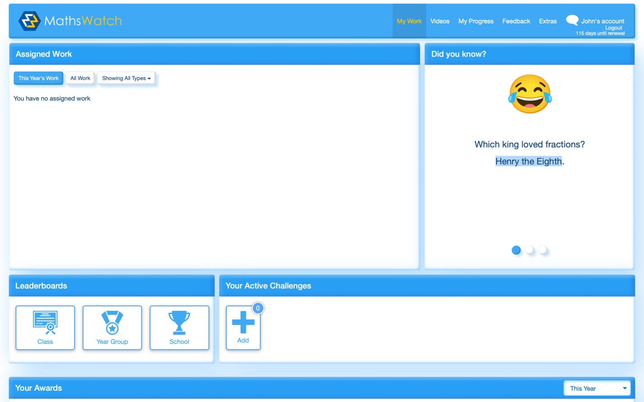

Very easy to navigate:

* Colour scheme is based on 3 different colour (sky-blue, yellow and white) which makes it more visually pleasing for the user.
* Icons making the user interface more friendly.
* Different sections split clearly (Leaderboards, Your active challenges etc...)

Points and Leader boards – Shown on different scales. 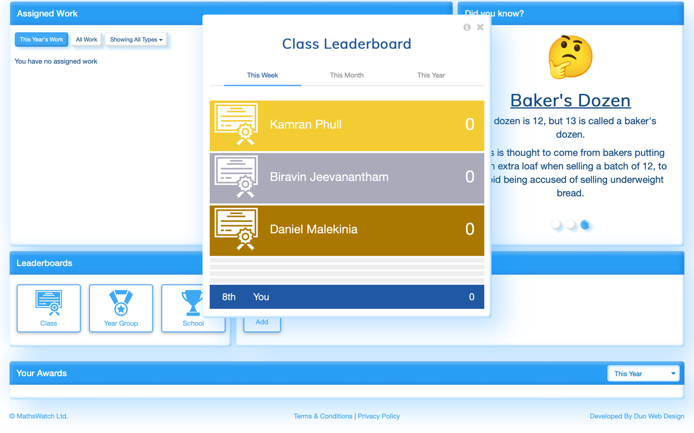

This shows the leaderboard is accessed via the LEADERBOARDS section. Once pressed this window pop up is shown, revealing the top 3 achieving within certain different areas (Class, Year group, School) and within 3 different timeframes (Week, Month, Year). Each of the top 3 students are shown with their rank (Gold, Bronze, Silver) in order to differentiate them. This creates friendly competitiveness.

Progress Of Student shown in an easy way for the user to comprehend which skills to work on.

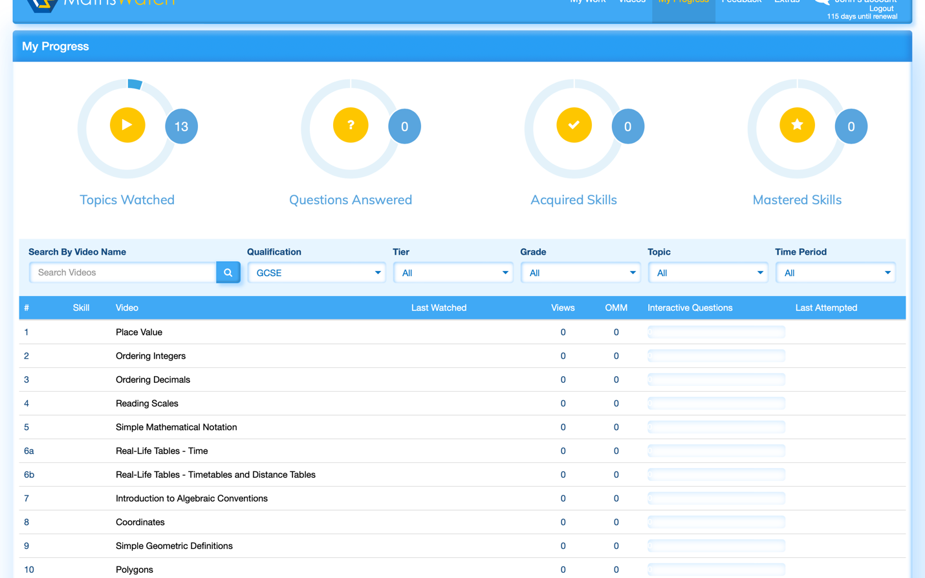

c

Questions and video clips for different topics can be filtered using different criteria such as: (Qualification, Tier, Grade, Topic etc…)

Progress is shown using a circle which is easy to comprehend for the students and visually pleasing for the user. It shows different statistics such as:

* Questions answered.
* Acquired Skills
* Mastered skills
* Topics Watched

MathsWatch Question Page

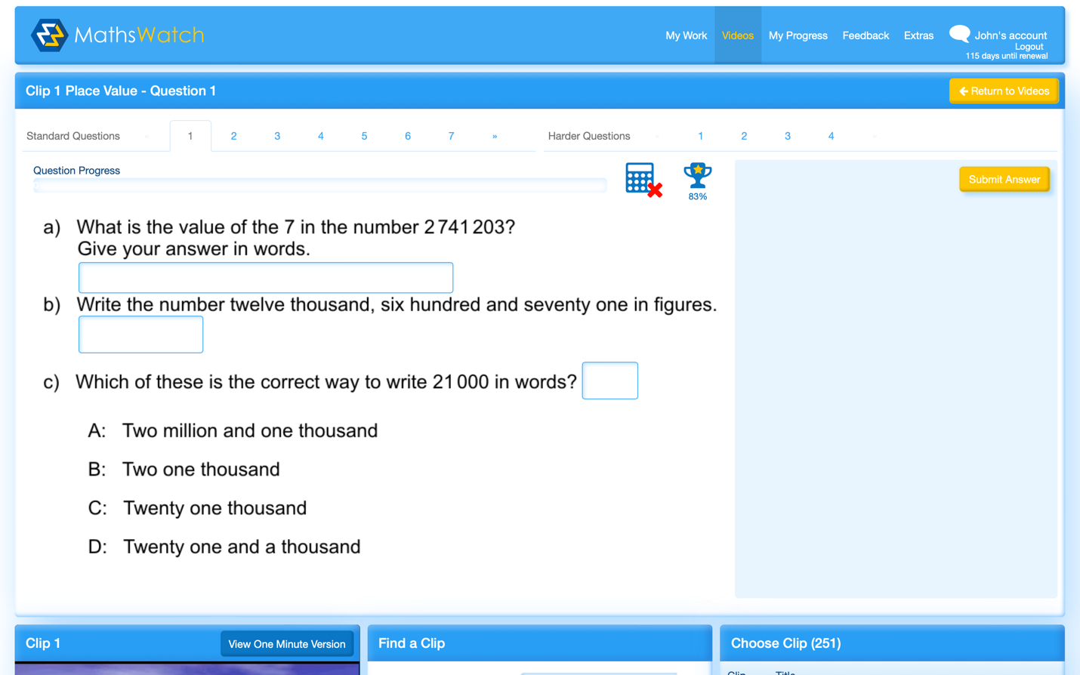

Boxes are used in order to receive the user input (answer to the question)

Submit answer button used to submit the answers for them to be checked if they’re correct.

Question progress is shown through the mark bar displaying the current marks being awarded for the user’s input.

MathsWatch Question Page once you get your answer correct.

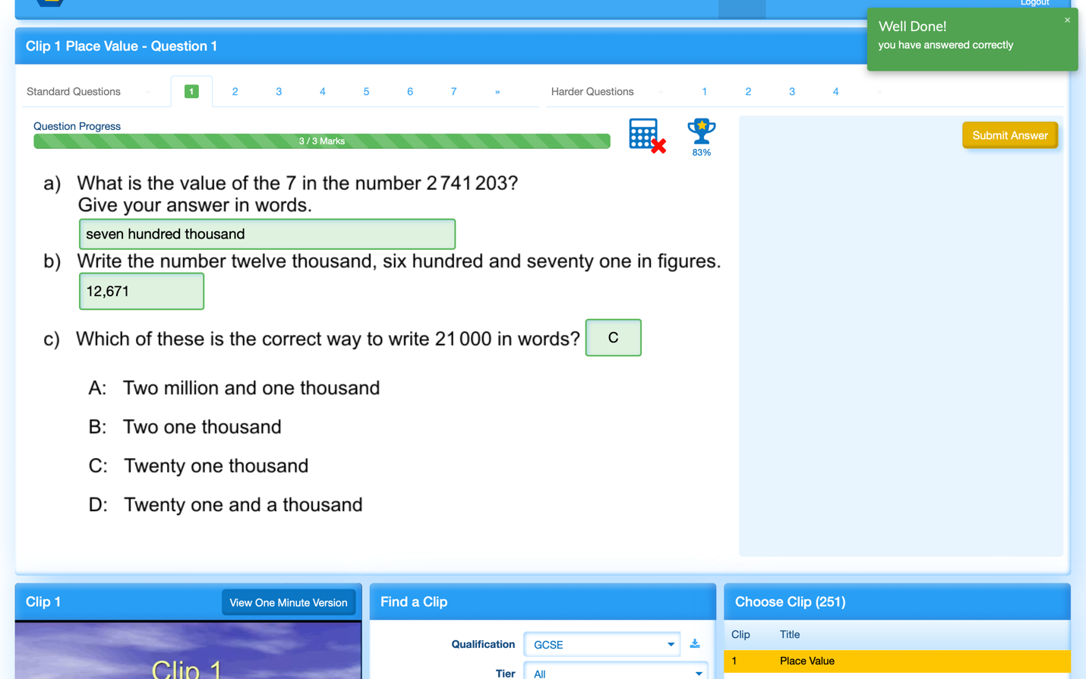

Once user input is validated and checked against the answer the input boxes are highlighted in green to show the student that the answer is correct.

Pop up message is shown informing and congratulating the student on getting the correct answer.

Marks Tab is filled up in green to show the number of marks that are being rewarded for that question.

MangaHigh – Another website similar to my project which has adaptive learning algorithms in order to aid the students using the website.

First Question on a Task -- >

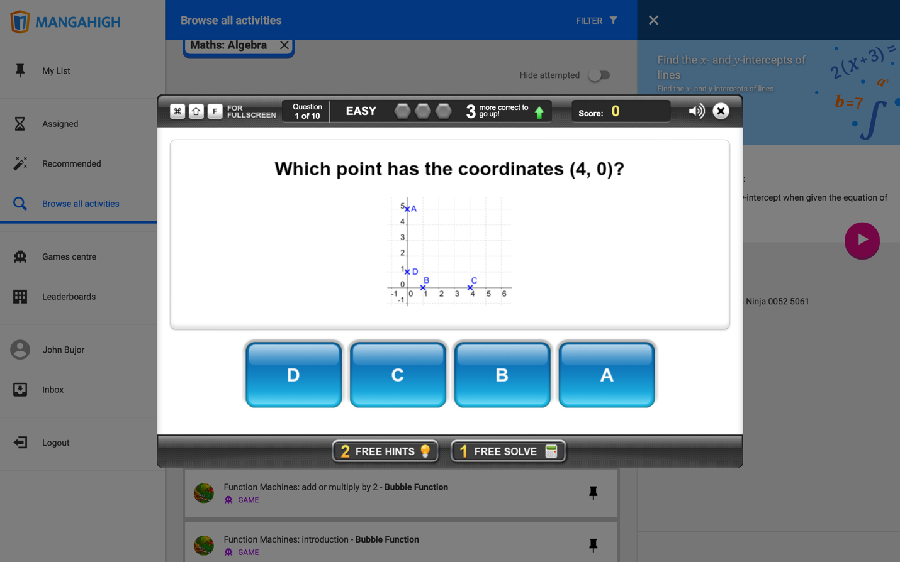

The questions start out as easy which makes it suitable for all students of different knowledge on the topic. If 3 questions are answered correctly the difficulty changes to medium and continually progresses.

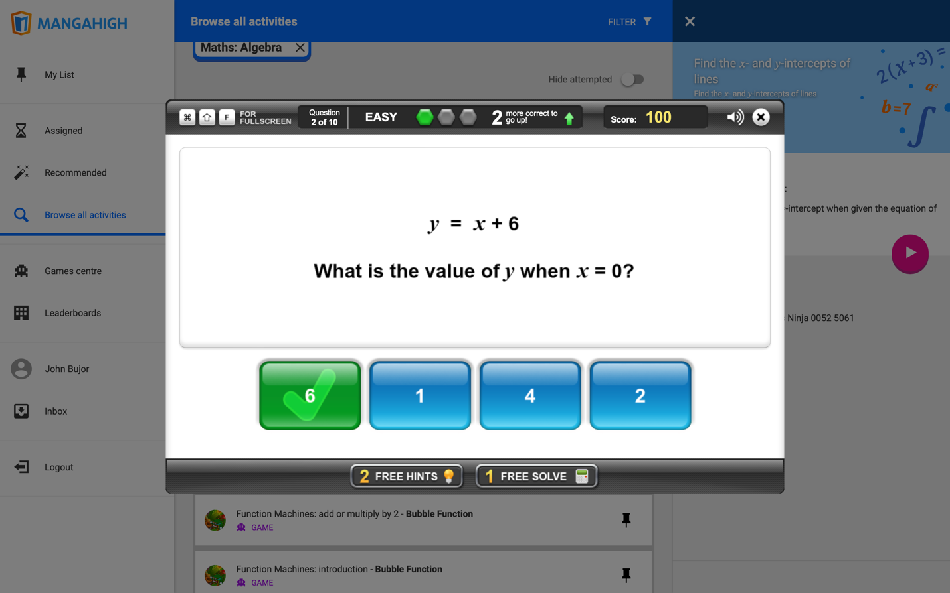

As the user gets a question correct the bar is filled up and letting the user know how many questions until the next stage, however this progress is exponential, and a streak of correct answers makes you reach the highest rank of questions quicker.

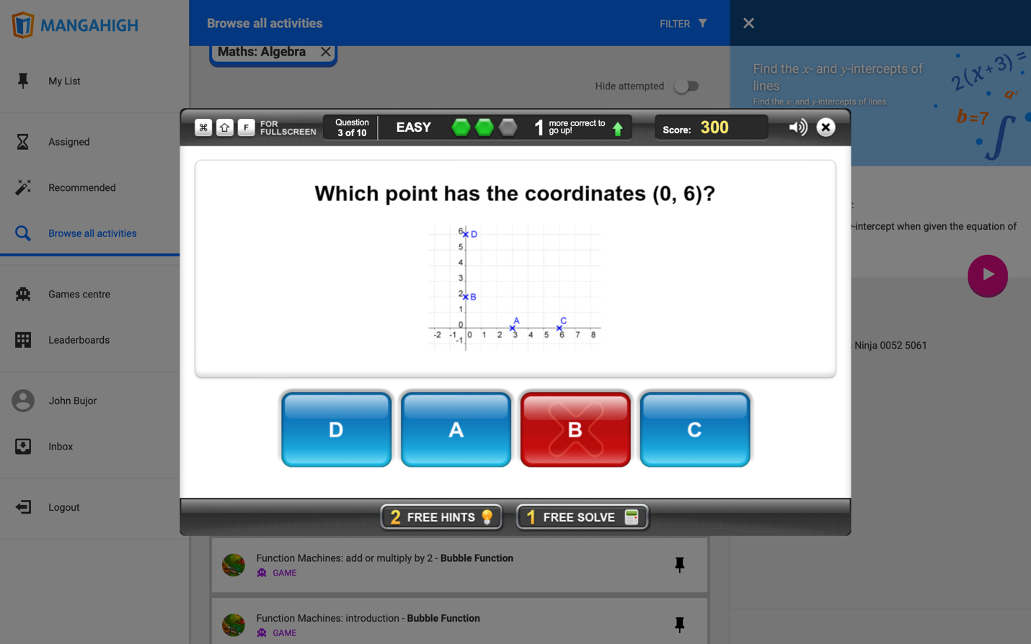

When a user answers a question incorrectly, we can see that the progress bar decreases and the user is given another question of similar difficulty, the same concept however applies, a streak of incorrect answers decreases the rank at a more exponential rate.

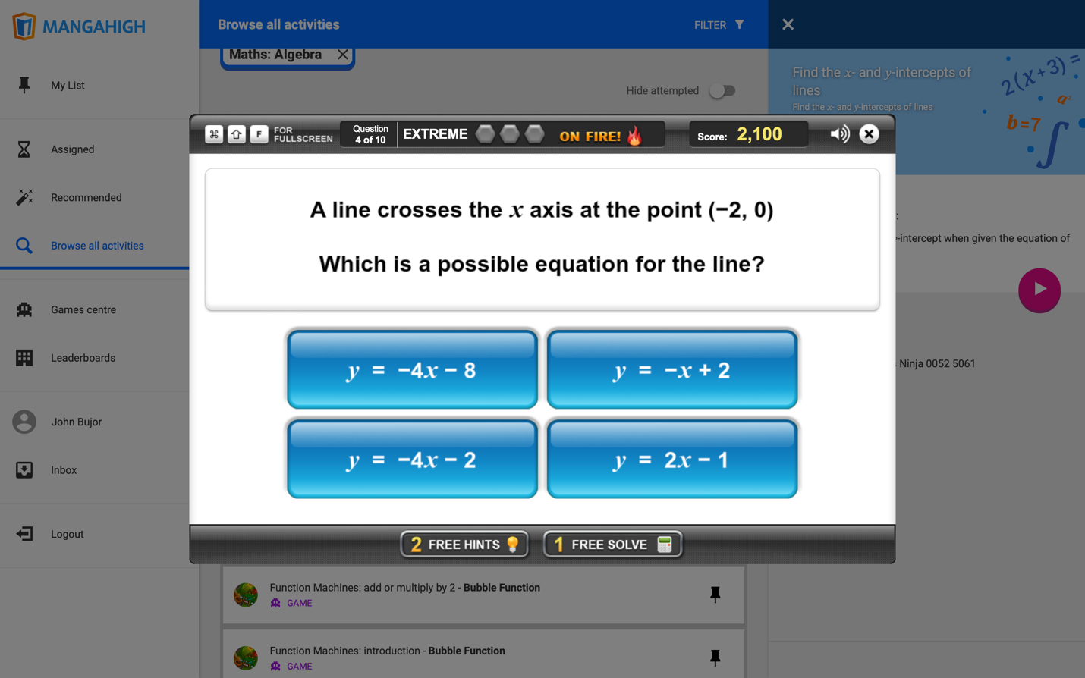

We can see that the end rank is labelled as extreme – this in correlation leads to harder questions and more points being earned per question.

## Interview with stakeholders

Questions for Daniel Malekinia ( Student ):

Q1. Do you think an AI chatbot which guides you to the answer by giving slight hints is a good feature that should be implemented?

Q1. Yes, as a lot of students who struggle look to just find the answer to the question online. This ai chat bot will enable students to solve problems in the right direction.

Q2. Would a leaderboard motivate you to strive and why?

Q2. Yes, a leaderboard will allow me to always strive to perform to the best of my abilities and actually put in the effort, this is because leaderboards and winning acts as a form of extrinsic motivation.

Q3. Do you think a community forum would be appropriate for students to discuss solutions?

Q3. Yes, with the right moderation and regulations it will be beneficial for me to discuss problems and questions with other students as it opens a new way of thinking.

Q4. In my version the difficulty of questions is based on the performance of the student, do you think this is a benefit?

Q4. Yes, as usually I tend to under challenge myself, this means that I won’t be able to be efficient and effective with my work. An automated system that changes difficultly based on my performance on other questions will enable me to consistently stay at the right level to progress further.

Q5. Should you be able to answer a question more than once?

Q5. Yes, a lot of websites like doctor frost etc, only allow me to answer twice at max before revealing answers. Being able to answer more than once will allow me to keep working towards finding a solution instead of just being given the solution.

Questions for Mr Neilson and Mrs Pitsillides (Head of Department / Teachers):

Q1. Performance of student would be based on the frequency of questions correct and time taken to solve the questions. Do you think other factors are important and which ones?

Mr Neilson - Type of question – multiple choice, free text with workings etc… initial starting point [difficult question or easy question etc…]

Miss Pitsillides- base line test/questions to assess students first? Type of question, maybe multiple choice

Q2. Do you think a community forum would be appropriate for students to discuss solutions or help each other?

Mr Neilson - This can be really good as students naturally want to collaborate. Only thing to consider is whether the questions are different [even if it’s the same type/style but with different numbers] otherwise it’s open to plagiarism.

Miss Pitsillides- This would be good for students to be able to explain to each other, however it may end up being a place that students just type their answers for others so may need different questions (e.g. every question having different randomised numbers).

Q3. Should you be able to answer a question more than once?

Mr Neilson - More than one attempt on a question is a good idea however it might make sense to provide hints/scaffolding for subsequent attempts.

Miss Pitsillides- Yes, maybe with a hint if there is a mistake. Students having more attempts allows them to be able to understand the question more.

Q4. Do you think an AI chatbot which guides you to the answer by giving slight hints is a good feature that should be implemented?

Mr Neilson - Yes, I think this is a great idea, however I think the ai should only be used once the user needs hints for taking too long on one question or getting it wrong.

Miss Pitsillides- Yes, but not to explain the whole question or not until they have attempted maybe 5 times and still don’t understand. Might be better for hints.

Q5. Do you think there should be an introduction test which determines the standard point for every new user (starting rank in terms of algorithmic ranking) or should there be an introductory test which sets this?

Miss Pitsillides- induction test quiz or multiple-choice questions to show their initial ability so the work set is the right level and not too challenging or too easy would be a better option.

Mr Neilson- Yes, I think this is a great idea, a diagnostics test should be used in order to identify the starting point for the students.

## Identifying and justifying suitable approaches based on this research.

Suitable approaches based on the website researched:

Multiple indicators of progress and efficiency of the student are needed for the student to track their progress with a question. For example, a marks bar showing the amount of marks being gained by the user (in order to track if they’re on the right path to solving the question) and the time taken (this is necessary due to exam conditions as they are timed). There needs to be multiple ways of displaying progress over time of the student (this can be done in a graph or a sort of circle / sphere that fills up as student progresses (reference to mathswatch)).

Type of questions – This will include multiple features from mathswatch as well as mangahigh. For example, for easier questions, they will be answered using a multiple-choice format, this is due to the low marks that would be given in the true exam therefore, no marks would be awarded for working out. As questions progressively get more difficult and be worth more marks, the format would change to a type box (simulation of the working out on paper) as marks can be awarded based on the working out of the user.

Pop up messages which congratulate the student would be a great addition (mathswatch reference) as this can be motivating for the student.

## Identified the essential features of the proposed computational solution explaining these choices

|  |  |
| --- | --- |
| Features | Description |
| Mark Bar | This shows the amount of progress on a question being performed by the user. It will have a maximum number of marks and the current marks scored by the user. |
| Submit Button | This is used for the user to submit their answers to be checked against the correct answer and retrieve the amount of marks gained. |
| Multiple Choice Answers | This allows for written questions to be answered relating to statistics in particular (sampling) / hypotheses testing. |
| AI ChatBot | This chatbot is only activated when it is identified that the student is struggling (Time elapsed per question is overdue / too many incorrect inputs) |
| Leaderboard system | This is used to output the top users (most questions answered correctly), this is going to be worldwide or multiple regions. |
| Pop Up Notifications | This can be used to show the student that they are getting the answer correct or incorrect |
| Input Boxes | These are required in order to retrieve data from the users to be validated. |
| Community Chat Forum | This is a big feature which can be split into multiple sections:   * Input boxes (user input will be validated to make sure no inappropriate words can be used or will replaced with * ) * Output system for other users to see their message or other users. |
| Attempting a question more than once | As suggested by the stakeholders, students should be able to answer a question more than once (hints will be used to guide the user to the answer) |
| Timer | This is useful as students need to solve these questions under timed conditions. This can be a great guide to see if the user is taking too long on the questions. |
| Adaptive Learning | This is an algorithm used to determine the difficulty of the question based on multiple factors. |
|  |  |

## Specified and justified the requirements for the solution including (as appropriate) any hardware and software requirements

Web browser – this can be any of the following:

🡪Safari

🡪Google

🡪Chrome

etc...

A good internet / internet connection is needed.

Standard hardware requirements which can be found on any modern laptop or PC:

🡪 4GB Ram

🡪 I3 processor

🡪 Mouse (if on PC) or Trackpad for laptop

🡪 Keyboard

🡪 A standard display

🡪 Speakers (in order to hear certain sounds however this is not required)

## Identified and justified measurable success criteria for the proposed solution

Success Criteria - > Build the fundamental website and approach in an agile way of coding. This allows me to have the website and as time goes on, I am able to implement certain features (functionalities of the website). Therefore, main focus will be to get the back-end development implemented so that data can be retrieved from a database. This allows me to focus on adaptive learning as questions can be retrieved from the database back to the user for the user to answer. Once this important feature is on the website this allows me to work around it, for example, I will be able to add a leader board or a chatbot specific to that question. Another important aspect is usability features. As I can see from the examples given (Mangahigh and Mathswatch) there is multiple usability features which make a more engaging user interface.

Such as:

🡪 Multiple Colours

🡪 Task Bar

🡪 Pop up notifications

🡪Timer

🡪 etc…

However, one limitation could be the community chat forum. This is due to time purposes; therefore, this will be one feature which takes less priority as we can see it is not a functionality in other successful alike websites.

|  |  |  |
| --- | --- | --- |
| Requirements | Justification | Reference |
| Start button – this will be activated via a left click on the mouse. | This is to make sure that the time used in order to answer the question is accurate, this is to ensure for an accurate adaptive learning algorithm | Proposed solution |
| Timer – this activates once the start button is clicked | Timer is necessary for students to see if they are completing the question within the time given during a real exam. | Proposed Solution / Mangahigh |
| Multiple Choice Questions are sent back to the user at random times based on the adaptive learning. | Multiple choice will be used for lower mark questions as they do not require a lot of working out. | Proposed Solution / Mangahigh / Mathswatch |
| Written questions are sent back to the user at random times based on the adaptive learning. | Written questions will be necessary for students to attempt more challenging questions which are assessed on the working out as well as the answer. | Proposed Solution / Mathswatch |
| Algorithm to check if written answers are correct. | This will be based around an array of possible answers and key elements needed in order to gain marks. | Proposed Solution / Mathswatch |
| Counter – data type – dictionary  This will hold the number of correct questions. Increments when question is correct | This will be needed to hold the number of questions correct (value) along with the difficulty of the question (key) | Proposed Solution |
| AI Chatbot needs to be able to activate once the student is detected to be struggling on a question. ( more than one minute elapsed time) | AI will need to be able to be automatically activated once a certain time is elapsed.  Able to take user’s inputs and process the input for an appropriate answer.  Detect when it isn’t able to help the user and report back as to what question it doesn’t understand (however this could be tackled using a google search library where it will be able to give back URL links to the user). | Proposed Solution |
| Multiple choice questions check if correct or incorrect. | This will be needed in order to give feedback to the user based on the question given. Answers will be checked via selection. | Proposed Solution / Mathswatch/ Mangahigh |
| Pop up notifications appear when a student gets the answer correct or incorrect. | This is part of the user interface –  Makes it more user friendly as the user is able receive a quick compliment if they completed the question or a motivational message in order to push the students to do more revision. | Mathswatch |
| Text Box – this is part of the user interface as well as a requirement for the users to submit their answers. This appears at the start of every written question. | This is needed for the user to input their answers to written questions and be retrieved for marking and validation. | Proposed Solution |
| Users can attempt a question more than once. | This is backed up by the stakeholder interview. This is due to students being able to try questions multiple times as practice. | Stakeholder interview |
| Diagnostics Exam – this will be introductory for every user once they log in.  Sets up the minimum level of the student in the adaptive learning. | This is going to be used as an initial rank (starting point for every topic) for the student. | Stakeholder Interview |
| Submit Button used to send user input back to the database. | This is going to be used for the user to send the results back to the server once they are pleased with the answers. | Mathswatch / Mangahigh / Proposed Solution. |
| Second Counter – Used to count points gained by the user over a certain period.  Counter increases if question is correct. | This is needed in order to determine the rank of the user for the leader boards. | Mathswatch/ Mangahigh/Proposed solution. |
| Leaderboard System used in order to sort the best performing users.  Top 3 will be in a bold font as well as coloured in Gold, Silver, Bronze according to rank. | This is going to be a feature where users will be ranked based on their performance in questions, this will be stored in an array / dictionary / linked list. | Mathswatch / Proposed solutions |
| Graph system – separate functionality which is accessed via a menu.  Shows students progress. | This will be used to display progress to the user over time and compare their progress over time. | Mathswatch |
| Progress bar -> part of the user interface, will fill up based on the progress of the user. | This is part of the user interface and allows the user to see how well they are doing on a question. | Mathswatch |
| User interface for questions ->   * Shows difficulty of the questions * Progress Bar which is filled up when question is answered correctly | This allows the user to see the difficulty of the question and allocate themselves to the conditions needed to answer the questions (time needed, amount of working out) | Proposed solutions / Mathswatch |
| AI can take in inputs and calculate certainties on which answer to output. | Not enough time to create a neural network where the ai is able to have unsupervised and supervised learning. | Proposed Solution |
| Algorithm which is able to create different level of questions:  Easy  Medium  Hard | This will be an algorithm used to make questions ranging in difficulty from easy to harder, based on a certain template. | Proposed solution. |
| Separate app for the monthly prizes tab which will be accessed via left click on the right heading. | This will be accessed via a left mouse click. Users should be able to only choose prizes based on the number of points they have. | Proposed solution. |
| Streak system – Question is chosen daily and is worth extra points if the users are able to complete it.  Double the points of the question on a normal day. | This will motivate students to log in to their accounts and do maths in order to not miss out on any points as these can be used to claim prizes. | Proposed Solution – Idea taken from LeetCode. |
| Users should be able to:  Access the community chat forum.  Send messages.  Retrieve messages. | This allows for students to communicate with each other in order to open new ways of thinking. | Stakeholder interview  Proposed solution. |
| Plays a sound when the user got a question correct. | Adds to the usability features of the website making it more user friendly. | Mathswatch |
| Play a sound when the timer is about to run out ( 30 seconds before). | This will alert the user when they’ve exceeded their time limit. | Proposed solution |
| Questions are released at the times with the highest user traffic. | This allows for users to be more engaged. | Proposed solution |
| Streak of answers creates a higher multiplier of points so that users can collect more in order to claim prizes. Points go up at a higher rate the more questions correct. | This motivates users to get questions correct. | Proposed solution  Mangahigh |
| Run the server as a local host.  Website communicates with server. | This is due to scalability not being an issue due to low traffic. | Proposed solution |
| Data is sent to the database. | This is needed once users need to log in. | Proposed Solution |
| Multiple input validation algorithms to make sure password and email are in correct format | To make sure that the password is strong enough and that email is valid. | Proposed solution  Mathswatch |
| Data is retrieved from the database | This is needed when questions need to be sent back to the website. | Proposed solution |

# B. Design

<See H446-03 Project Advice Booklet for help and guidance of what must go here.>

## Systems diagram

<file:///Users/john/Desktop/Flowcharts/Top-Down-Diagram.pptx>

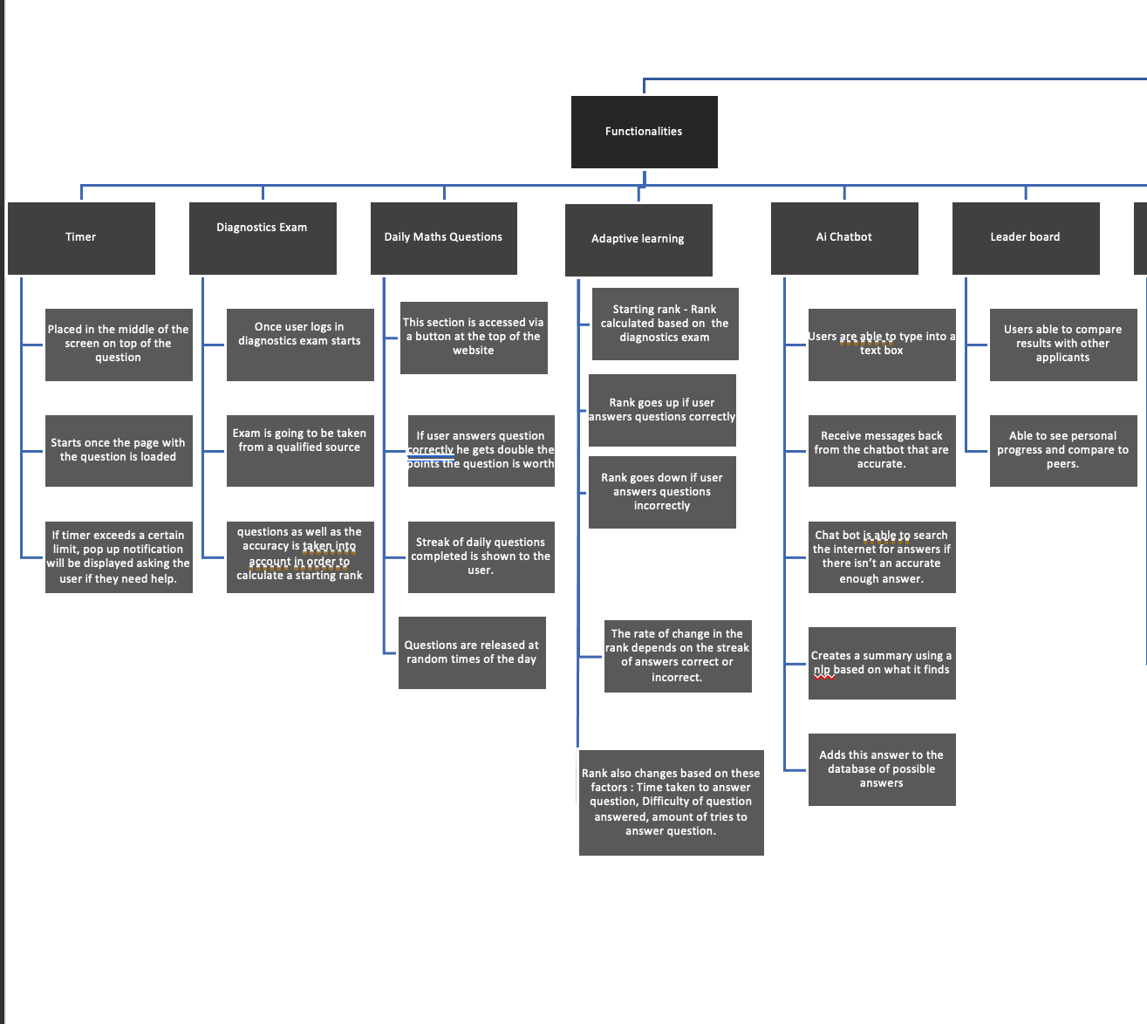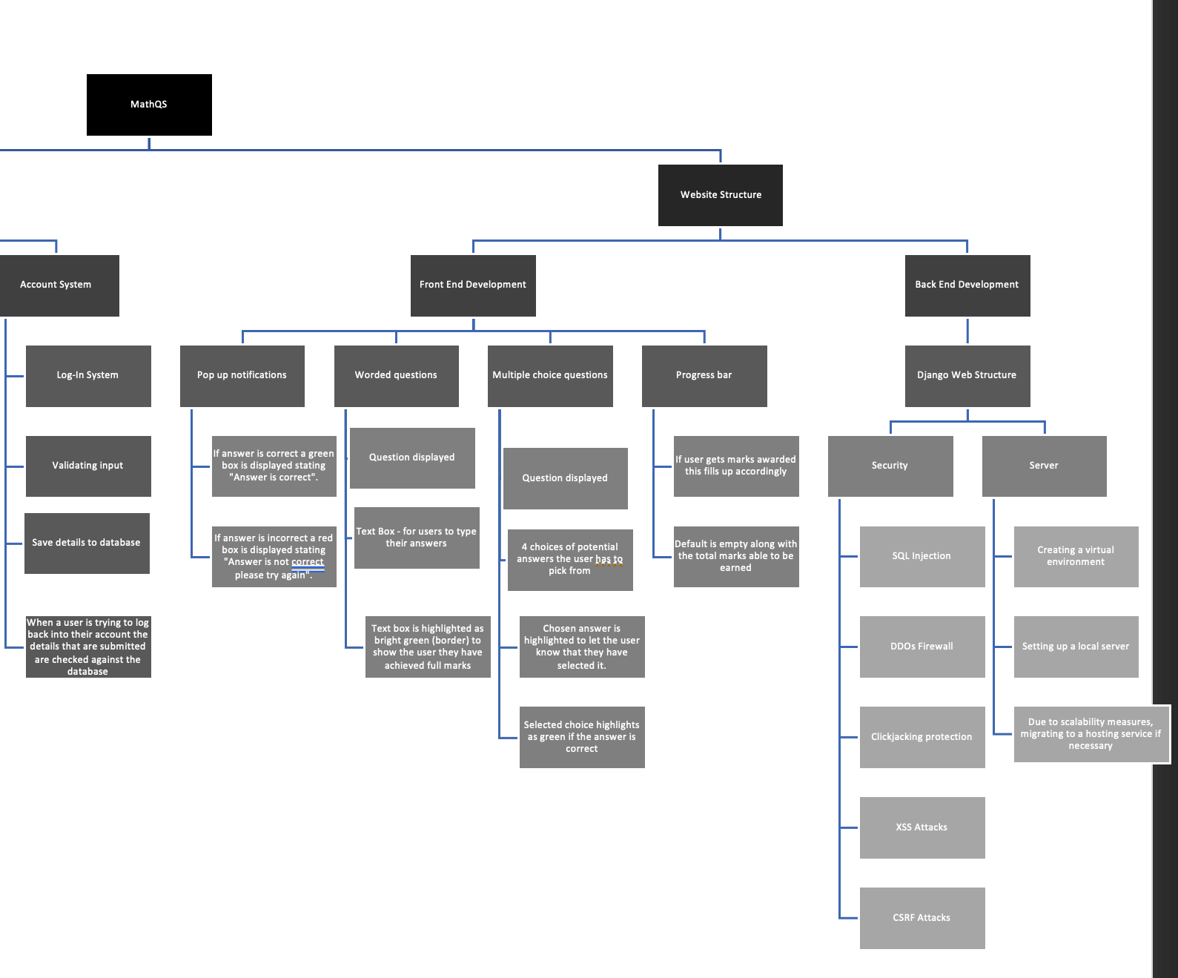

## Broken the problem down systematically into a series of smaller problems suitable for computational solutions,

## Explain and justify the process you have taken for breaking down the problem.

I have split the problem into two different main subcategories:

🡪 Functionalities:

* This shows all the functions the website should be able to perform once a user has reached the website, logged in to their accounts or has started taking a question-based exam. This is further broken down into the different functions and their roles within the websites. For example, timer 🡪 this is a function of the website which is activated once the user is attempting a question.

🡪 Website Structure:

* This is essentially the backbone of the website/ this is essential in order for the website to function as well, by creating the website structure I am able to create a foundation on which I am able to start implementing the multiple features and functionalities which my stakeholders and I have organized.

## Defined in detail the structure of the solution to be developed – explained each part of your structure diagram

Functionalities:

* Timer – This will be achieved via the time library which will be imported.

Once the user has clicked the green button with the tag (START) this timer will instantly start counting upwards and be displayed back to the user in order for them to time themselves. This timer will be placed on top of the question in the middle of the screen. Average times to complete the questions will be monitored and adjusted accordingly based on the user’s rank. This means if the user has a lower rank, they will be allowed a longer time to complete the question and vice versa for users with a higher question rank (lower time allowed). If the user exceeds this time they can be deemed as struggling and AI Chatbot feature will be permitted in order to help the user. Final time taken by the user to complete the question is stored and used to further adjust the rank of the user for the next question.

* AI CHATBOT- This feature will use multiple libraries such as: --- Threading, googlesearch, newspaper, re, random,
  + Once the chat box is opened the user will be greeted by the AI stating “Hello, what can I help you with?”
  + Once the user responds and inputs a message this is processed by the chatbot and responds appropriately
  + Chatbot splits the message into words which are stored in an array by splitting via recognizing any common spacing techniques such as (SpaceBar,[].?) and making all the words lowercase.
  + The words are analyzed and based on that they’re checked against certain formats which the chatbot has built into it and if the required words for that output as well as the words needed for that output are discovered, this creates a probability of each answer format the chatbot has installed.
  + The format with the highest probability is sent back to the user.
  + If the probability reaches 0 this means that the AI doesn’t have any response that is accurate to send back to the user, in order to solve this, the chatbot asks again for a clearer query from the user.
  + The chatbot sends back a loading animation which runs via a daemon thread (background process) whilst performing the following tasks:
    - Performs a googlesearch on the user query and returns the URLs of the top 5 websites with the highest PageRank for that search and stores them in an array.
    - Using Threading and the newspaper library the chatbot creates 5 different threads for each of the URLs. Each thread uses the function “Article” from the library newspaper in order to extract all the important data from the URL, also known as web scraping (ethically) This article is then downloaded and parsed for the important information. Using natural language processing (also implemented in the library) this can return a summary of the articles text as well as date published.
    - Once this is done the loading animation disappears and the summary of the text is sent back to the user.
* If the user is sent back this data their rank is also lowered by 50 points due to outside help being requested on the question, this is to assure that the adaptive learning algorithm is accurate.
* Diagnostics Exam – this needs to be completed once by the user once they create an account is created and they log-in for the first time. Diagnostics exams are used to test someone’s knowledge across a certain subject and determine their strengths and weaknesses. The exam consists of questions which are multiple choice where the answers are similar in order to avoid the user from guessing. Once the diagnostics exam is completed the total score is recorded and based on this the starting rank for the user is calculated. This exam cannot be retaken once the user has completed it once. This exam is going to be taken from <https://qualifications.pearson.com/content/dam/pdf/GCSE/mathematics/GCSE%20Maths%20Online%20Study%20Course_Diagnostic%20Assessment.pdf> in order to have an accurate exam. Maximum rank which could be achieved is 2000, accuracy of the users’ answers is taken into account (if they’re close to the answer some points are awarded.)
* Account System – Users are able to create accounts in order to save their progress. This will be created via a username and password. This input will be validated to make sure that the passwords are appropriate and meet certain requirements such as (length, use of certain characters, uppercase letters, etc.….). These credentials are stored in a database in order for the user to be able to log back into their account at any time as long as they have an internet connection and web engine. Once the user wants to log back into their account their input is checked against the database and they’re able to log back into their account. To create an account or to log-in, users will click on a button tagged (Log-In) which is placed on the top right of the website. If a username is taken, this will be flagged back to the user when creating an account in order to avoid confusion when checking the leaderboards. If this is flagged, the username box border will be colored red, and the user can try to create an account again.
* Adaptive Learning – Adaptive learning will be used to alter the difficulty of the questions based on how the user is performing, this will be determined via a rank (integer) – maximum being 2000. Different questions will have a different rank which is determined via the difficulty of the question (this is determined by multiple factors such as the topic being examined as well as the marks being awarded). The adaptive learning rank will adjust based on the user’s performance, if a user gets an answer correct their rank increases accordingly to how hard the question they completed is, streaks are also gained if a user answers multiple questions correctly or incorrectly in a row, leading to a higher rank.

The rank is affected based on multiple factors such as – Time elapsed on a question compared to an average time taken to complete the questions, a higher time elapsed will lead to a lower rank being gained by the user and vice versa. Another important factor is the accuracy of the answer, an answer within close proximity of the correct answer which can be achieved by slight miscalculation will still be considered when reducing the rank.

* Daily Math Questions - Once a day a question is released in the section which is accessed via the top right of the screen on a button which looks like a fire. This question will be released at a random time of the day, this is achieved via the time and random library. Each question is awarded points which are taken into account in terms of adaptive learning. Streaks are also gained by answering these questions and a separate leaderboard is shown to compare the best performing users. These questions are worth double the points they should be worth once completed.
* Leaderboards – these leaderboards will be refreshed every day showing the top users points as well as the username. Each question awards points to the user, points cannot be deducted despite user potentially answering a question incorrect. I’m going to create a leaderboard across the whole website, however I’m going to try and further upgrade this into trying to make a leaderboard for each classroom.

## Described the solution fully using appropriate and accurate algorithms

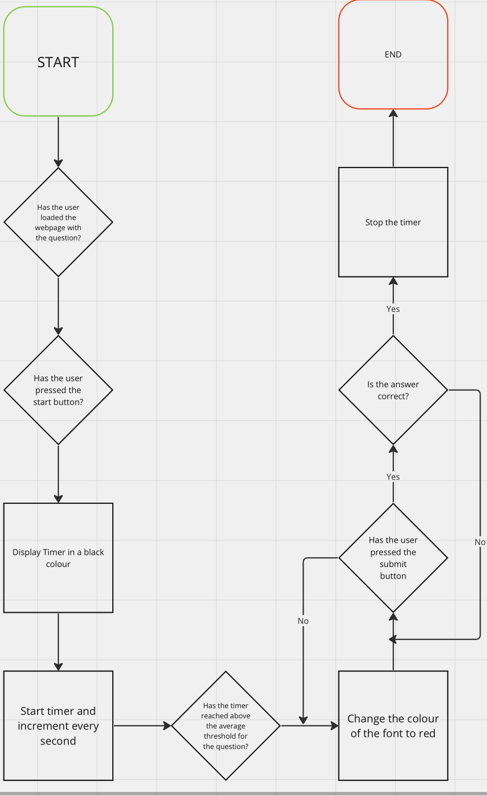

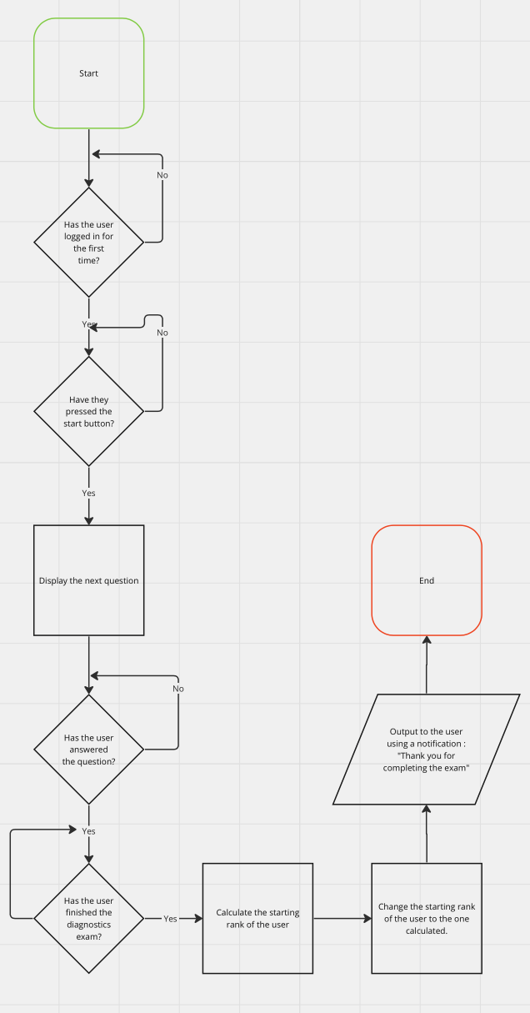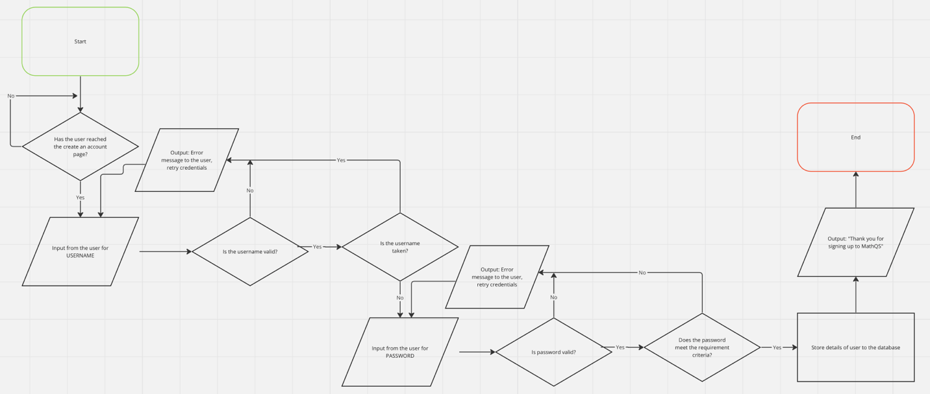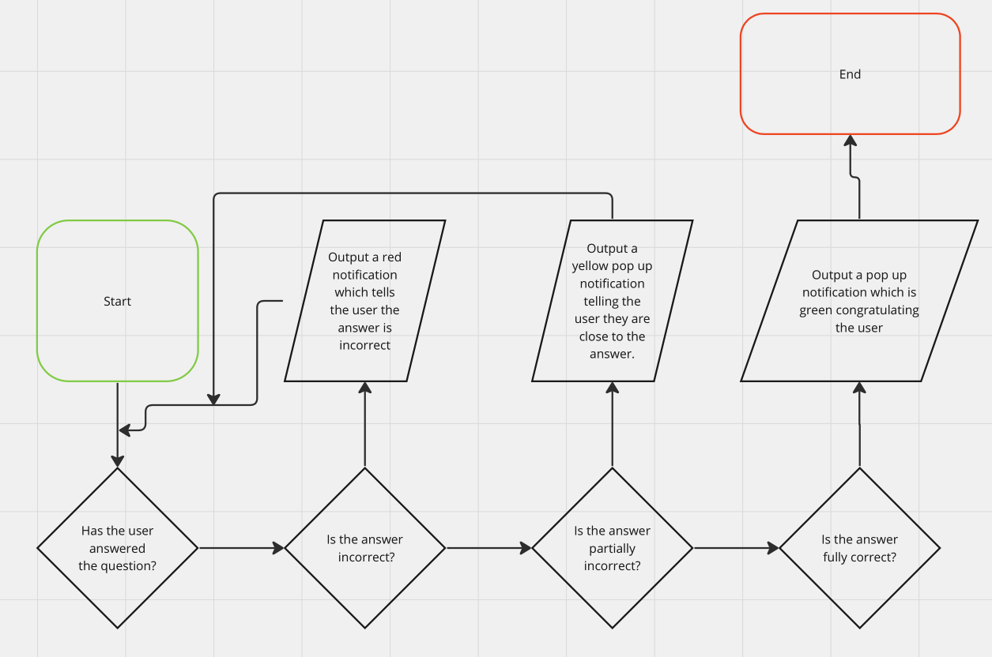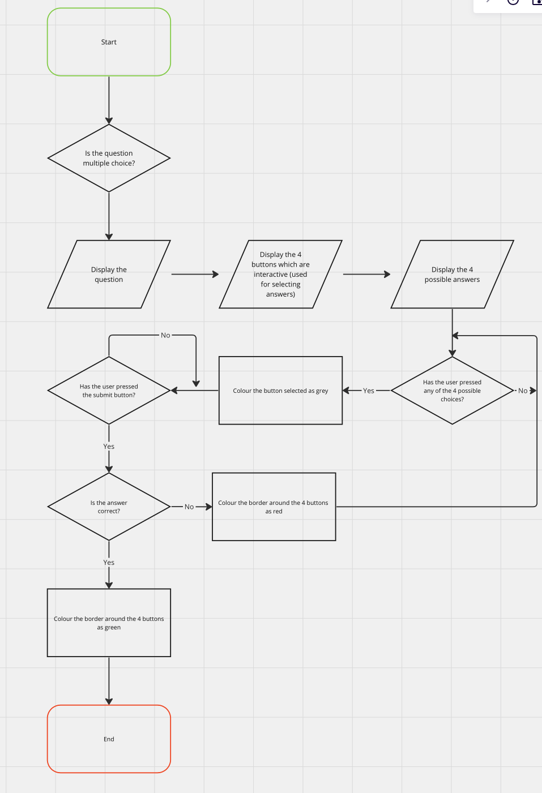

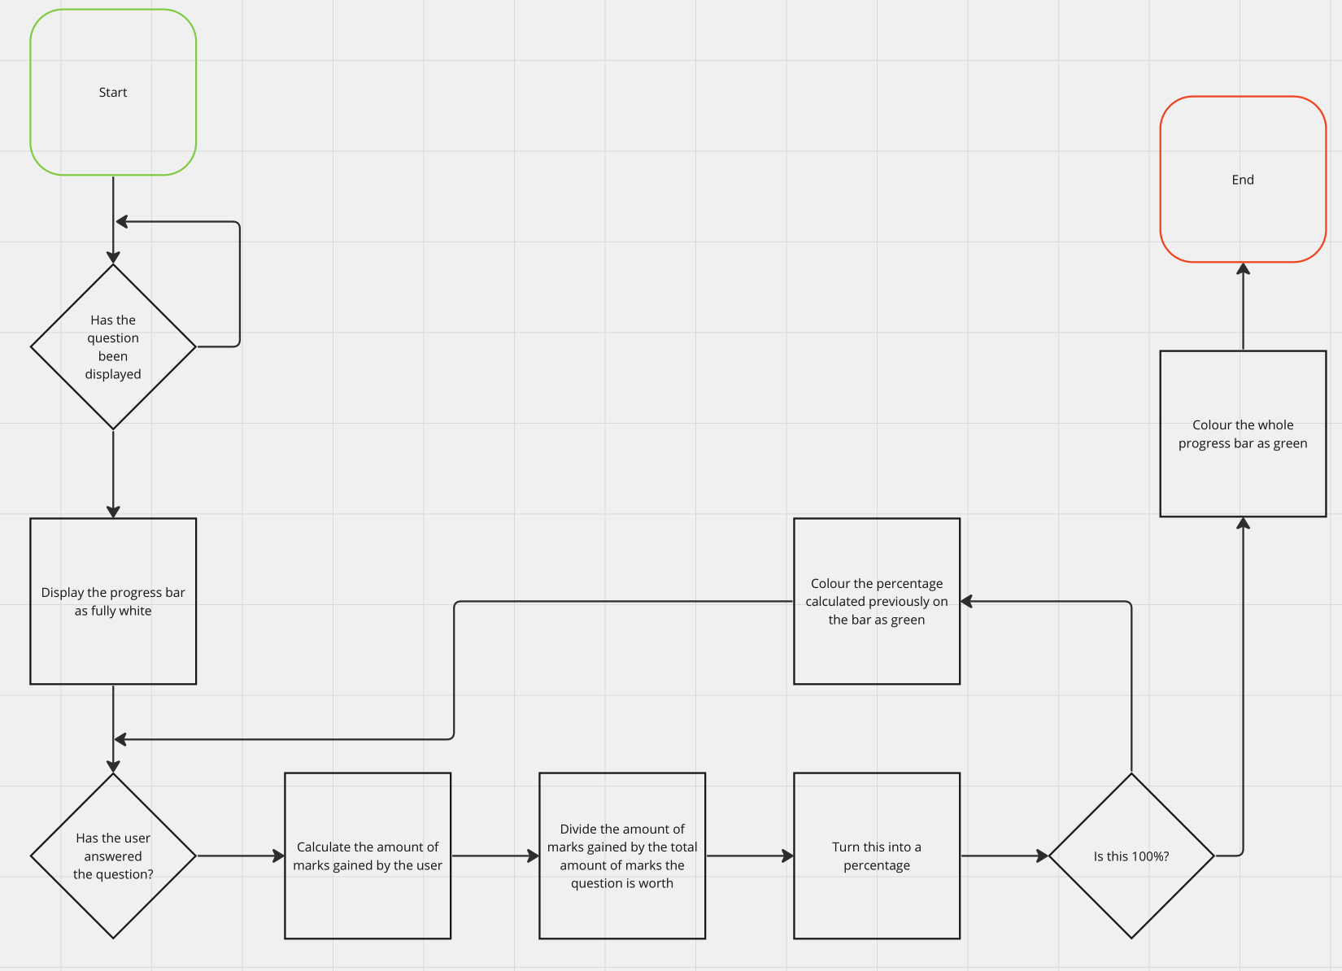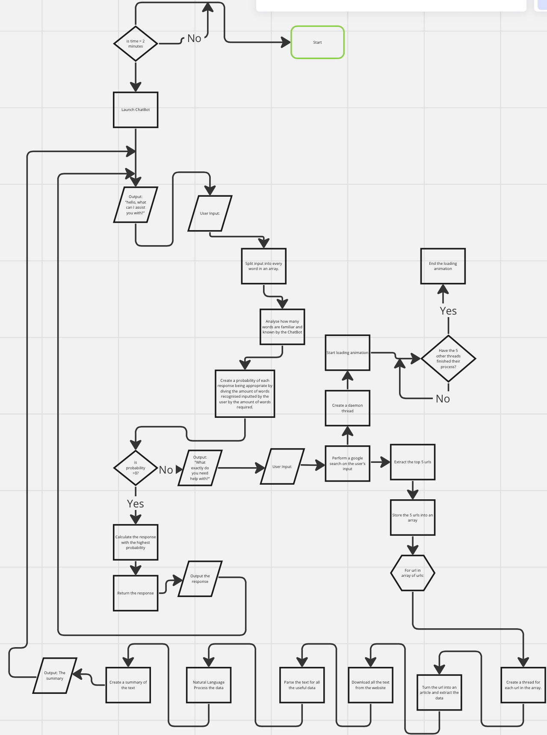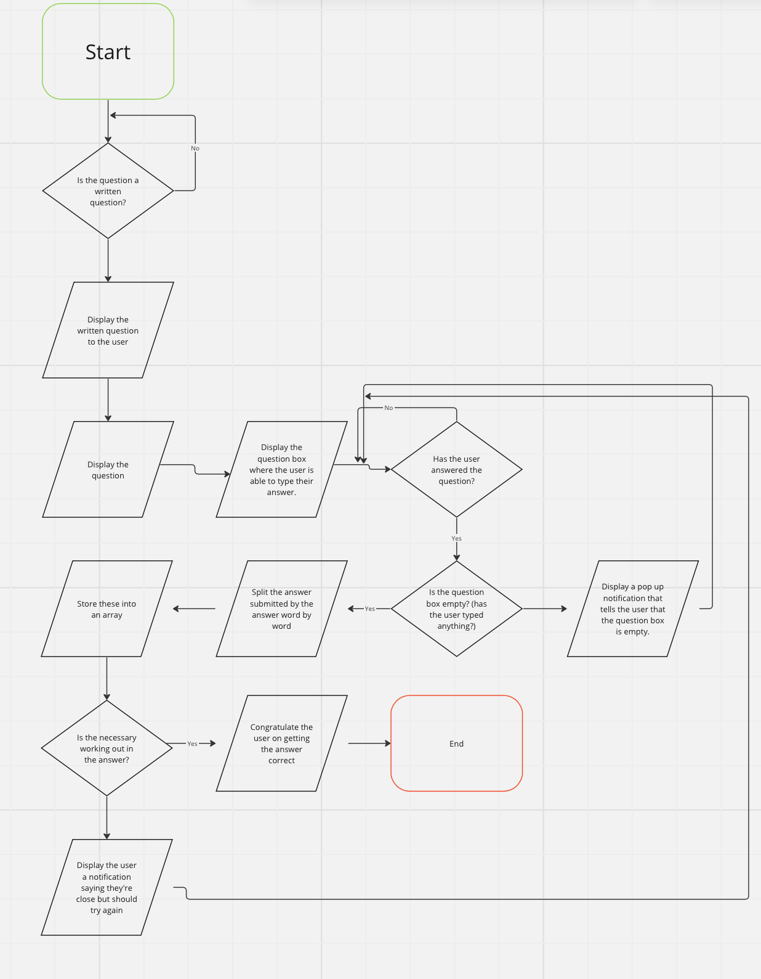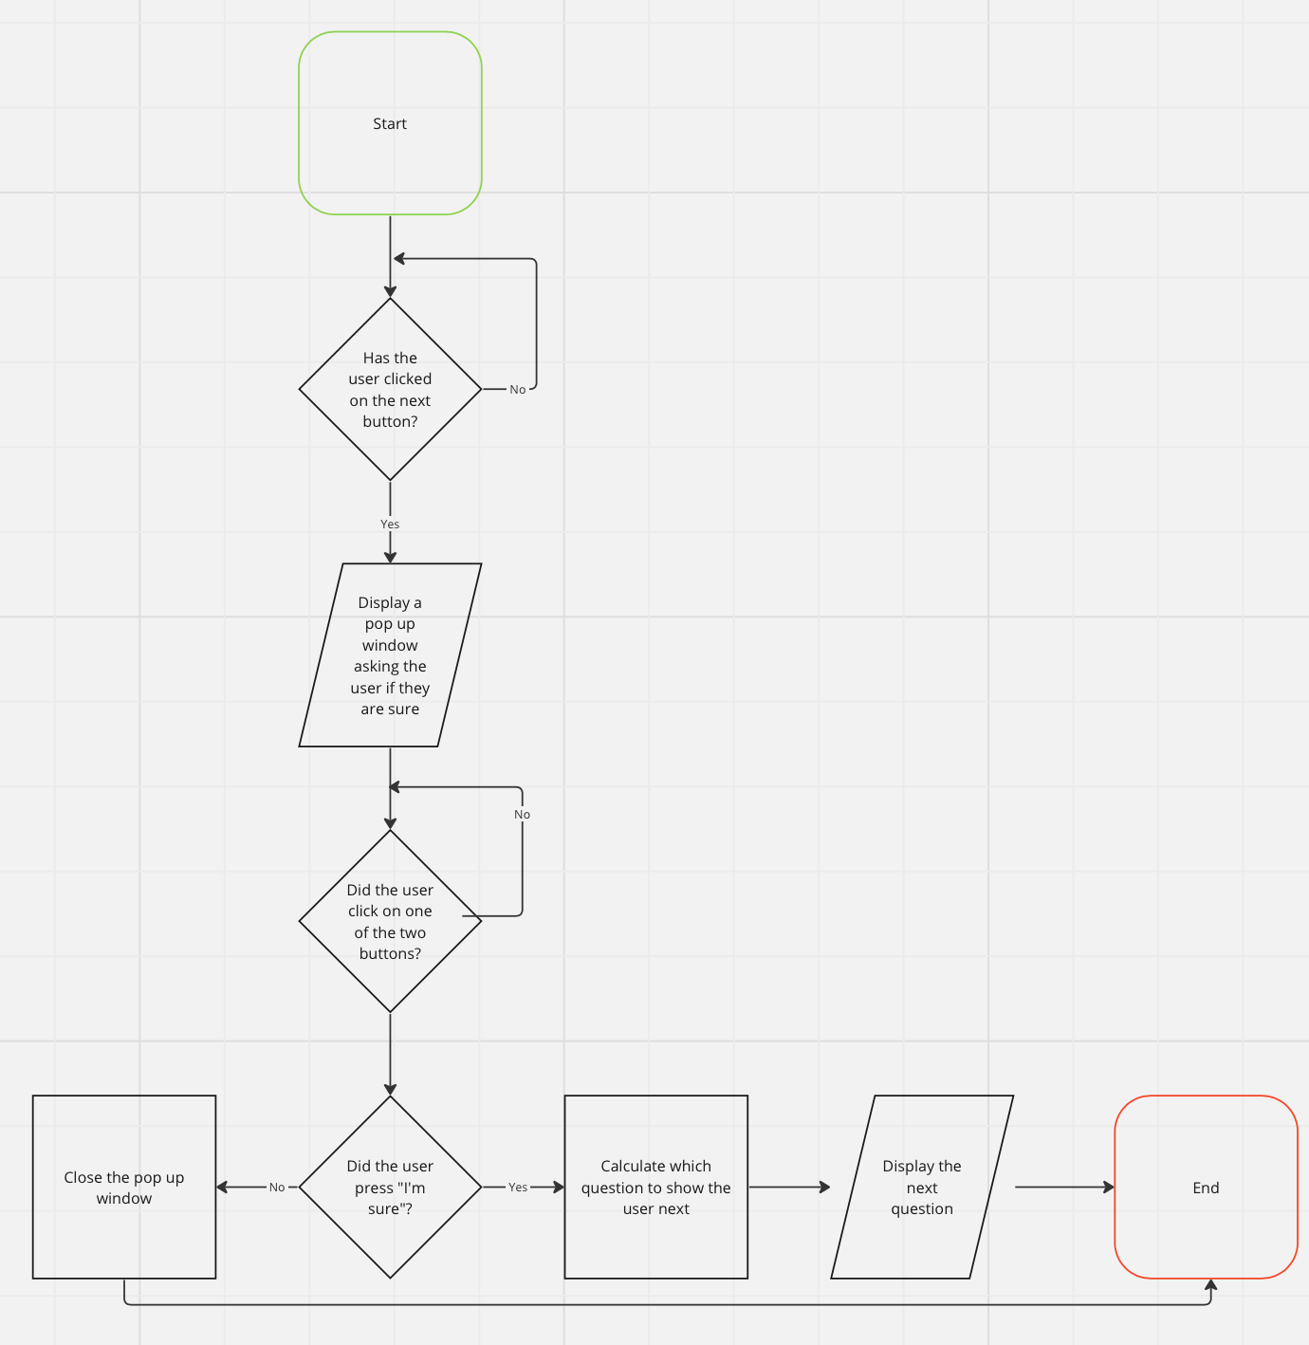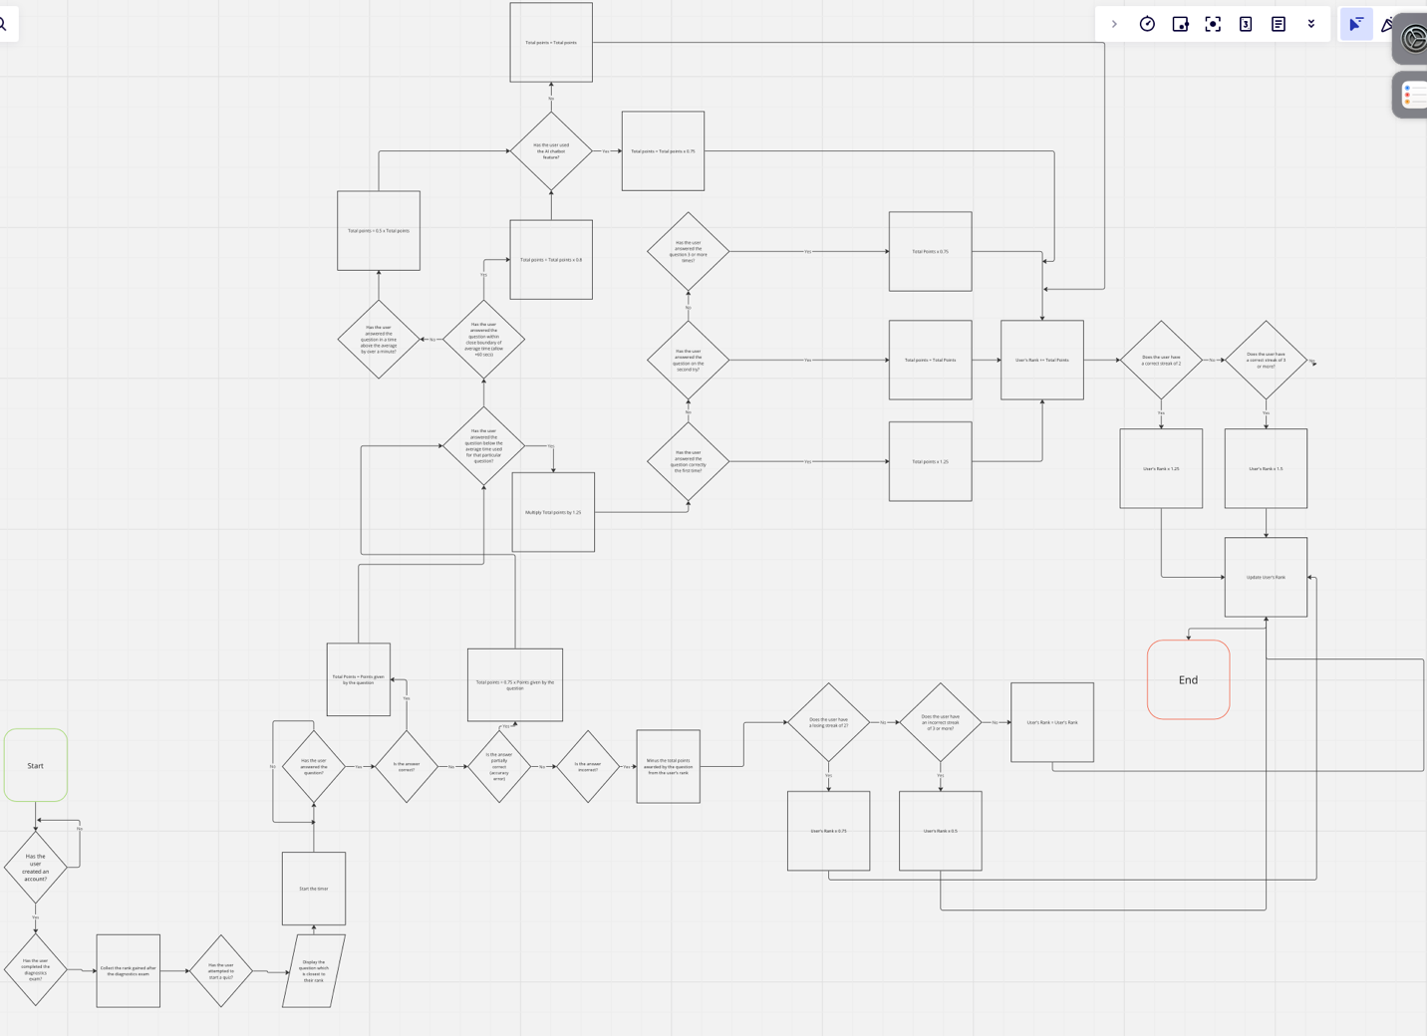

## justifying how these algorithms form a complete solution to the PROBLEM

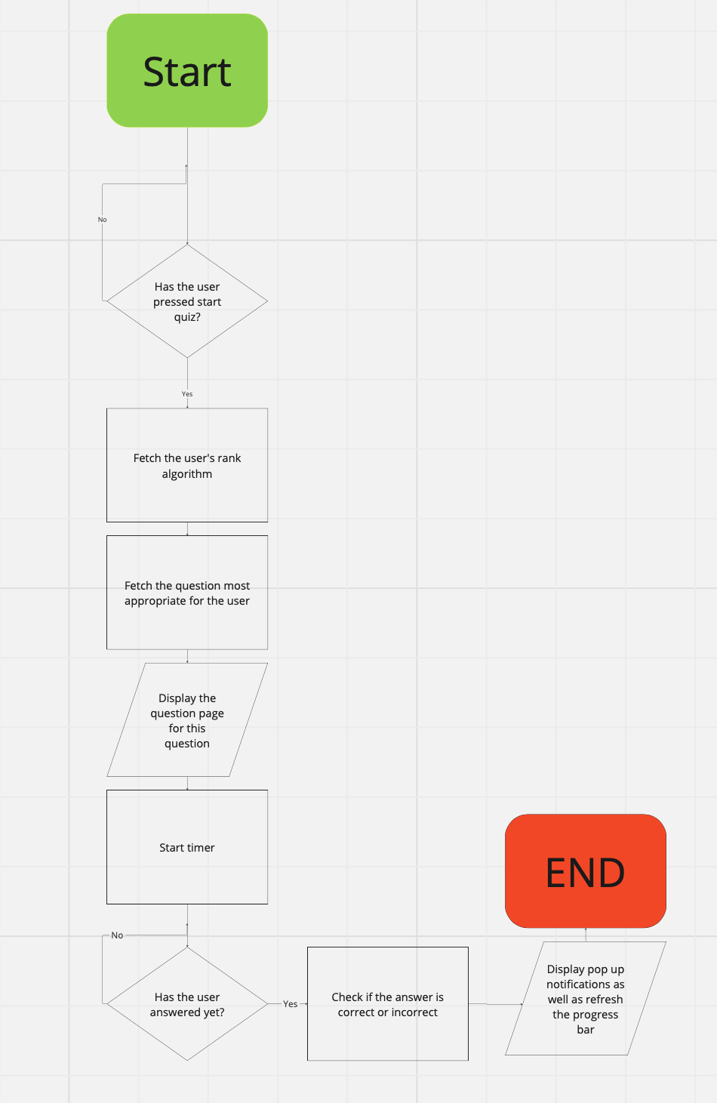

## Describe, justifying the choices made, the usability features to be included in the solution.

I used a range of icons due to their simplicity making it easier for a user to navigate through the website. These icons have a close resemblance to the feature that they are displaying making it easier to understand what each icon represents. The variance in color will also make it a more vibrant user-interface which is extremely important due to the target audience being in the younger bracket therefore sparking their interest. Icons are also smaller than text therefore making the website more space efficient, furthermore icons tend to be understood across multiple languages, for example, the settings icon is recognized worldwide which can make it easier for people with lower strength language skills as well as people struggling with language-based learning difficulties such as dyslexia to interpret the features.



This fire icon will be used in order to display the feature “Daily math questions “. Clicking on this icon will route you to the page displaying the math question for that day. The fire icon is used due to resemblance of being on a streak of correct answers (metaphorically on fire)



This icon of a robot will be used to display the chatbot feature. If this icon is clicked, the chatbot feature will be activated. This is used due to the chatbot representing a robot-like feature which can interact with the user when needed.



This icon represents starting a quiz. If this icon is pressed a quiz will start for the user. This follows a simple scheme and clearly shows its purpose as it is tagged with the word QUIZ.



This icon will be used as the logo of the website. This is used due to its simplicity as well as clearly showing that the main theme of this website is math, which is shown through the math formulas as well as the pencil which usually connotes as well as resembles math.



This icon represents the settings of the website. This icon is universally understood as many games and websites worldwide use a replica of this type of icon.



This icon is used to show that the user has notifications which they have not read. The bell is a universally understood icon for notifications due to its iconic sound of a bell when a new notification is sent.



This leaderboard icon is used due to its universal understanding. This is due to the usual gold, silver, bronze which are used to symbolize the top 3 achievers across multiple areas such as sport (Olympics) as well as websites and games worldwide.



This icon will be used to display the feature of the account system. The asterisks *** connote passwords as they are known to be hidden therefore this will make it easier for a user to understand that this icon will be used to log-in or create an account with the platform.



This icon is used for skipping a question, once again this icon is recognized worldwide, most commonly from platforms such as YouTube and Spotify, therefore this will be easily recognized and interpreted by the user.

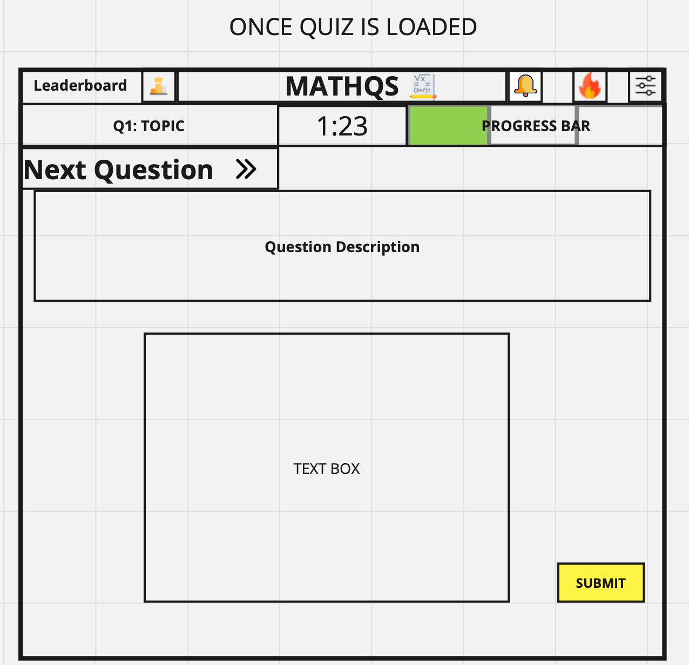

The quiz is also kept simple by having a non-complex layout making it easy for the user to complete questions.

The submit button is colored yellow which is an inspiration from the website “MathsWatch”, can almost be seen as rewarding when pressing the button as they have completed a question.

The progress bar fills up as green and it is clearly displayed in the top right corner of the page, I chose the colour green due to further inspiration from MathsWatch as well as the color of progress being seen as green.

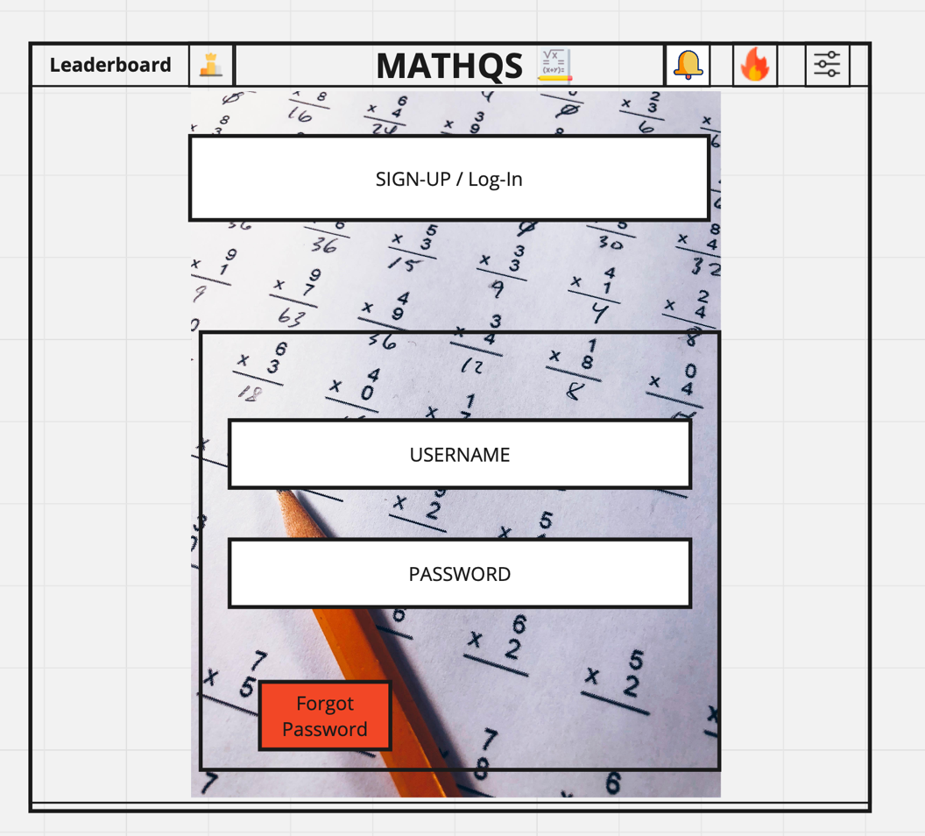

The log-in page is kept further simplified by having minimal detail.

The forgot password button is colored red to make it clear to the user that they are able to reset their password and that all progress can be recovered.

The website logo is still displayed at the top of the page in order to remind the user which website they are trying to connect to, this can add a layer of comfort as they know where their credentials are going.

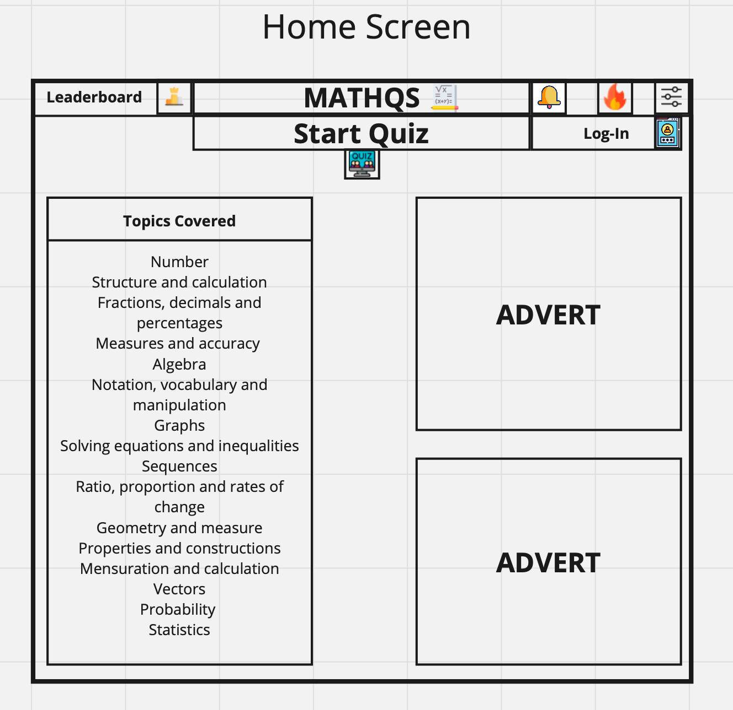

The home screen of the website is kept simple and easy to navigate for users.

The adverts can be a slight inconvenience for the users as this can be almost an eye-sore however this is mainly due to the marketing purposes, this could be however changed into an integrated live leaderboard.

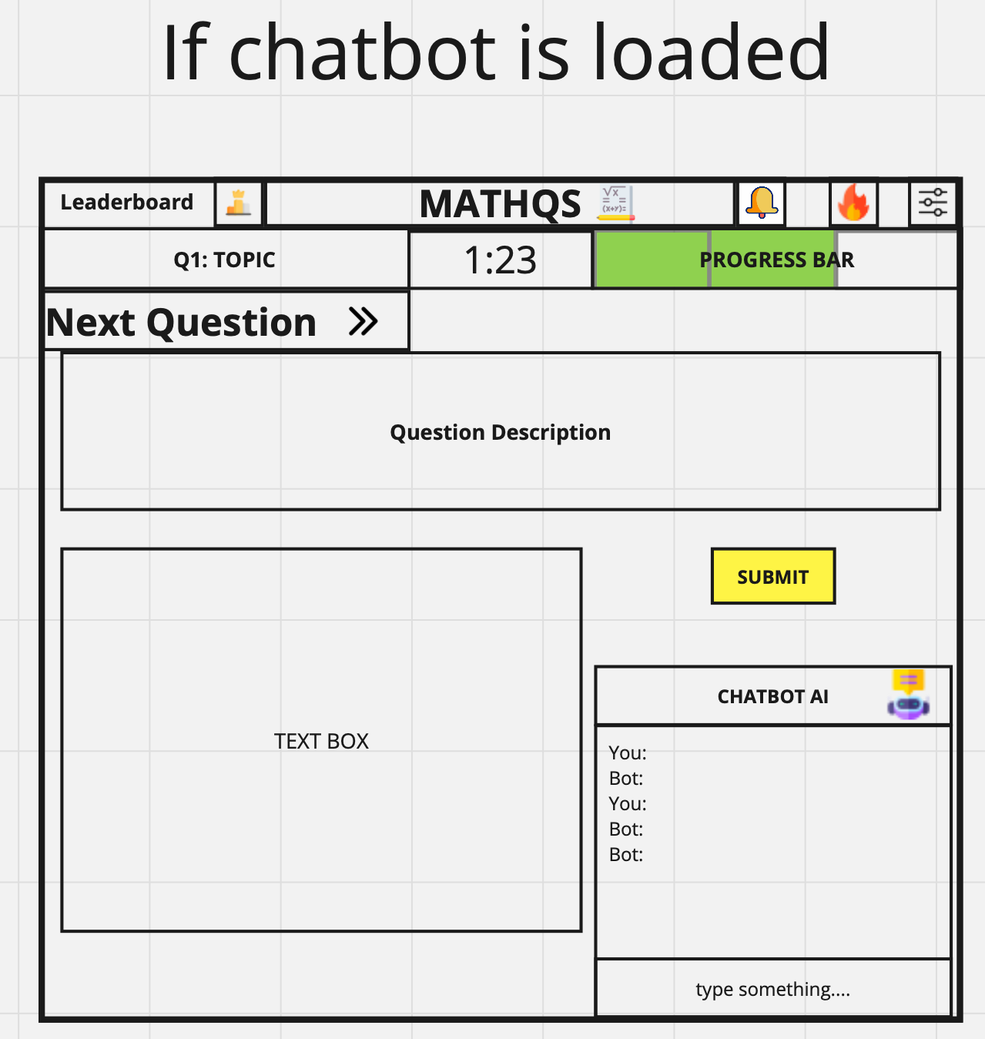

If chatbot is loaded, a pop-up window containing a chat will pop up. This is kept relatively simple further making it easier for the user to interact with the website’s functionalities.

## Identified and justified the key variables/ data structures/ classes (as appropriate to the proposed solution) justifying and explaining any necessary validation.

|  |  |  |  |
| --- | --- | --- | --- |
| Variable name | Data type | Description | Validation |
| Algorithm_rank_user | Integer | This variable is an integer which is used in order to keep count of the users rank within the adaptive learning algorithm. | No validation needed |
| Algorithm_rank_question | Integer | This is a constant integer which shows the level of difficulty of the question in relation to the adapting learning algorithm rank | No validation needed |
| Question_ranks_TOPIC | Array | This is an array which is used to store all the (algorithm_rank_question) of all the questions within a certain topic. Further used in order to find which question is closest to the rank of the user. | No validation needed |
| Web_urls | Array | This array contains all the urls which have been fetched based on the users input by the chatbot | No validation needed |
| Num_results_urls | Integer | This variable is used to determine the amount of urls being fetched by the bot as well as showing the index upper range of web_urls | No validation needed |
| User_query | String | This string is used as the statement which is used to find relevant urls on google search. This is what is going to be searched on the search engine | No validation needed |
| Final_summary | String | This string contains all the summarized data from all the urls into one string,which is returned back to the user. | No validation needed |
| Required_words | String | This will contain the required words needed for the AI to return back a certain message. | No validation needed |
| User_message | String | This string is the message that the user will ask to the AI initially, which could be followed up by the user_query | No validation needed |
| Highest_probablity_list | Array | This array contains all of the probabilities associated with each in-built message which the AI has | No validation needed |
| Best_match | Integer | This shows the highest probability percentage of a message being likely to be the answer to be returned | No validation needed |
| Thread | Register set | This variable contains the initialization of the threads which will work independently on each URL | No validation needed |
| Timer | String | This will be used to show the timer back to the user | No validation needed |
| Timer_font_colour | Condition | This will be used in order to set the color of the font of the timer/ red if it exceeds a certain time | No validation needed |
| Average_time | Integer | This integer is used to show the average time taken to answer the specific question. | No validation needed |
| Username | String | This string will be used to store the user’s username when creating accounts | input must not exist already/ contain at least 2 characters |
| User_password | String | This string will be used to store the pure version of the users passwords ( no changes being done) | Input must contain a special character as well as containing 8 characters or more |
| Hashed_user_password | String | This will store the users password after being hashed | No validation needed |
| Leaderboard | Array | This will contain all of the users points in descending order | No validation needed |
| Leaderboard_Top_users | Array | This will contain the usernames of the top 3 performing users across the website | No validation needed |
| Leaderboard_top_points | Array | This array will contain the points of the top 3 users across the website | No validation needed |
| Diagnostic_exam_no_qs | Integer/ constant | This constant shows the amount of questions in the diagnostics exam | No validation needed |
| Diagnostic_exam_Qs_correct | Integer | This integer is used to show the amount of questions that the user has answered correctly | No validation needed |
| Diagnostics_exam_percentage | Integer | This will show the percentage of the questions correct in the diagnostics exam | No validation needed |
| Multiplier | Float | This multiplier will be used to deduct or increase the amount of points which each user gains from the question, by multiplying it by a factor. | No validation needed |
| Streak | Integer | This will be used to keep track of the users streak of questions being correct or incorrect. | No validation needed |
| Chatbot_usage | Boolean | This will check if the user used the chatbot feature when answering a question | No validation needed |
| Time_taken | Integer | This will keep track of the time taken to answer a question | No validation needed |
| Time_taken_percentage | Integer | This will be used to store how efficient with the time the users were when answering a question | No validation needed |
| User_answer | String | This will be the answer which is received from the user | String cannot be empty when submitted |
| True_answer | String | This is the correct answer to the question that the user is attempting | No validation needed |
| Is_question_accurate | Boolean | This will be used to keep track if the user’s answer was on the right path and had a slight accuracy error. | No validation needed |
| Question_being_released | String | This will contain the question being released at a certain time on that day | No validation needed |
| Time_question_release | String | This will contain the time at which the question being released daily will be released that day | No validation needed |
|  |  |  |  |

## Identified and justified the test data to be used during the iterative development of the solution

Account system - username

|  |  |
| --- | --- |
| Test Data | Type |
| 12 | Boundary |
| Johnthegreat | Valid |
| 1 | Invalid |

Account system – password

|  |  |
| --- | --- |
| Test data | Type |
| 12345678 | Invalid |
| Helloitsme@ | Valid |
| Hell0itsme | Invalid |

User inquiry- chatbot

|  |  |
| --- | --- |
| Test Data | Type |
| 12312414 | Valid |
| 1@$$WSSS | Valid |
| HOW DO I DO THIS | Valid |

User message – chatbot

|  |  |
| --- | --- |
| Test Data | Type |
| 1241412 | Valid |
| Hello | Valid |
| Noway | Valid |

Text box input – question page

|  |  |
| --- | --- |
| Test Data | Type |
| Null ( no input) | Invalid |
| X =5 | Valid |
| Afafhasfak | Boundary |

Icon buttons across the website.

|  |  |
| --- | --- |
| Test data | Type |
| Left mouse clicked on the button | Valid |
| Keyboard pressed | Invalid |
| Right mouse clicked on the button | Invalid |

Answer 🡪 x = 5.5

|  |  |
| --- | --- |
| Test Data | Type |
| 5.5 | Valid |
| 5 | Boundary |
| x = 5.5 | Valid |
| x = 5 | Boundary |
| Yes | Invalid |

Green pop-up notification appears.

|  |  |
| --- | --- |
| Test Data | Type |
| Answer is correct | Valid |
| Answer is partially correct | Invalid |
| Answer is incorrect | Invalid |
| User doesn’t answer question | Invalid |
| Timer runs out | Invalid |

Red pop-up notification appears.

|  |  |
| --- | --- |
| Test Data | Type |
| Answer is correct | Invalid |
| Answer is incorrect | Valid |
| Answer is partially correct | Invalid |
| User doesn’t answer question | Boundary |
| Timer runs out | Valid |

Yellow pop-up notification appears.

|  |  |
| --- | --- |
| Test Data | Type |
| Answer is correct | Invalid |
| Answer is partially correct/incorrect | Valid |
| Answer is incorrect | Invalid |
| User doesn’t answer question | Invalid |
| Timer runs out | Invalid |

Question rank = 500

|  |  |
| --- | --- |
| Test Data | Type |
| User algorithm Rank = 500 | Valid |
| User algorithm Rank = 700 | Boundary |
| User algorithm Rank = 800 | Invalid |
| User algorithm Rank = 300 | Boundary |
| User algorithm Rank = 200 | Invalid |

Progress bar filling up.

|  |  |
| --- | --- |
| Test data | Expected outcome |
| 25% of answer is correct | 1 out of 4 sections of the progress bar turns green |
| 50% answer is correct | 2 out of 4 sections of the progress bar turns green |
| 0% of the answer is correct | Progress bar doesn’t fill up |

A user username is “Johnthegreat” and a user tries creating an account.

|  |  |
| --- | --- |
| Test Data | Type |
| Johnisthegreat123 | Valid |
| Johnthegreat | Invalid |
| Johnthegreat1 | Boundary |
|  |  |

Notification Bell activating.

|  |  |
| --- | --- |
| Test Data | Type |
| User has no notifications | Invalid |
| User has notifications to be read | Valid |
| User cleared the notifications to be read | Invalid |

Quiz is started.

|  |  |
| --- | --- |
| Test Data | Expected Outcome |
| Question Description | Question description is loaded in its appropriate layout space |
| Text Box | Text box is loaded in its appropriate layout space. |

## Identified and justified any further data to be used in the post development phase

# C. Developing the coded solution (“The development story”)

<See H446-03 Project Advice Booklet for help and guidance of what must go here.>

## Iterative development of the coded solution

### Provide evidence of each stage of the iterative coded solution retalating this to the break down of the problem from the analysis and explaining what they did and justifying why

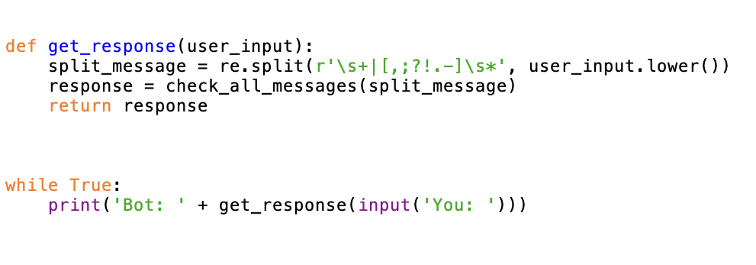

I started developing the Chatbot by creating a while True loop which took in the input of the user. This allowed for constant communication to allow for multiple questions to be answered without a massive delay. This variable input is then passed through the function get_response(). The user’s input is then split into words by checking where there is any space or comma to allow for easier recognition of the sentence being inputted.

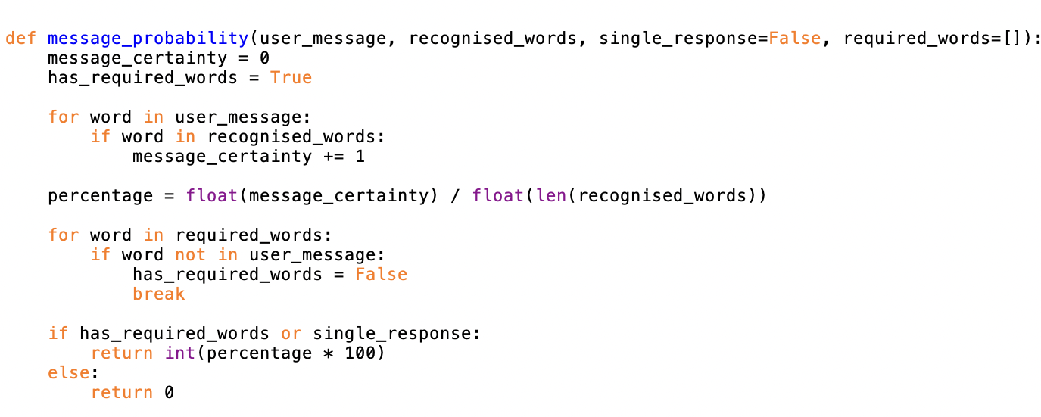

The function message_probability takes in the users input as well as the array recognised words. This array contains multiple words which are integrated into the chatbot, and it is able to recognise. This includes a set of words which I implemented that are simple such as hello and how are you. The function is an algorithm to check how many words are recognised and compare it against a list of responses. For every word in recognised words there is a counter. However, if the required word is not present this probability automatically turns into 0 as the required word is as stated required. The recognised words are then used to create a probability for each response that the chatbot has integrated. This probability is then returned.

FOR CODE BELOW.

The function check_all_messages() compares the message probability against all the responses. Each response is a output such as “hello, See you”, and the array next to them is the recognised words. Longer responses such as “I’m doing fine and you?” have required words next to it such as “how”. This is to ensure that the outputs don’t get mixed up as it is common that the input for that answer has the word how within it.

The highest probability response is then returned unless this is less than 1, in other words the chatbot doesn’t have a valid answer. In which case this is then told to the user and the chatbot searches up the answer to the question online.

The function loading_animation() provides a loading animation due to this process of fetching web urls as well as summarising the text that is found tends to have a longer process time. I implemented this to allow the user to see that the chatbot is working and that it hasn’t crashed. It uses averages of times which I recorded to approximate the amount of time estimated until the answer is outputted -🡪 [1.768869161605835, 2.8689160346984863, 3.0753371715545654, 3.253603935241699, 3.533507823944092, 5.506211042404175], [3.0753371715545654]7

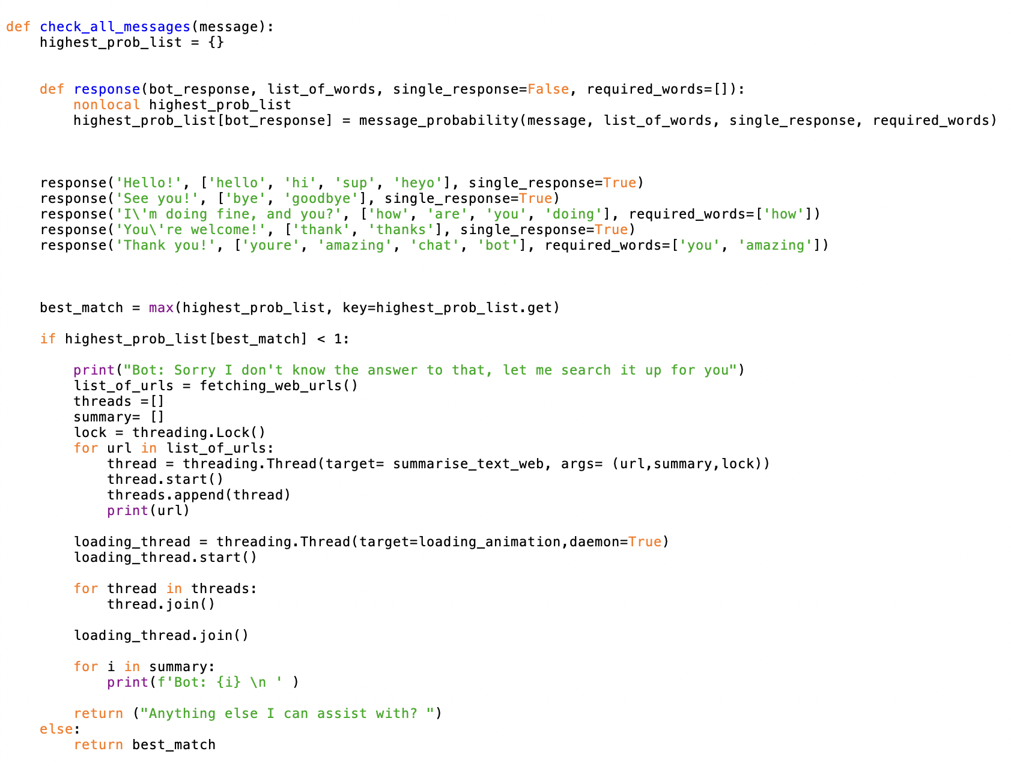

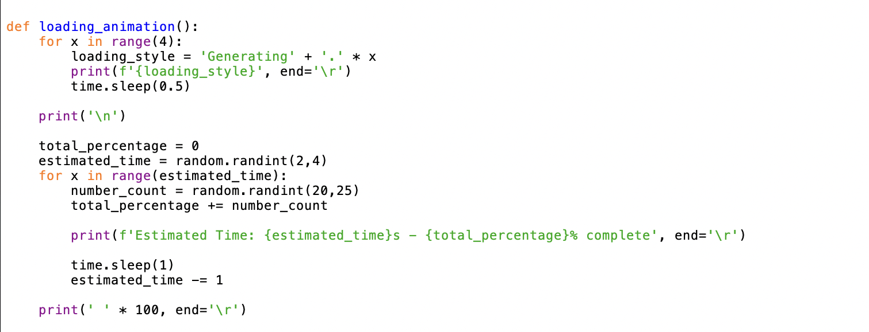

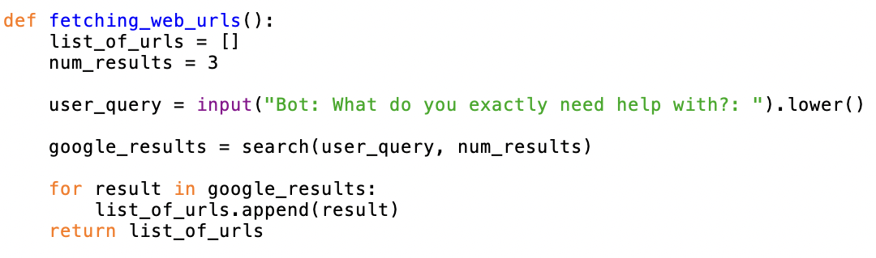

The function fetching_web_urls can search the users query in a search engine and return the URLs. The library google search allows for direct google searching and the function search creates a generator object which I’m able to take the URLs out of by using the for loop. This is necessary as the generator object doesn’t directly provide the URLs; therefore, they need to be extracted.

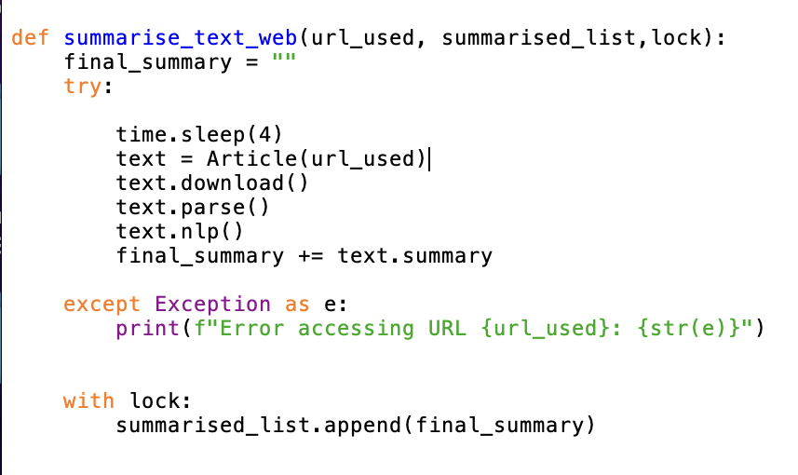

The function summarise_text_web() uses the functionality of the library nltk which is a natural language processing algorithm as well as newspaper3k which allows for parsing text as well as turning a html page into an article, removing all the details outside of the body which is what the chatbot needs.

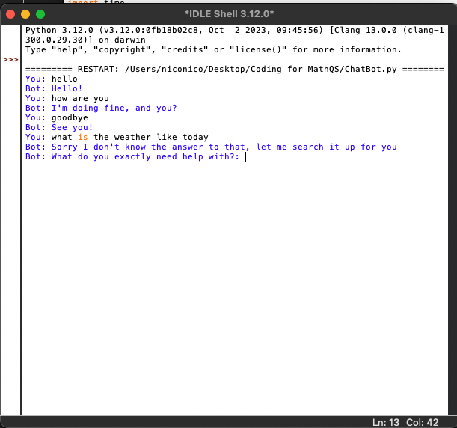

Here I tested to see what the chatbot will output based on the sentences and phrases which have been programmed into the responses such as hello and how are you. The chatbot outputted the correct phrases therefore I asked a question in which the probability would be zero.

As we can see this outputted the sentence I was looking forward to that it isn’t able to answer the question.

### The solution will be well structured and modular in nature

### Code will be annotated to aid future maintenance of the system.

### All variables and structures will be appropriately named

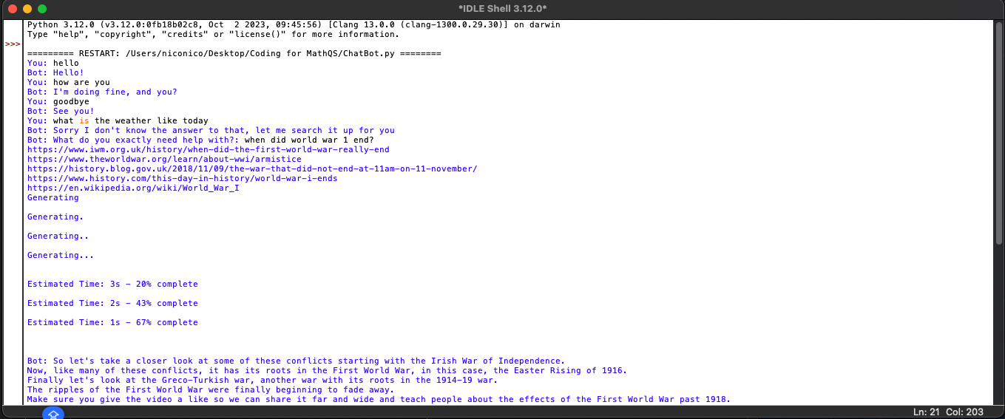

Here we can see each individual thread working to generate an answer from each of the URLs that the chatbot was able to scrape from the web. We can also see the loading animation which is iterated to show the progress it takes however we can see that it is functional, and the timing is accurate

### There will be evidence of validation for all key elements of the solution.

### The development will show review at al key stages in the process

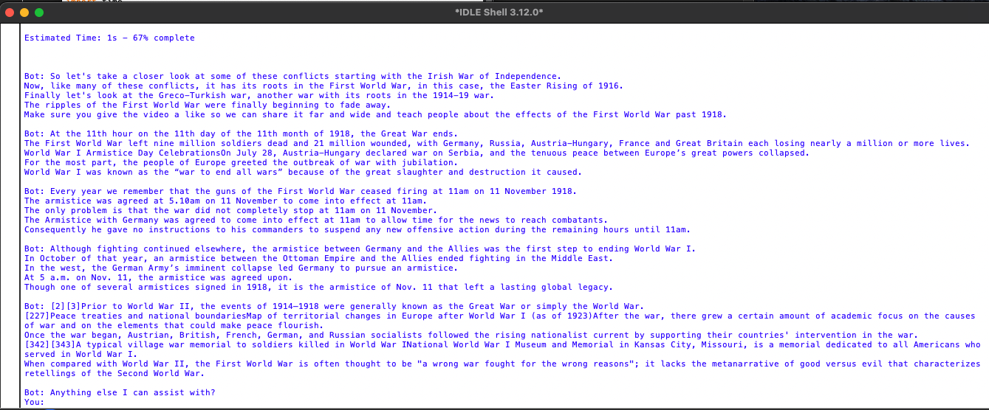

Here we can see the final output of the chatbot which I don’t have much power over however we can see that the natural language packet did a great job in summarising the data that was web-scraped. It was able to create multiple (5) summaries of answers based on the different URLs that were fetched. However, the only issue I can see is that this is too much information for a user to read for a question that has a direct answer, therefore I might change the amount of summaries to 2 or 3.

Next I decided to create the web structure itself (the foundation) on which the website will be created. For this I will be using Django which is a python based framework that will allow me to code the views of the websites in python and therefore making it dynamic without using JavaScript.

## Testing to information development

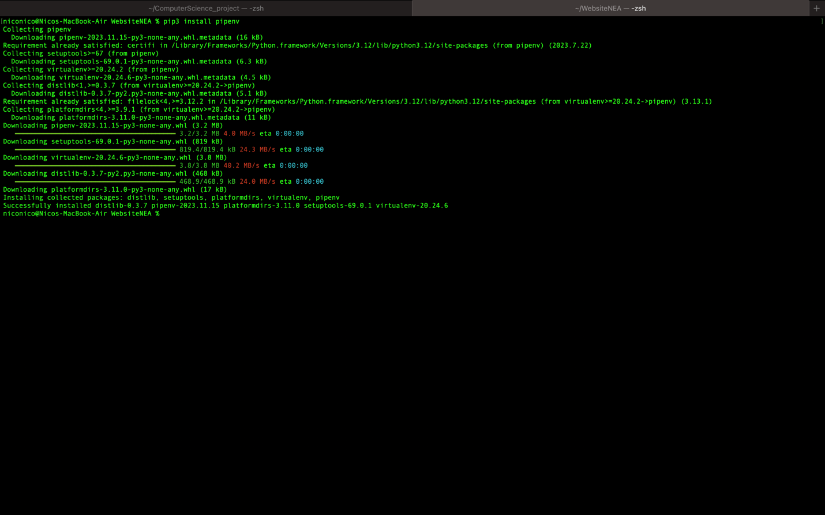

Here I installed the pipenv module which would allow me to create a virtual environment in which my program will be situated. A virtual environment will allow me to separate dependencies from other projects which I have on my laptop. This means that I will have to configure a different interpreter in order to avoid any clashes. Once this was installed I was able to continue setting it up.

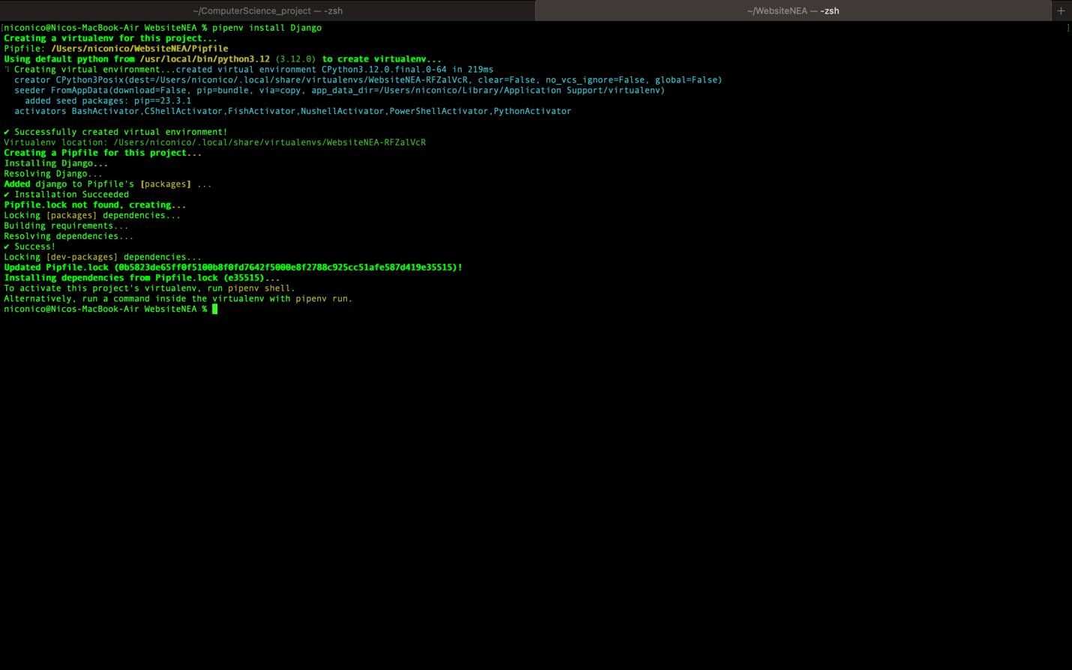

Here I I ran the command line necessary in order to install the Web-Framework I will be using (Django) inside of the virtual environment itself. All that was needed to do was to activate the virtual environment, which I did by running the command line specified.

(this should be included at each key development phase.

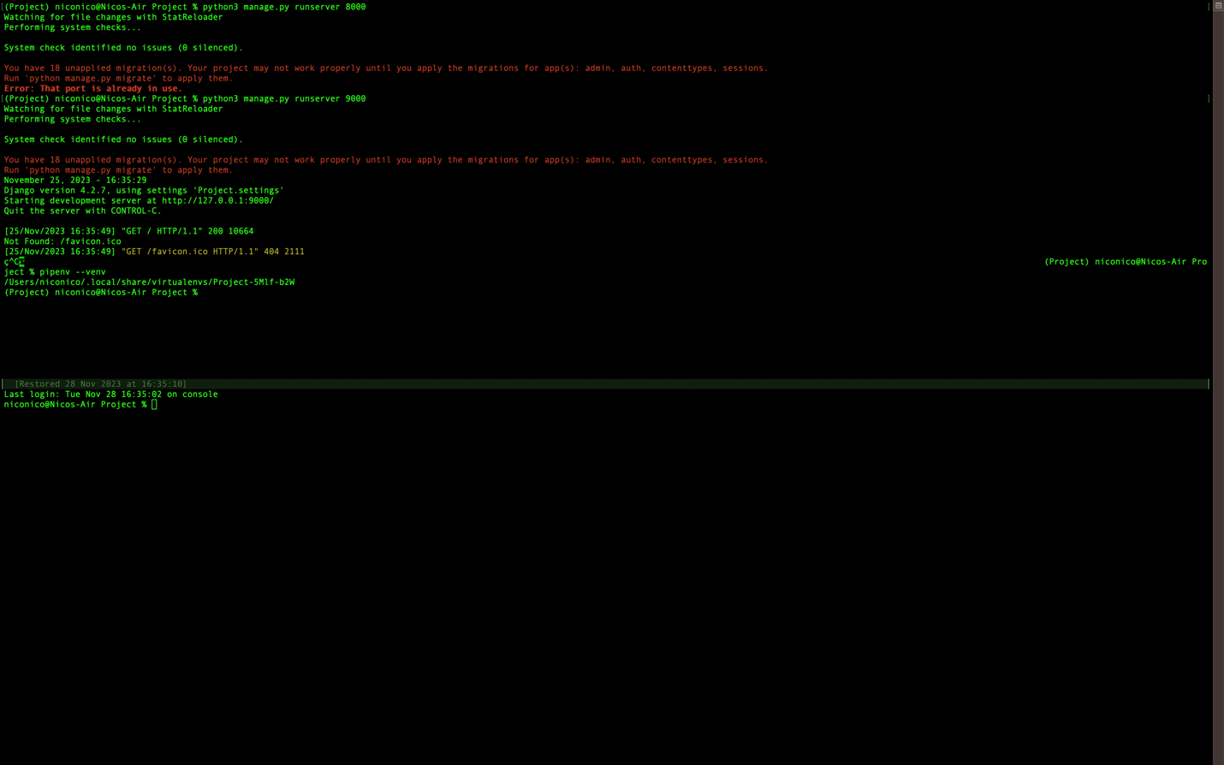

Once the virtual environment was activated I decided to run the server to ensure this was done correctly. I was getting a lot of port errors that were being used therefore this was a trying process till I was able to get a free port. This created a url for our local server in which I was able to see the foundation of the website itself.

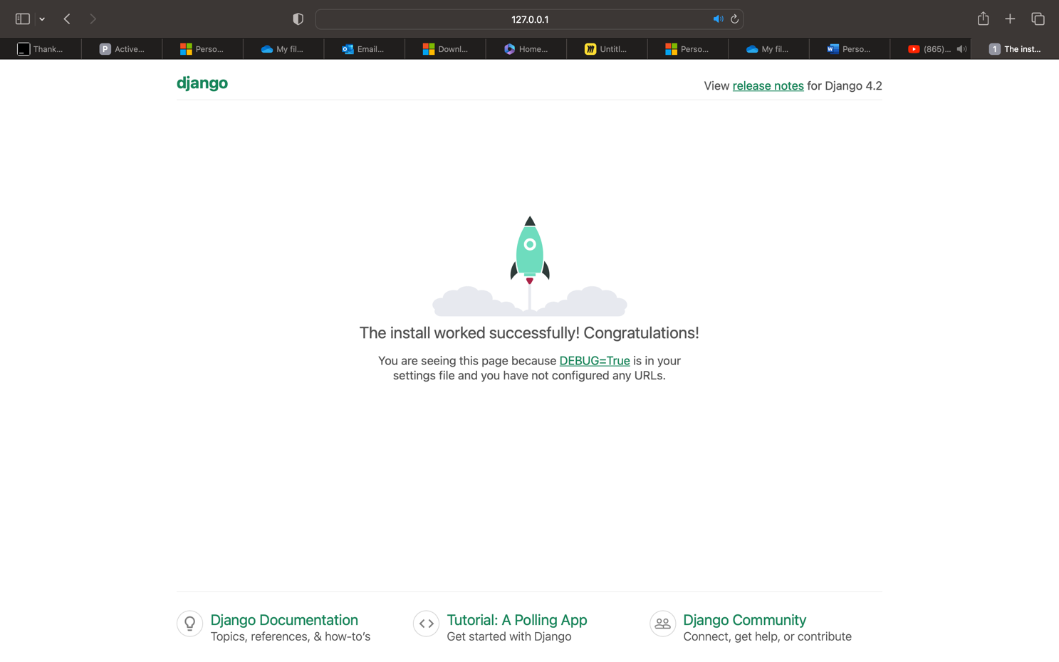

As we can see everything has run smoothly. Everything that was left to do was starting to create my applications for the different features which I would like to implement. The first app I will be creating will be playground and it will just be the main menu for the website itself.

First I decided to create an app that solely handles the main menu of the website (“Home”). This is done by using Django admins built in tools.



When I run this line a folder shows up in the project file which contains all the independent files that an app needs such as models.py and the migrations folder which is needed for when I create models and make databases.

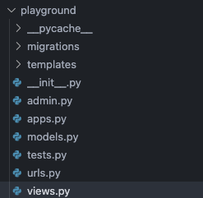

Here are all the files which have been created in the playground folder. These all-handle different sections of the app. The URL file will allow me to create URL configurations so that the app will be able to be accessed via URL.

The views file takes one of the most important roles. This file consists of what the app is doing such as rendering a template or doing the backend work. So I’m going to create a views for the main menu to render back the template which I have taken from www.webleb.com.

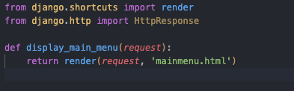

The library django.shortcuts allows me to import render which is a function used to show templates to the user. I created a function display_main_menu which takes in the parameter request. Request is an instance of the HTTPRequest object which is integrated in Django. This is used to send in important data such as the way data is being sent back to the server. The return render sends back the request as well as the html/css template of the main menu which can be seen below.

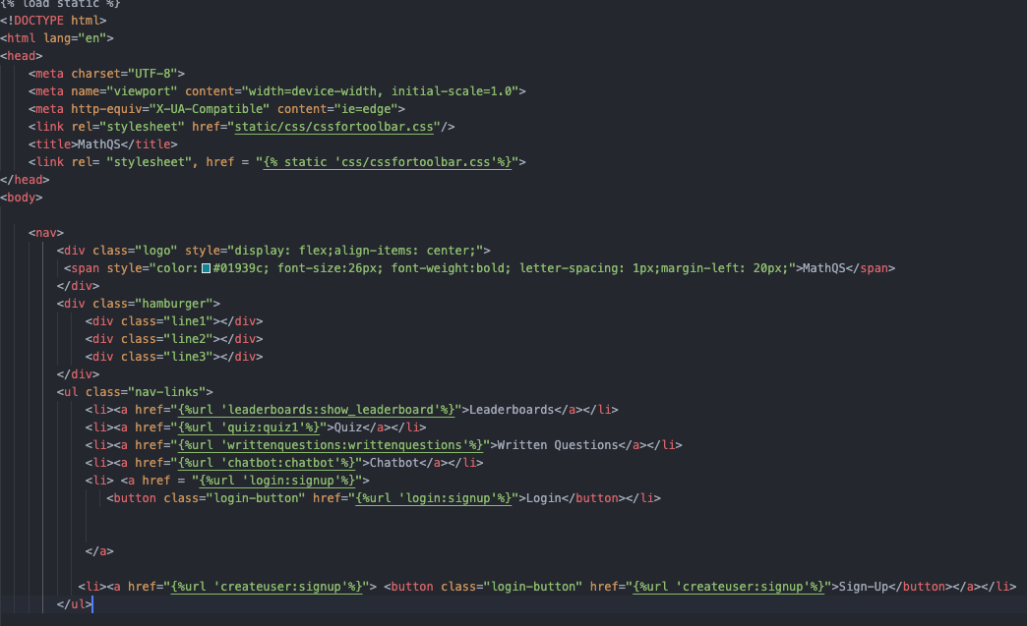

After this I needed to create a URL pathway to reach the menu.

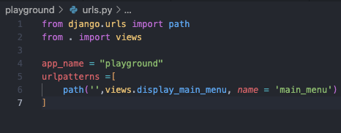

This is the URLs file of the playground app.

The function path which is imported from Django URLs can create a path linked to the url. In other words as the first parameter is an empty string and the server is running locally on the Ip <http://127.0.0.1:8000> this means that the main menu is going to be shown as it doesn’t consist of /mainmenu for example. The second import allows me to import the function which I previously created which allows me to render the main menu itself. We can see this inside the function as the second parameter, this is called upon when the user goes to the main menu. In this code I also decided to give the app a name in order to allow me to distinguish it easier when creating url paths and I decided to also name the path itself as main_menu to further allow me to be able to call it easier using Django terminology.

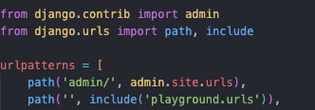

Here we can see the settings file of the URLs of the project itself. This includes all the paths that the website will have. There is already one that is included which is admin. The admin URL allows me to visualise different objects and databases which will be useful later once my models are created.

Here I assigned the URL of the app playground and added it to the URL patterns.

Next there was another vital step which is to assign the url path to the Django settings itself. This means that Django will recognise this path when its called upon and this is done in the settings of the project itself.

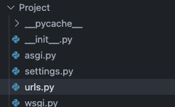

Next step was to assign the app itself to the settings file. This means that the app needs to be configured otherwise it wouldn’t be recognised by Django. This is done in the settings file of the project.

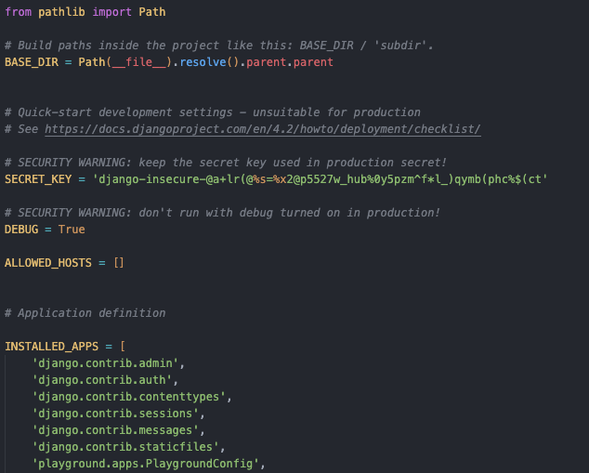

Now when we run the server I should be able to see the template of the main menu.

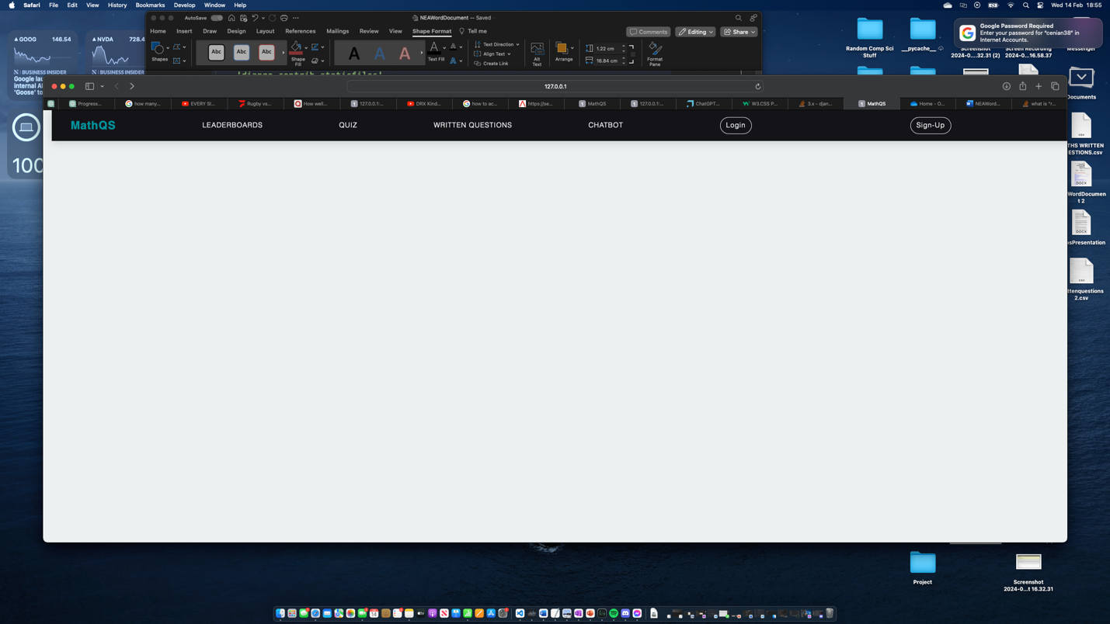

Now that we got the main menu, I’m going to follow the same steps as they are quite iterative when creating apps. I want to make all the headings have a function. First, I wanted to create a sign up for users so that they can sign up and create accounts. Therefore, I’m going to follow the same steps and use a template from ww.webleb.com to create a template which I’m going to alter.

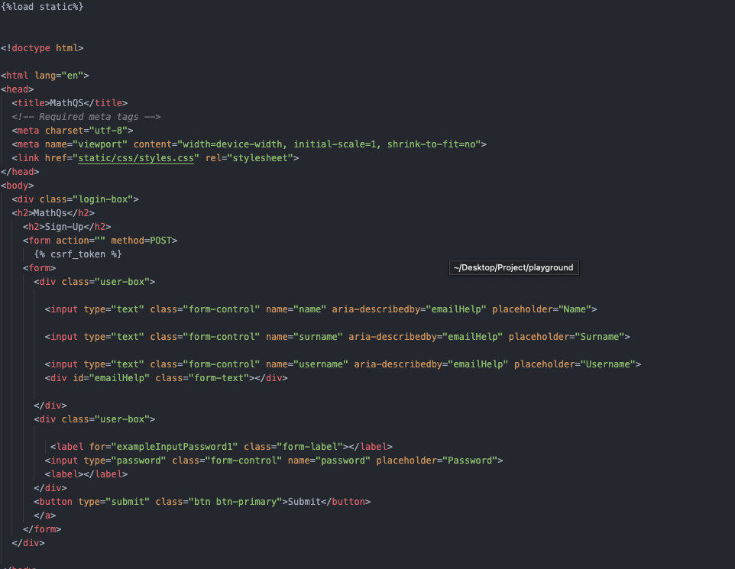

Here we have some basic html code however it has some features such as form and certain tokens. The csrf token is used to prevent cross site request forgery which is an attack that that tricks users into performing actions on another website where the user is logged in.

Inside the form tag there is multiple inputs which I named as name surname username and password which I will be using in the views section in order to authenticate and create new accounts. For this form I used the request method of POST as it is usually used when sensitive data is being handled. This just allows me to receive this data once a user inputs their details.

At the end of the code there is also a submit button that the users can use to submit their data but they can also press enter.

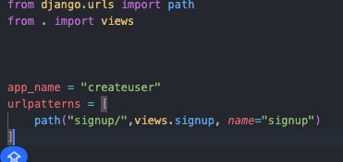

Here I created the URL pattern of the website, and we can use some Django terminology in the main menu in order to be able to reach this URL through one of the buttons that is displayed. When writing logic within a template in Django the {%%} notation is used. Here I am assigning the URL path of the app to sign up to the button which shows “Sign-Up”. The notation I’m using specifies that this is a URL from the app createuser with the path name signup. Next I needed to create the models.



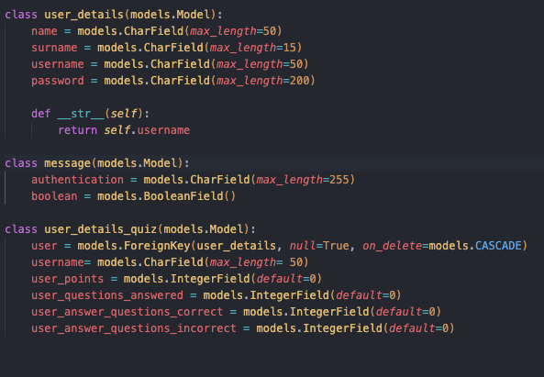

Here I have 3 different models which I created for the user.

The class user_details is a database which consists of the fields name surname username and password. This is the data which I am requesting from the user. This will be stored in the default database which is created by Django at the start of the project in sqlite3. The next model is message. This follows the same principle in terms of models however this is not needed to store in a database therefore I will change that. This class has authentication and Boolean. Authentication is a Charfield which will contain the message being sent back to the user which either indicates that the signup was successful or a failure. The Boolean field will have the values either True or False which further indicates this and will be used to redirect the user to an appropriate page to either sign up again or login to their account.

The last model is user_details_quiz. This is also a database which is storing the users details regarding their performance. I decided this was necessary to be made when the user creates an account as there is a relationship between the database of user_details and this one. This is due to the one-to-one relationship between them (one user can have one set of details about their performance). This also meant that if this wasn’t done when the user first signed up this would break some rules regarding sterilisation and some users will not have this if they signed up before the feature was made. This link is made in the user field. This field will act as the foreign key which is connecting the 2 fields together. The 3rd parameter is another method to further keep this sterilisation of databases by ensuring that if a user deletes their account (if I decide to add this feature) that both records will be deleted.



Next thing I needed to do was to create the views section of the app.

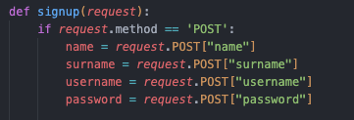

Here in the views file, I created my signup function. In this code I am requesting all the data to be sent from the front end of the website. The request.POST is used in order to get the input that was sent by the user in the input box by the names of name surname etc.. which can be found in the template code of the signup code.

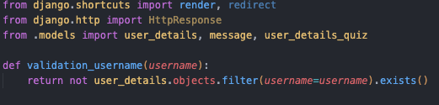

The first important thing I needed to do was to import the models which I have created which is done by importing it from .models, I don’t need to specify the apps name as they are in the same directory. The function validation_username is used in order to check if an username is available or not based on if a user has already chosen it. I used a reverse Boolean method as if the .exists() comes back as True I want that to be a False state as its more intuitive and clearer to use.

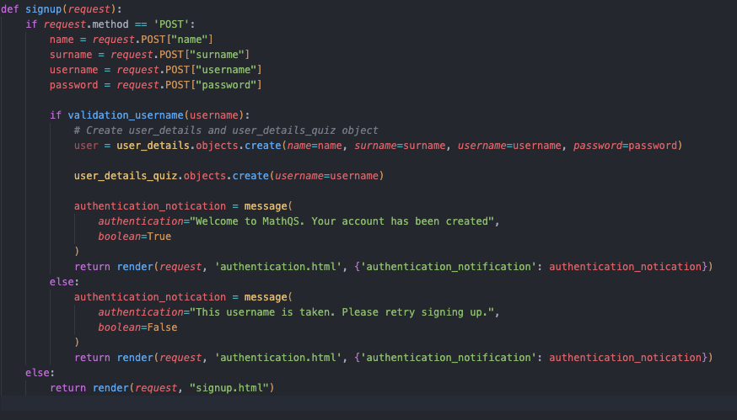

The function signup now has this key component of checking if a username is valid however now I want to create a further component which sets some rules for a password. If the username is valid therefore validation_username returns True, then a record is created for the user’s details. Once this is done another record in the relational database user_details_quiz is also created. For the second record I don’t need to specify some parameters/attributes as I have defaulted them to 0 in the models’ section therefore the only parameter needed is the username.

Once this is validated and the account has setup now, we move to the message model. I created an instance of the message object called authentication_notification and defined its attributes. If everything is validated there is a positive message stating that the account has been created, and the Boolean attribute is set to true. The vice versa happens if the validation fails. The last step was to render an authentication template which I personally made using the current template of the sign-up page. However this time I included {‘authentication_notification’: authentication_notification}. This is used in order to pass objects to the front-end of the website in order to be rendered to the user, however before doing that I want to create a secondary function to validate the password of users.

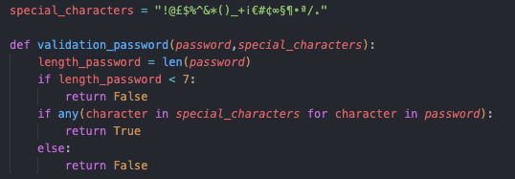

Here I have created the validation_password function in order to further validate the users credentials and ensure that they are using a strong enough password.

First, I created an array containing every special character which I have on my keyboard as a string.

Afterwards I created the function which I’m giving this array as a parameter as well as the user’s input password. First criteria which is checked is the length of the password. This is done by using the len function which is built in python afterwards I use selection to validate that the password is longer than 7 characters.

If it is then this continues, and nothing is returned. The next criteria which is checked if the password contains a special character. I used the built in function in python called any. This checks the iterable condition inside its parentheses and returns true if an element is true. The iterable I used takes every character in special characters and checks if it matches with any character in passwords. Now I just need to integrate this in the signup function

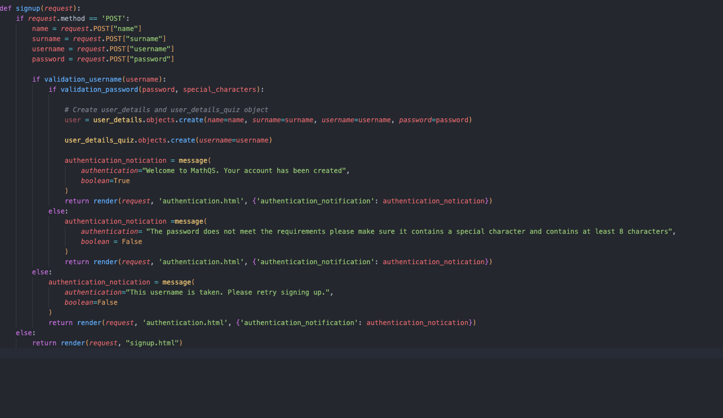

In this improved function the users record is only created if both the validation functions return True.

However, there is a chance that someone might have a valid username but invalid password therefore I made sure to specify in the authentication notification which it is that the user needs to make sure to retry.

Next thing I want to add is in the admin file. In the admin file I will be able to register my models to the admin section. This means that I will be able to see the database in a better way with all its fields etc. before starting to test this section.

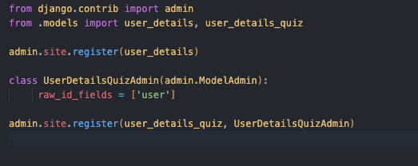

Here I am in the admin file, and I registered both of the databases. This is done using the built in commands from Django. For the user_details_quiz however I needed to do some adjustments as it links to user_details therefore I needed to set the attribute of raw_id_fields to the value of the foreign key. Now I will be testing this and will submit a video with name as reference (“Sign-Up Maths”), but first I want to show the authentication template as it contains some logic.

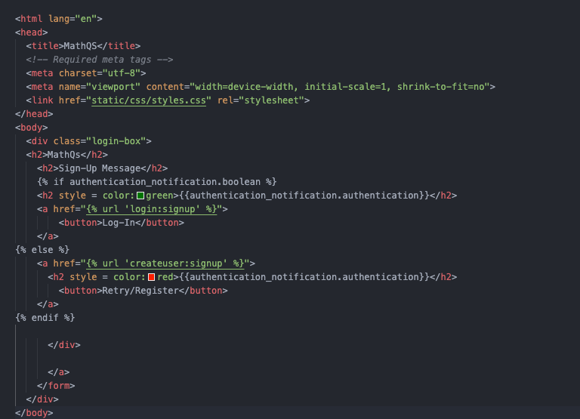

This is the authentication.html file and it contains some elements of Django’s python logic. Here we can see the object which we passed earlier “authentication_notification”. Inside the {%%} I created a condition to check if the sign-up was a success or fail and depending on that different colour text and redirects are shown. For example, if the user’s sign-up process was successful aka the attribute Boolean had a value of True, the authentication_notification will be shown in a green font and the button will redirect the user to a URL which I will create in which they will be able to login into their accounts. However, if the sign-up was a failure the authentication_notification will be shown in red, and the button will redirect the user back to the sign-up page. Next I wanted to show the databases in the admin section -🡪 video with reference name (Databases in Admin)

The next step was to create an app to allow users to login.

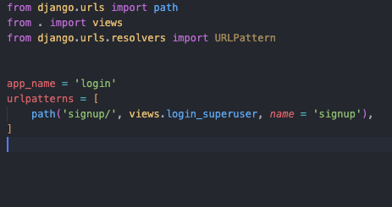

This was the URL’s file which contains the URL path of the app login. I wanted to show this as this was referenced earlier in the authentication file.

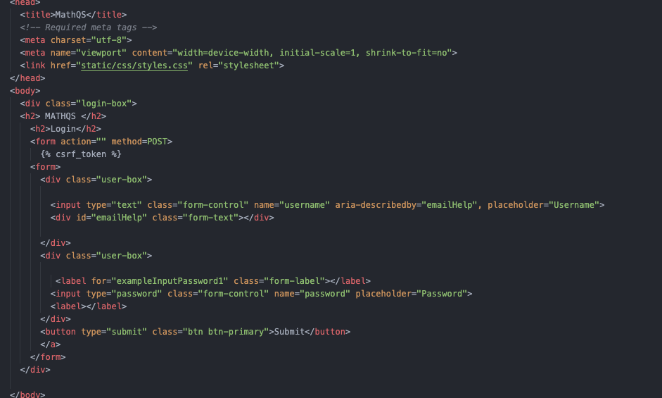

This is the template I’m using which follows from the authentication and signup templates in order to keep consistency.

Here I used the form action POST again to as sensitive data is being handled and created a form in which users have the 2 necessary inputs of username and password as well as a submit button in order to submit their details.

Next thing that I needed to do was add this URL path to the main-menu so that the users can log in straight away without going into the sign-up option.



Now that this is done the login page can be accessed directly through the button in the main menu which contains the word Login.

Next thing needed to be done was to create the views of the app to authenticate the users.

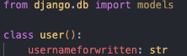

First I created this model for a user in order to have a saved version of the username which I can use later on to create personalised pages.

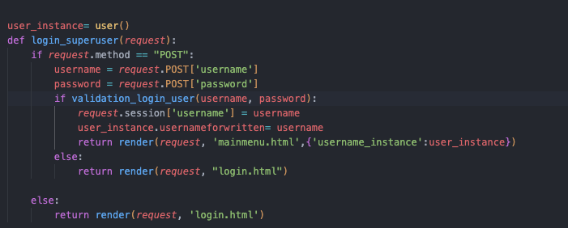

This is the views file of the app. First thing I needed to do was create an instance of the object user in which it will be stored in user_instance.

Now I decided to take my own way for login credentials as there is a built-in way by Django which focuses more on encryption of passwords however I decided to try and recreate this.

First thing I did was request the username and passwords from the front end and store them in variables with appropriate names .

Next thing I needed to do was validate that the user’s account did exist. So, I first needed to check if the username existed which I did using the function below (get_password_for_username). This function takes in the parameter of username which is the one that was inputted. Next, I used a try except loop as I thought this was appropriate and used it previously in the chatbot to handle errors. The query being used follows the following syntax, it checks the objects in the database user_details and gets the objects which has the username equal to the username that was inputted. In this case due to the way I setup the login this will be a single unique object. If this was successful, then the user.password is returned. This means that I can use this function to get the password of the user and validate it. However, if a user without that username isn’t found None is returned.

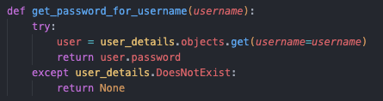

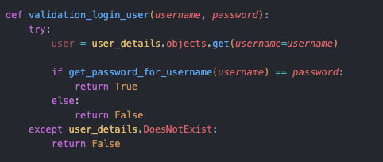

Next thing that I needed to do was validate the login of the user. First I got the user’s record out of the database but I realised that this wasn’t necessary to get to the password as I did It previously in the function get_password_for_username, therefore this was unnecessary. Afterwards I called upon the function and checked its returned value against the password which was inputted by the user. If these passwords match, then a value of True is returned else if the passwords don’t match a value of False is returned. Now going back to the code that I previously shown.



I used selection and called the function validation_login_user. If this returns True, this means that the users’ details is matched and the user can be logged in. once this is approved I request a session for the value of username as I will need this to use it in another views to retrieve data from the database. I also set the attribute of usernameforwritten to have the value of the username and render back the main menu template and pass through the user_instance.

However, If the user’s details don’t match, I render back the login-form.

Whilst writing this I came upon the conclusion that I need to create a few more features such as log-in attempts and some hashing algorithms for the passwords being stored in the database as. They are way too easily accessible. So I’m going to create a hashing algorithm in the createuser file.

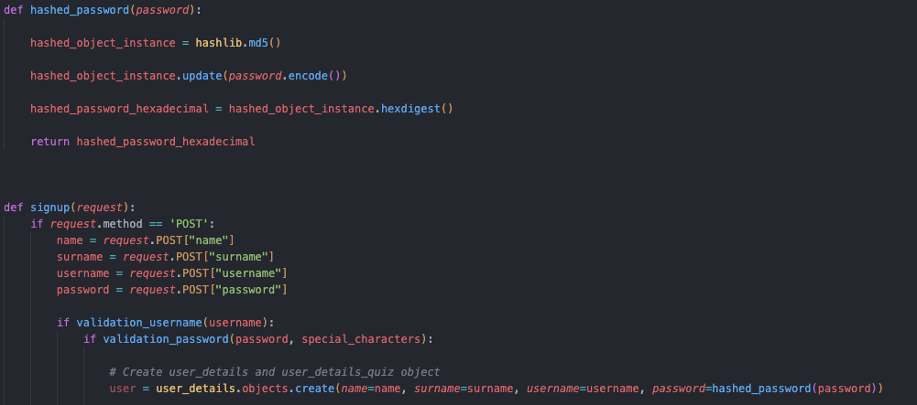

This is the hashing algorithm I used which is MD5 this is quite an old hashing algorithm however I thought it was suitable. In this code I create an instance of the md5 object from the library hashlib. Afterwards I use its built-in function to encode the text and create a hexadecimal equivalent. I use this using the parameter of password and use this when storing the password. So now I’m going to create an account and see the difference. Video(HashPasswords)

Now, as seen in the video that wasn’t the password, I inputted but rather a hashed version. This algorithm doesn’t have a decoding algorithm which means that the passwords true value cannot be found therefore I need to change the login views as this won’t work anymore.

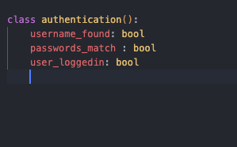

First I created this further model/object which I will use to guide the user to tell them if the username doesn’t exist or if the passwords don’t match. The last parameter I’m going to use to see if the user is logged in. I’m planning ahead here as I realised that I will need to have a log-out button for the users to log out if they are logged in as log in won’t be appropriate anymore.

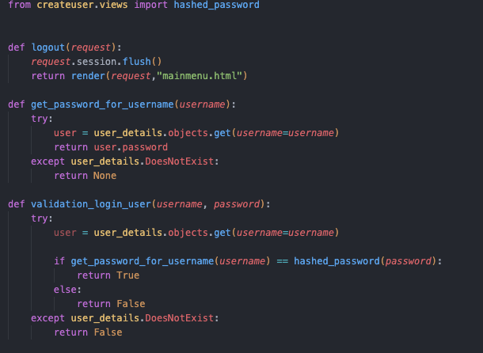

In this improved I code I imported the function hashed_password from the views file in the app createuser.

I also created a logout function, this function flushes all the sessions which I have created previously (the username of the user logged in) and renders you back to the main menu therefore I need to add this in the URL section.

Now in the validation_login_user I added the function in the selection to use the same algorithm to hash the password which was inputted by the user.

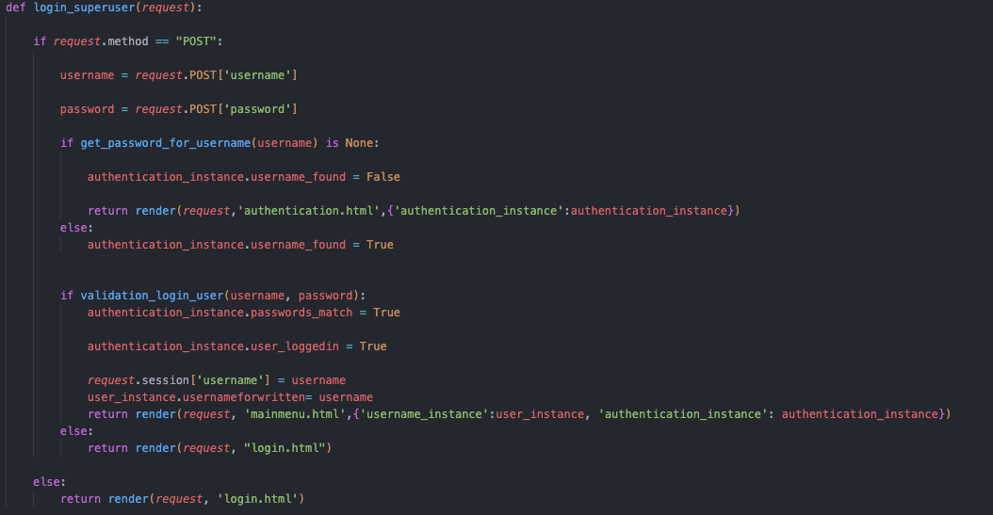

Now the main function looks like this. I added some if statements to check if the username is not found or if the passwords do no match. If the username is not found then the instance of authentication object which I created just above the code -🡪

This turns the username_found to false if the username is not found (the function is none) and renders the authentication.html while sending the instance. This is the same template I used for authentication with the createuser in which I will apply some logic.

Otherwise the username_found is set to True.

Now in this code if validation_login_user is true that means that both the passwords match and the username was found therefore I can set both of these attributes to True.

Another change I did was that now I also send in the authentication_instance to the template mainmenu if a user is logged in because I will need this to check if a user is logged in so that there will be a logout button.

Next thing I need to do is work out this logic in the front-end template.

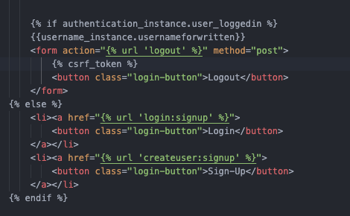

Here is the template for the main menu. In this improved version I have created a if statement to check if a user is logged in via the instance of the authentication. If a user is logged in, their username is shown to clearly indicate that they are logged in as well as a logout button. The logout button has the form action of the url that I have previously created shown here 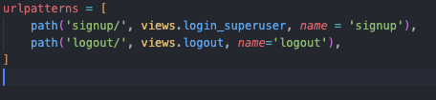This means that when the logout button is clicked, they are taken to the URL path of logout where the logout function from the views occurs.

Next thing I needed to do was implement the logic in the front end relating the username and passwords not matching.

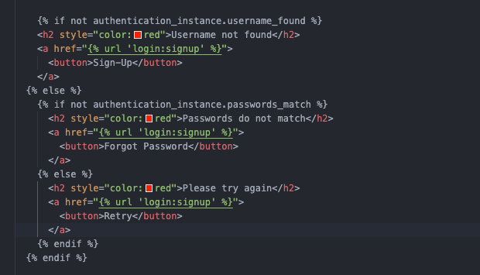

Here is the logic I used in the template for authentication. In this code the instance of authentication is checked to see if a username is found as well as if the passwords match. If the username is not found the user Is shown a message that tells them so and redirects them back to the login url. If the passwords don’t match the message shown tells them that they don’t and redirects them back to the URL again. I used buttons that would have a meaning such as forgot password however I will not be implementing this feature at this time. Now I’m going to show a video of this working (reference video: Account/Login)

With this done I decided that I finished the development of my account feature and I think I’ve created a good foundation that will help me create the next functionalities. Next thing I decided to do was to create my chatbot and implement it within the website. As I have already coded this, I needed to only tweak a few details in the code which will show as well as the models and URL paths that are standard in every app.

URL: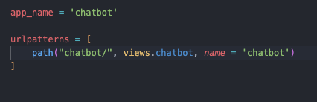

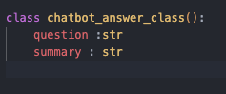

Here is a model I created that I could use to send back to the front end. In this model I created 2 attributes which are question and summary. I will show the code that I created that was needed for the chatbot to work in a http model.

As we can see I created an instance of this model. Its question attribute will represent the users input from the front-end side and the summary attribute will have the value of the response that it has generated. I used a chatbot template from webleb again and changed it to match my project which I will show now.

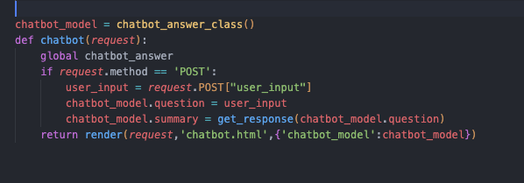

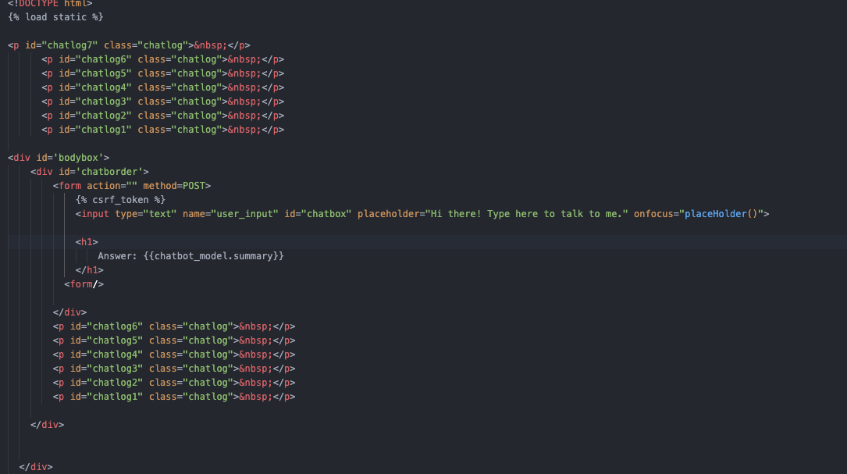

There is some simple logic I implemented. I created a form with the method POST that takes in the user’s input, and I also returned back the summary which was evaluated in the views file. I wanted to make this chatbot be a part of the whole adaptive learning system however I realised that due to its accuracy and not being ideal for solving independent questions, I’m going to leave it as a feature that users can use to further solidify their learning. This means that points will not be affected based on the interaction with the chatbot. I’m now going to show the chatbot in action with video reference name chatbot.

Next thing I wanted to create was the written questions/quiz. In this section I’m going to have a written questions that I took off a gcse maths book provided by my stakeholder. To do this I created a csv file containing all of these questions as well as their difficulty and answer.

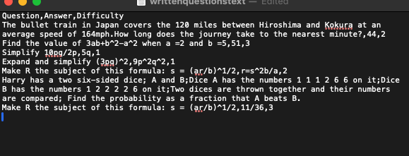

Now that I have the questions that I’m going to use I needed to get them from the csv file itself to a 2d array.

First I needed to import the csv library.

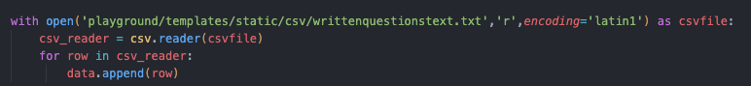

This codes functionality is that it opens the csv file which I added within the main menu templates static files as this won’t change over the duration of the program.

Using the built in csv functions I read the csv file using the function csv.reader and store the data in the variable csv_reader.

Afterwards after this data is read, I created a loop that goes through all of the rows in the file and appends them to a 2d array data.

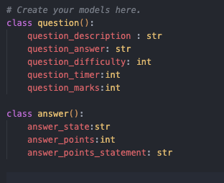

Here I created all the models that I will need for this app. The question model will contain all the necessary information needed to display the question as well as its difficulty. This relates to the user’s question.

The answer model I will use to store the needed information regarding the user’s answer. Inside this model there is 3 attributes. The answer_state will contain the message being sent back to the user based on if the answer is correct.

Next thing I decided that I needed to do was determine what the user’s question will be based on the points that they have so far, so I decided to split the 3 questions with the difficulty level ranging from 1-3 to have a minimum points and maximum points needed to be answered. I decided that questions with level 1 difficulty will need to be to a maximum of 300 points, question difficulty 2 will be from 300 to 600 and question difficulty 3 will be from 600-1000 points for the starting point.

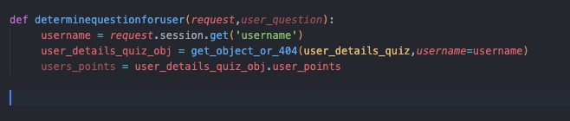

Here I have the function that I’m going to be using for this part named appropriately as determine question for user. I have passed as a parameter user_question which is an instance of the model question. Inside this function I have requested the username from the session to see who is logged in at the time. The next thing I did was use a bit of query. As the 2 databases that I previously created are linked together by the key username I can use this to search through the database user_details_quiz.

In the second line I am retreating the object from the database user_details_quiz where the username is the username of the user that is logged in. This means that inside the object variable I will have all the fields I have set and their values.

Next thing I needed to do was fetch the points of the user which I did by using the 3rd line.



However in the progress of doing this, I realised that I could just store the questions in the SQLite database I’ve been using to store the user’s data instead as this would be more efficient when searching for queries and such.

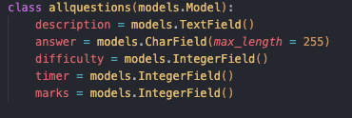

Here I created the model allquestions with the following fields: description, answer difficulty etc… Afterwards I needed to migrate these changes to the database so I’m going to do that now

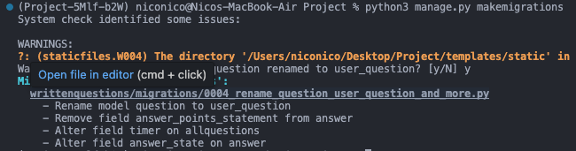

The next thing I needed to do was to input all of the questions into the database however, first I needed to assign this to the admin panel so I can manually access it. After this I should be able to enter the database manually and create a record for each question.

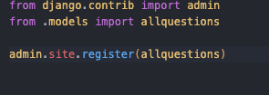

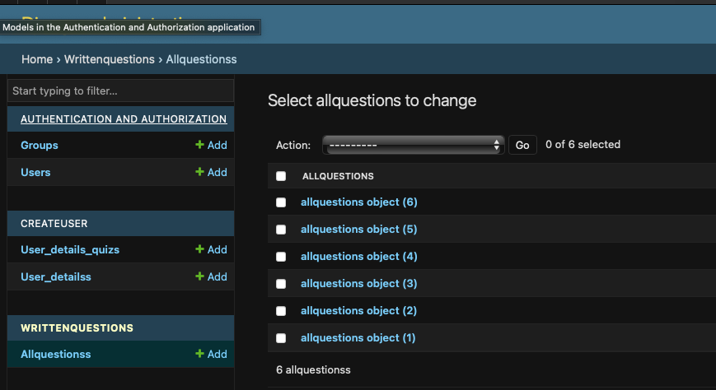

Here we have every record for every question that I previously shown that I pulled out of the csv file. I’m going to show one of the objects to show the layout.

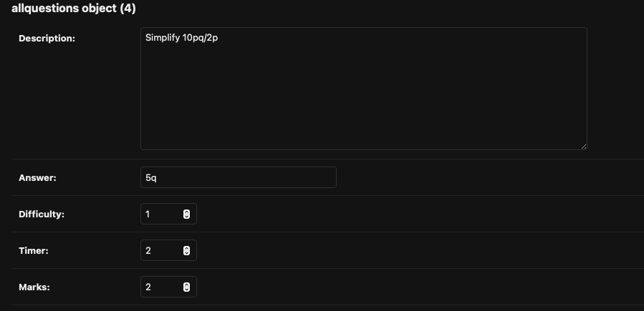

Next thing I needed to create was the template of the website. I’m going to follow the template of the chatbot itself as this worked nicely and I personally think its important to keep a certain style to a webpage.

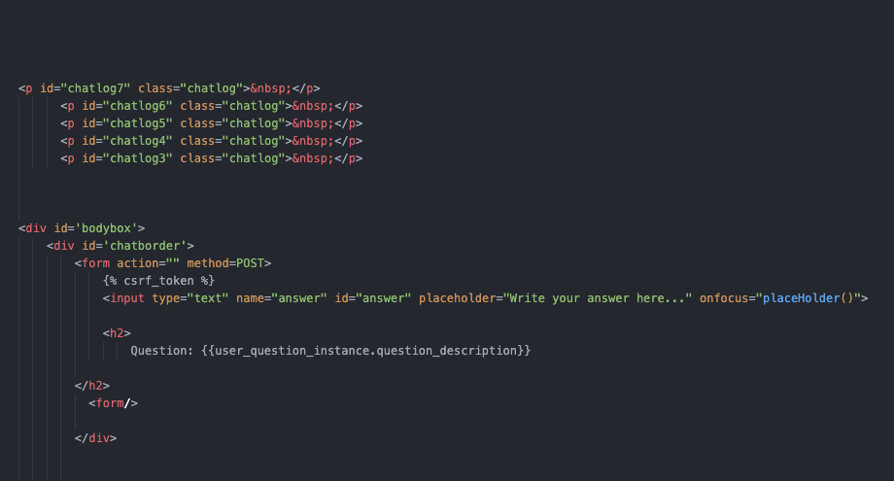

Here is the front-end html code for the webpage itself. Once again, I’m using the csrf token in order to validate the input of the form. The input of the user will be stored under the name answer, and I decided to place a placeholder, so it makes it even easier for a user to understand where they need to input the answer to the question.

Underneath the answer box we have the question description itself which is used by getting the attribute value of the user’s question itself.

Next thing I needed to do was create the views itself.

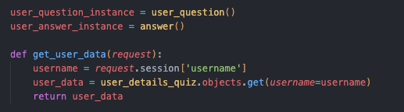

Inside this code I created 2 instances of the user_question and one of the answer objects. Inside the get_user_data function I requested the username of the current user that is logged in. Using the username, I will be able to fetch all of their data in the user_details_quiz database and store it as an object in the variable user’s data.

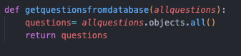

In this function I extract all the questions from the database and just return them. I will need this in order to filter out which question is suitable for the user.

Now I needed to create an algorithm for determining the user’s question and detect which one is suitable for the user to attempt. The first approach I thought was to create an initial difficulty for the user based on the points they have accumulated whilst attempting questions previously. After this initial difficulty has been determined there would be another system which will take over and determine the difficulty of questions based on the progress they are making on the current session answering questions.

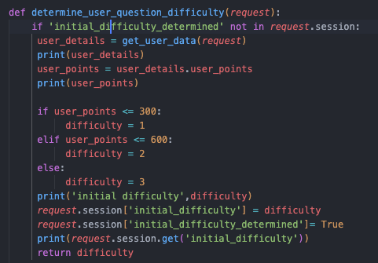

Here I have the function that determines the difficulty of the question. As I mentioned previously, I wanted to create an initial difficulty first. Therefore, in this code the first selection is used in order to determine if this has been created. First thing I needed to do was to get the user’s data and filter out their points as this is the necessary information. I added some print statements to check that this data is being processed properly so that I can examine the code. Afterwards I did some simple condition checking using if statements to check within which bracket the difficulty will fall into.

Once this is determined I requested a session with the name ‘initial_difficulty’ and assigned it the value of the difficulty that has been calculated. Afterwards I needed to create another session called ‘initial_difficulty_determined” and I set it to True. This means that now that loop won’t run again as initial_difficulty_determined is in request.session. Next thing I needed to create was the algorithm to check what question will the user have to answer.

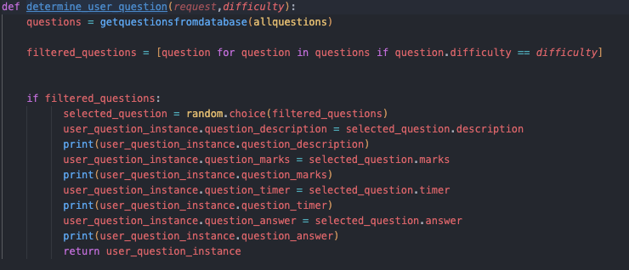

Here is the function determine_user_question. The parameters are request and difficulty however I have realised that request is a redundant parameter as the request is being handled by the function getquestionsfromdatabase therefore I can get rid of this. First, I needed to extract all of the questions that are in the database questions. This means all the objects inside the database allquestions. Next, I needed to filter all of these questions and place them within an array. The statement inside the [] filters every question based on if the questions.difficulty which is the questions attribute is equal to the value of the difficulty set of the user. If that is true, then this question is stored in the array with all of its attributes.

Next, I wrote a statement to check that there is something inside the array filtered questions as otherwise the process wont work. Now I needed to choose a random question with a matching difficulty therefore I used the random function which I imported from the random library. After this I set all the user’s question attributes to the attributes of the question. I also created some print statements to further allow me to debug in case something goes wrong. I decided to do this as I didn’t know any other way of passing all of the questions attributes to the front end of the website other than through an object.

Now that the answer of the question is determined I needed an algorithm to check if the answer is correct. However the first thing I need to is to create the code that handles the POST request and retrieves a user’s answer.

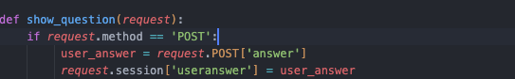

Here I have the code that requests the value inside of the input with the name answer and starts a session names useranswer using this value.

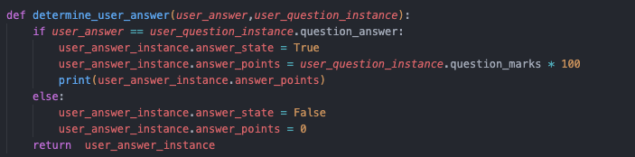

Here I have the algorithm used to check if the user’s answer was correct and how their points are affected.

First it checks that the user_answer is the same as the question answer by checking the respecting attribute of each object. If it is the same, then the answer_state is flagged as True and the points are equal to the marks of the question itself multiplied by 100. I also added print statements to make sure this is correct when running it.

If it isn’t then the answer_state is flagged as False and the points are assigned a value of 0

The points I’m referring to in this function are the points that the user is being awarded for the question at hand.

Next thing I needed to create was the adaptive learning algorithm itself. I’m going to create a basic one that will just increment or decrement the difficulty based on if the answer is correct.

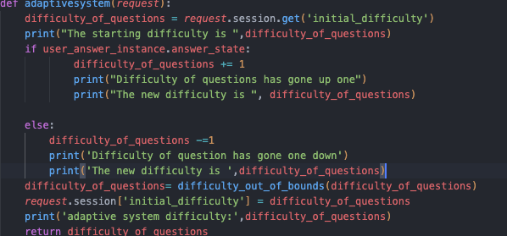

Inside this function I first need to request the session with the name initial_difficulty. This means that the difficulty that the first updates will be made to will be to the initial difficulty.

Next, I used selection to check if the answer to the question was correct, if the question is correct, the difficulty of the questions will increment by 1. I added some print statements as well to help me with debugging if necessary.

If the answer is incorrect the difficulty of the questions decreases by 1

Next, I realised that in the process of this happening I will need to check that the difficulty is not out of bounds therefore I used a simple function to check this which can be shown below.

The difficulty out of bounds will check if the difficulty is above 3 or below 1 and handles this by setting it back to boundary data.

After this is assured, I save the value of the difficulty to the session with name initial difficulty to ensure that next time the algorithm is run, this is saved in the progress.

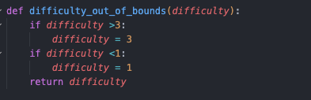

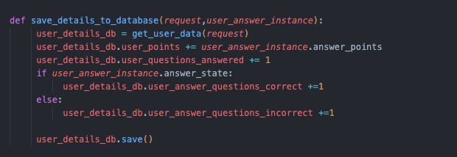

Afterwards I needed to ensure that all these changes are being saved to the database itself.

I passed the instance of the useranswer as a parameter into the function save_details_to_database.

Afterwards I gathered the data of the user that was logged in and added the points that were awarded to the user into their total points. Afterwards I incremented the amount of questions that the user has completed.

If the answer that they inputted was correct their attribute in the field user_answer_questions_correct will also increment by one and vice versa if the user’s answer was incorrect.

Next I needed to bring all of these functions together in order to create a working algorithm. However, I realised for this work I will need to implement a button so that the user can go to the next question. So I’m going to configure that first.

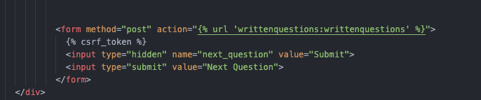

Inside the template of the writtenquestions.html I inserted a button with the name next_question and if clicked it will produce a value of Submit if not then this button will have the value None.

What this will do it will essentially refresh the page and in turn of this happening a new question will be produced for the user.

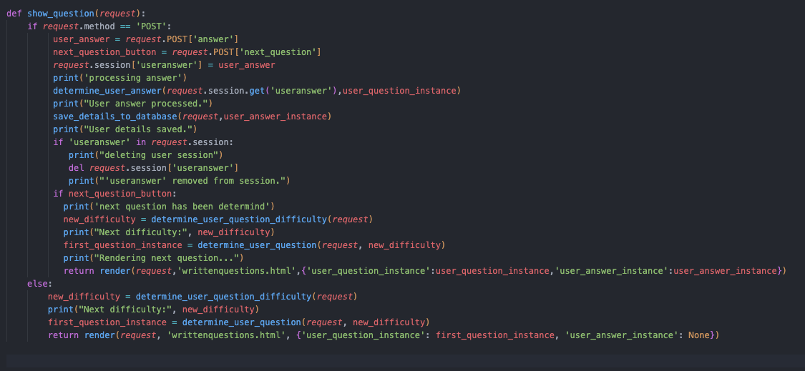

Now I have the full function done. This has every function put together working together to produce the desired result. This code is quite lengthy so each text box will explain 5 lines at a time. I will not be mentioning the lines of code that include print statements for debugging.

In the first 5 lines of the code, I check if the user has inputted anything into the box, (sent in a request). If the user has sent in a request, then I fetch the user’s answer as I have shown before.

Next, I need to check also if that request was a click on the next question button as this will mean I will need to show a new question instead.

Afterwards I create a session with the user’s answer as this answer is only relevant for one question and can be discarded afterwards.

In the next 5 lines of code, I determine if the user’s answer is correct. The parameters I pass are the session value inside the session with name useranswer which should have the user’s answer if they have inputted anything as well as the question instance.

After the user’s answer has been determined I call the function save details to database so that I can save the progress or regress that the user has done.

Next, I checked if a useranswer was within the session and that the user didn’t click on the next question button instead. If there is already an answer saved within that session this is deleted using the function del

However, if the next question button was clicked instead, a new difficulty is determined from which a question is determined and a new question is rendered.

I render back the template with multiple objects being passed that I will use in the future to create things such as the taskbar and to show back to the user how many points they have gained.

However, if the user has not sent in a request, the same progress I just explained earlier happens where a new difficulty is determined, and a question is appropriately picked. Essentially this will act like the first question that the user must answer. Now I need to check that everything works which I will do using a video named (QuestionsTesting).

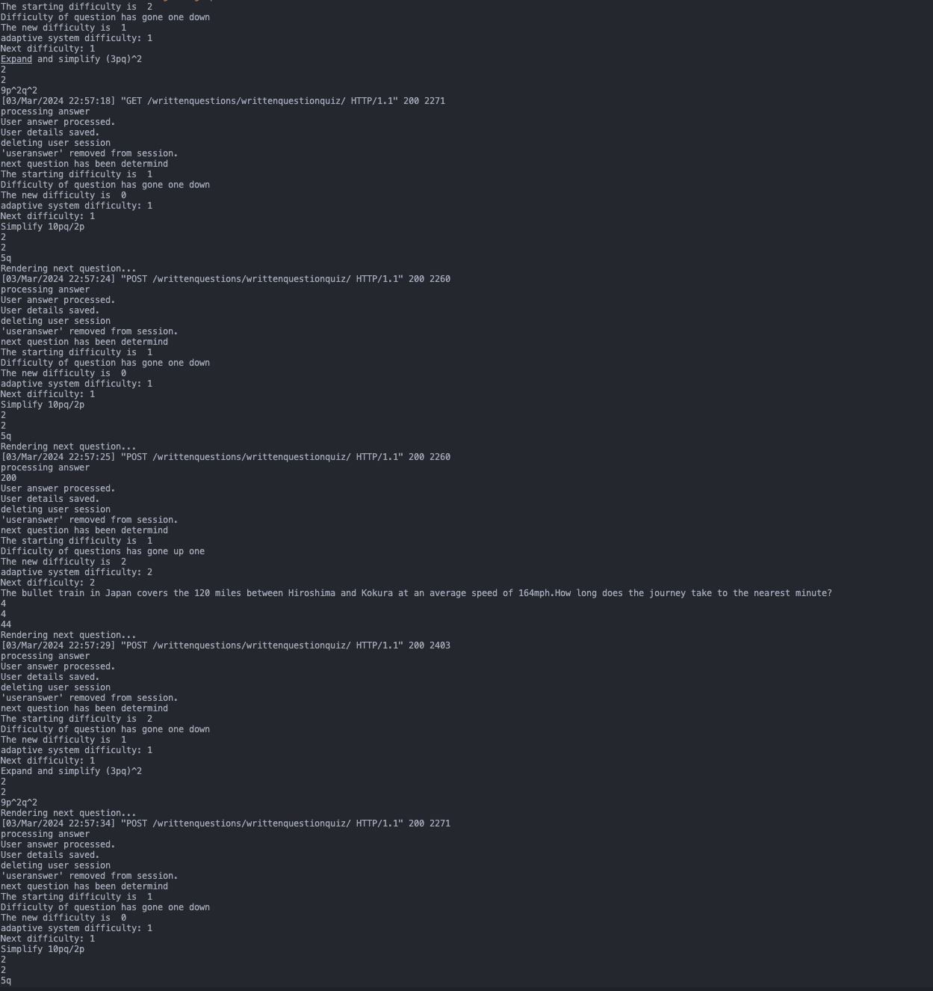

Here we can see all of the print statements that were produced during the video.

As we can see everything is working correctly in terms of the next question and the user being able to answer the questions. Now I need to test that the difficulties are fine. First, I will show the record of the account I’m logged in to do these questions. But just before that I want to implement a progress bar.

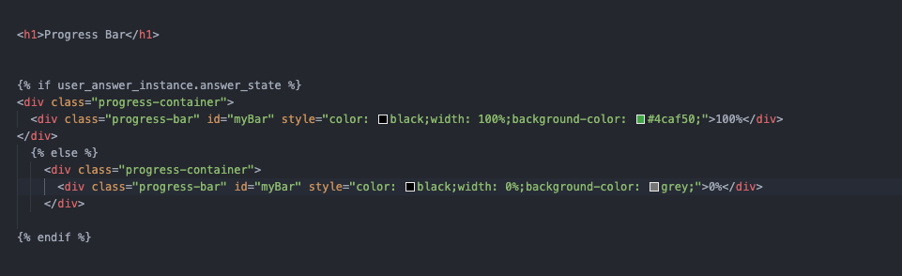

I will be using the instance of the user’s answer that I previously passed earlier when rendering the template.

I wrote some simple selection to check if the answer_state is flagged up as true or false. If the answer_state is flagged as true (user answered correctly) the progress bar will have 100% covering up the whole of the top side of the website in a colour green displaying the value 100%

If not, this means that the user hasn’t got the question correct therefore it stays as 0% width and has the value 0. I’m going to try this first to see if it works. This will be in the video titled (ProgressBar)

As we can see from the video, I answered the first question wrong therefore there was no change in the progress bar at all.

However, in the second question I answered it correct which made it green and display 100%.

Now I will stop getting distracted and check if the algorithm is functioning correctly.

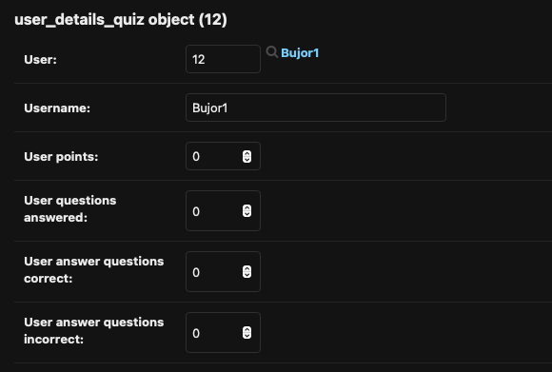

Here is the account I will be using.

I decided that everything should be set to 0 to make it easier to check what’s going on.

I’m going to create a video of me answering 3 questions correctly, and 2 incorrectly. I’m also going to check the print statements to make sure that the starting difficulty is appropriate and that it is 1.

Video name (AnsweringQuestions)

(Need to watch video for this to understand). Now I checked the object again to check all of the attributes of the user.

As we can see the user’s questions answered, questions correct and questions incorrect have appropriately been updated based on what happened in the video.

The user points are also correct as I have answered a difficulty level 1, difficulty level 2 and difficulty level 3 question. This means that the marks are double this so 1+2+3 = 6, 6x2 = 12, 12 x100 = 12000

This means that everything is working as it should. Now I need to check all of the print statements.

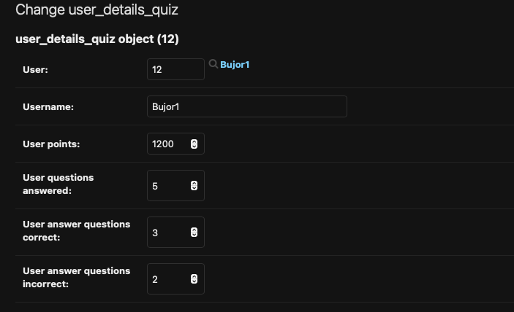

The print statements show that the correct data has been extracted, the points are 0 and that the initial difficulty has been calculated to be 1.

This also shows the first question that I attempted, its answer marks and timer.

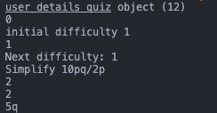

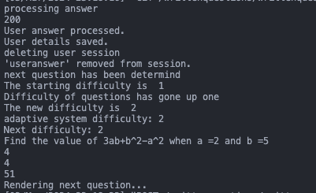

Next we can see that my answer was processed.

The details have been saved to the database.

The session of user answer has been deleted and that the next question has been determined.

Then it shows me that the starting difficulty was 1 before being processed and that it should go up by one which it has based on the next print statement.

Same thing happening again but value going up again.

Now I’m going to show the print statements if the answer was incorrect.

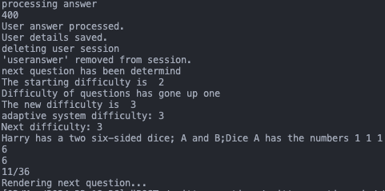

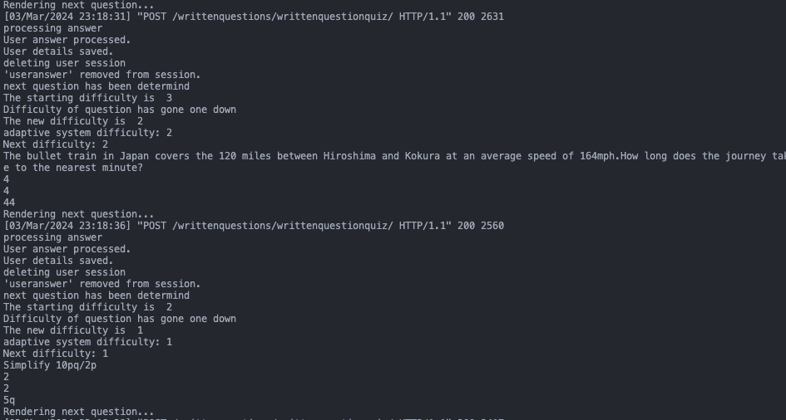

As we can see this follows the same process but only backwards by decrementing the difficulty by one.

Now that I know everything Is working, I want to create a new feature which is the leader boards.

Within the leader boards I will have the top 5 scorers along with their username and points

First I created the URL path. 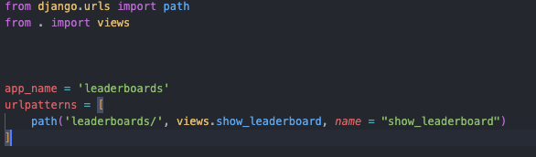

Next I decided to create the models.

Within this model which I named leaderboards_class.

This contains all the users that rank between 1 and 5 as well as their points. These are all stored as strings.

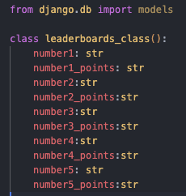

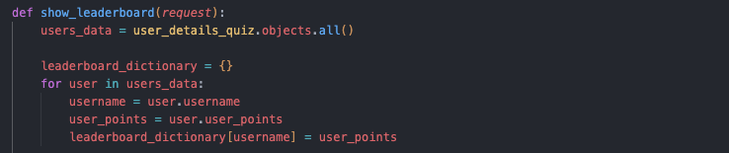

Here I was extremely stuck on which data structure I should use in order to store the username with the corresponding data therefore I decided to use a dictionary as I thought this would be appropriate. The key in this dictionary will contain the username of the user and the value will contain the user’s points.

In the function show_leaderboard I extracted all the user’s data from the database users_details_quiz.

Next, I initialised the dictionary and stored it in the variable name leaderboard_dictionary.

Next, I needed to move all the data that contained the username and the points from the database to the dictionary.

The iteration goes through every user and assigns each username the value of their points.

Now I needed to create an algorithm to sort out the dictionary based on the value not the key.



I will be using the inbuilt python function sorted as I personally don’t want to use a sorting algorithm and don’t know how to create one on a dictionary. Within this function I need to specify the items of the dictionary, the key =lambda x: x[1] specifies to the function that the dictionary needs to be sorted based on the values and not the keys, and flagging reverse as True means that this will be sorted in descending order

Afterwards I created an instance of the model that I have shown previously.

The last thing I needed to do was to create a loop which will set each of the attributes of the instance leader board, (number1, number1_points) as I don’t want to do this manually by repeating sections of code.

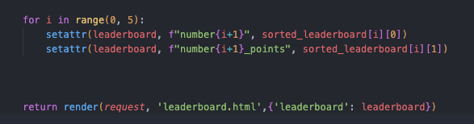

In this loop I reiterate through the code 5 times (for the 5 users).

I used the function setattr to set the values of the attributes. As the loop reiterates the[i] will change meaning that the next attribute will have the value of the corresponding key or value at that position.

Next I rendered a template which I have taken from [www.webleb.com](http://www.webleb.com) and passed the leader board instance.

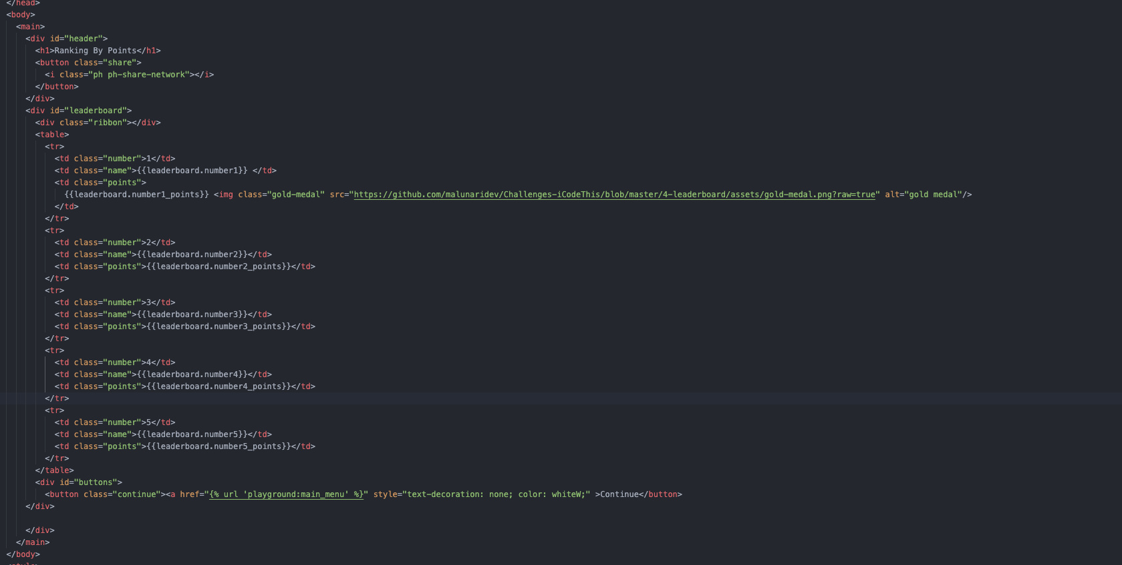

Here is the template of the leader board. It contains three different sections, name, number and points.

For each name I replaced it with the according attribute from the instance leader board based on what number it is

As well as I replaced the points.

At the end I also created a button that can be used to go back to the main menu of the website. I

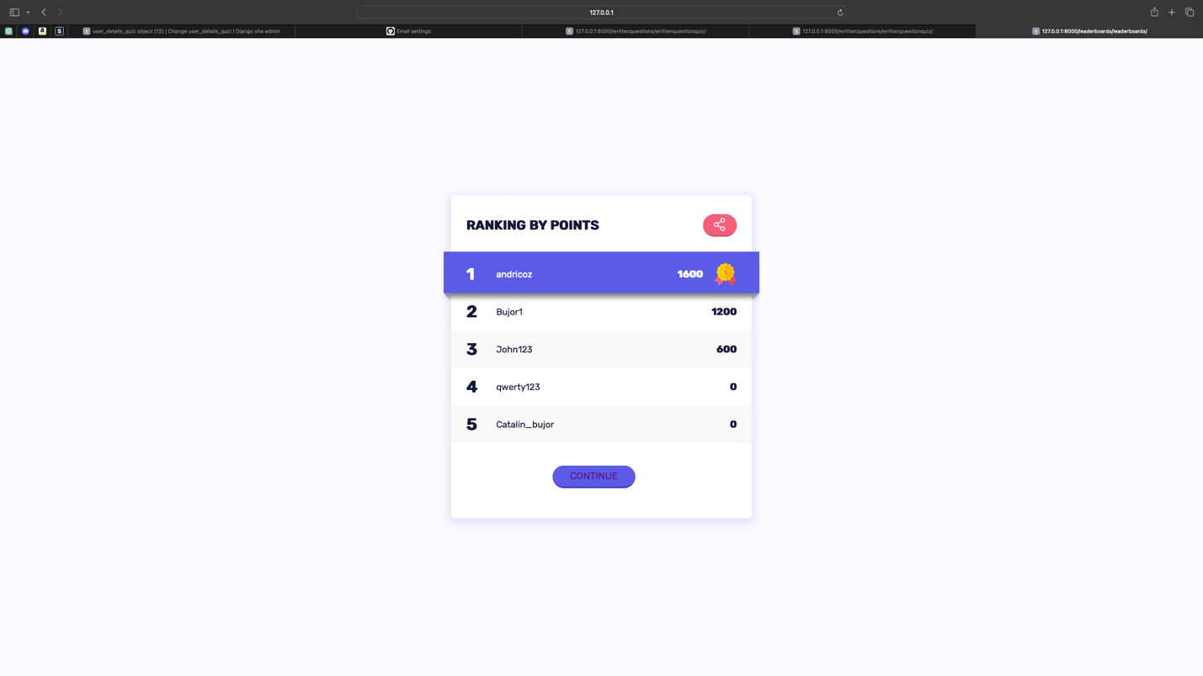

Here is the page now I will answer some questions correct on the Bujor1 account and make sure that this is working as expected.

This video will be titled (LeaderboardsTesting)

Next thing I wanted to do was enhance the adaptive learning algorithm by taking in some other factors or variables that can be used to determine a more suitable question.

The factors that I want to further take into consideration are:

Time taken for a user to answer a question.

Their average correct answers.

First thing I want to do is record the time taken for the user to answer the question.

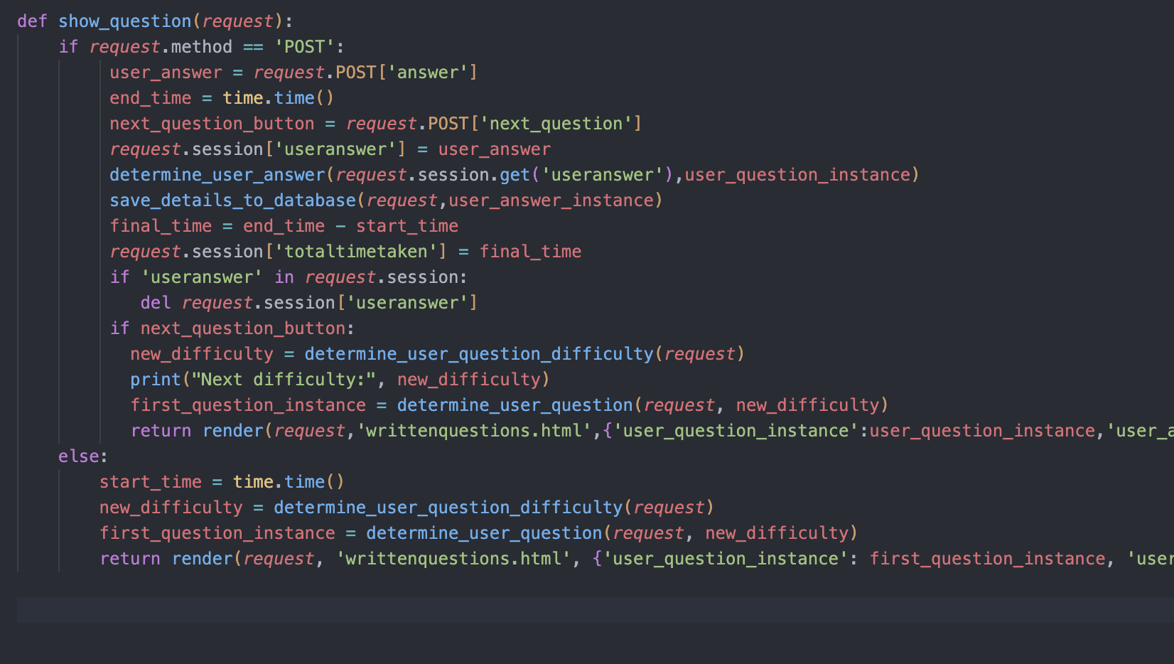

Here we have the previous function that was called upon the URL path. In this new and improved version, I used the library time to keep track how long it takes for a user to answer the question. I called upon the function time once when the question is shown as seen by start_time = time.time() which will return the time the user first saw the question.

Afterwards, I called upon the time function again once the request has been received, and this will return the time that the user answered the question at.

Afterwards, I did some simple arithmetic to subtract these 2 times and created a session with this value.

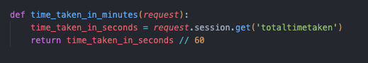

Next, I needed to convert this value into minutes as this is what is being used in the question description.

I did this using the DIV function as I want it as an integer.

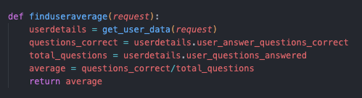

Next, I needed to find the users average questions correct.

I first used the function that I previously created to fetch their record from the database.

Afterwards I used some querying to further filter the fields I need which are user_answer_question_correct as well as user_questions_answered.

Then I worked out the ratio of correct questions to total questions and returned this value.

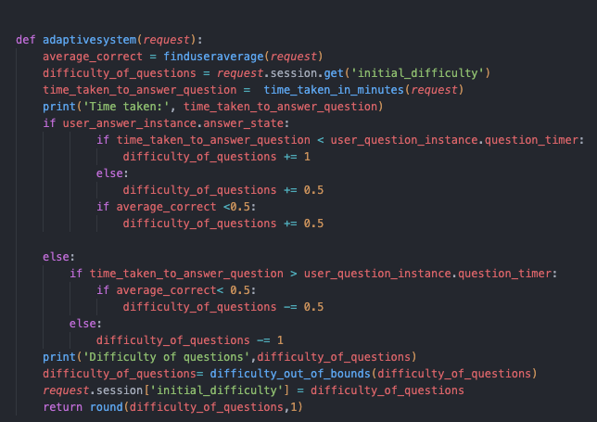

The final steps were to implement this within the adaptive system function itself.

First, I needed to fetch the users average therefore I called the function find user average and stored this value in the variable average_correct.

Next, I needed to fetch the time taken for the user to answer the question which I did by calling the function time_taken_in_minutes and storing it in the variable timetakentoanswerquestion.

Within the algorithm which determines the difficulty of the question I first did selection as previously shown to check that the user has or hasn’t answered the question correctly.

Afterwards I want to check if they answered a question quicker or faster than the recommended time given.

If they answered the question quicker than the time recommended this means that they found this question relatively easy therefore they should attempt a question on the next difficulty.

However, if they take longer than the recommended time they should gain 0.5 difficulty as they still have answered the question correctly, however if their average is greater than 0.5 they should gain another 0.5 which essentially means that if they answered the question correct with a longer time period they should get another question of the same difficulty. However, if they answer a lot of questions correctly on average I still think it would be advisable for them to attempt a harder question. (There is an error in the code which I will fix now)

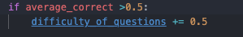

The second selection statement should also include another statement which I will do now.

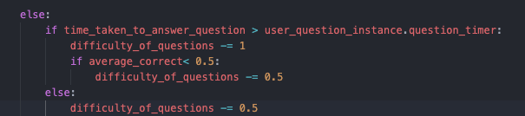

Now, this shows the code if the answer wasn’t correct.

First I need to check if the time taken was greater than the time recommended. If it is then this is a likely possibility that the student struggled extremely on the question therefore, I think that they should attempt a question with a lower difficulty.

However, if they also have an average lower than 0.5 they should also drop down another 0.5 as I believe they should answer another 2 questions of the difficulty below. For example, if they were at a difficulty 3 and they struggled deeply they should try 2 difficulty level 2 questions.

If they took a short time to answer the question this means that they understood the concept but could be a protentional calculation error therefore I think its appropriate for the user to attempt a question of the same difficulty.

# D. Evaluation

<See H446-03 Project Advice Booklet for help and guidance of what must go here.>

## Testing to inform evaluation

### Provided annotate evidence of post development testing for function and robus

VIDEOS WILL BE NAMED IN ORDER OF TESTING – VIDEO 1 WILL HAVE THE TESTING OF THE TEST BELOW

Account system

|  |  |  |  |
| --- | --- | --- | --- |
| What is being tested | Test Data | Expected Outcome | Actual Outcome |
| Testing which Usernames would be allowed to be inputted in terms of format- VIDEO 1 | 12 | When creating an account if this is the username inputted, account creation should continue | As expected |
|  | Johnthegreat | When creating an account if this is the username inputted, account creation should continue | As expected |
|  | 1 | When creating an account if this is the username inputted, account creation should not continue | As expected |

The reason that the test data “1” is valid is due to me not setting a certain criteria for a username as I thought as long as its original people should be able to call themselves whatever they wish.

|  |  |  |  |
| --- | --- | --- | --- |
| What is being tested | Test data | Expected Outcome | Actual Outcome |
| Testing different inputs of passwords and if they should be allowed.- VIDEO 2 | 12345678 | Password should be invalidated, and user asked to retry | As expected. |
|  | Helloitsme@ | Password should be validated, and account created | As expected. |
|  | Hell0itsme | Invalid | As expected. |

I tested which passwords would be allowed. With this I took more care as this is more sensitive data rather than usernames therefore there needs to be requirements that should be followed in order to keep these passwords safe.

|  |  |  |  |
| --- | --- | --- | --- |
| What is being tested | Test Data | Expected Outcome | Actual Outcome |
| Checking if a user trying to create an account with a username already in use should be able to create an account  Username being used = Johnthegreat  VIDEO 3 | Johnisthegreat123 | Account should be created as this username doesn’t match any in the database | As expected |
|  | Johnthegreat | Account shouldn’t be created and user should be asked to retry and create a different username | As expected |
|  | Johnthegreat1 | Account should be created as this username doesn’t match any in the database | As expected |

Chatbot

|  |  |  |  |
| --- | --- | --- | --- |
| What is being Tested | Test Data | Expected outcome | Actual Outcome |
| Which inputs are validated by the chatbot to be searched  VIDEO 4 | 12312414 | Chatbot should search this query on the search engine | As expected |
|  | 1@$$WSSS | Chatbot should search this query on the search engine | As expected |
|  | HOW DO I DO THIS | Chatbot should search this query on the search engine | Not as expected, chatbot calculated that I’m doing fine and you was a suitable answer due to the required word ‘how’ in the response. |

|  |  |  |  |
| --- | --- | --- | --- |
| What is being tested | Test Data | Type | Actual Outcome |
| Which inputs are validated by the chatbot when a user first sends an input.  VIDEO 5 | 1241412 | Should provide a response that’s already implemented | Not as expected. Chatbot searches this as a query instead. For some reason this query takes a very long time to search but eventually it provides an answer. Cant be seen on video as this would make it way too long. |
|  | Hello | Should provide a response that’s already implemented | As expected |
|  | Noway | Should provide a response that’s already implemented | As expected |

Here I wanted to test that the chatbot is handling each answer how it should despite of its obscurity.

Text box input – question page

|  |  |  |  |
| --- | --- | --- | --- |
| What is being Tested | Test Data | Expected Outcome | Actual Outcome |
| Which user input can be validated as an answer to a question that they are answering  VIDEO 6 | Null ( no input) | This answer should not be  Validated and instead user should be sent to the next question. | Not as expected – answer is still checked for correctness and impacting the adaptive learning system |
|  | X =5 | Answer is validated and should be checked for correctness | As expected. |
|  | Afafhasfak | Answer is validated and should be checked for correctness | As expected. |

This didn’t go to plan due to a submit button being implemented. This meant that whenever a user pressed Enter or pressed the button and there was no input in the input box this was still sent in as a request to the sever for processing.

Icon buttons across the website.

|  |  |  |  |
| --- | --- | --- | --- |
| What is being tested | Test Action | Expected Outcome | Actual Outcome |
| If the user’s can access all of the links across the website by left clicking on them, ensuring that they take them to the correct URL  VIDEO 7 | Left mouse clicked on the button | User should be directed to the URL which they intend on visiting, labelled by the name of the anchor link | As expected. |
|  | Keyboard pressed | Nothing should happen | As expected |
|  | Right mouse clicked on the button | Nothing should happen | As expected |

Answer 🡪 5q

|  |  |  |  |
| --- | --- | --- | --- |
| What is being tested | Test Data | Expected Outcome | Actual Outcome |
| How different answers should be processed based on the answer of the question given  VIDEO 8 | 5q | This inputted answer should be treated as correct | As expected |
|  | 5 | This inputted answer should be treated as incorrect | As expected |
|  | x = 5q | This should be treated as correct | Not as expected- this answer is not treated as correct as the algorithm checks that the answer is identical to the value and x shouldn’t be included. |

The last set of tested data shouldn’t be treated as incorrect as it is correct however within the algorithm the answer is just perfectly matched instead of the answer being searched within the string that the user has inputted.

Question rank

|  |  |  |  |
| --- | --- | --- | --- |
| What is being tested | Test Data | Expected Outcome | Actual Outcome |
| Which initial difficulty should be set based on the amount of points that the user has. | User points = 100 | The question rank(difficulty) that is initially set should be 1 | As expected |
|  | User points = 600 | The question rank that is initially set should be 2 | As expected |
|  | User points = 1000 | The question rank that is initially set should be 3 | As expected |

This can be seen in print statements in the development of the adaptive system

Progress bar filling up.

|  |  |  |  |
| --- | --- | --- | --- |
| What is being tested | Test data | Expected outcome | Actual outcome |
| How does the progress bar fill up based on the user’s answer  VIDEO 9 | 100% of answer is correct | The whole bar should turn green | As expected |
|  | 50% answer is correct | 2 out of 4 sections of the progress bar turns green | Not as expected, the progress bar stays the same (doesn’t fill in at all) |
|  | 0% of the answer is correct | Progress bar doesn’t fill up | As expected |

This is due to the question not being able to be partially correct as this wasn’t a feature I implemented.

Quiz is started.

|  |  |  |  |
| --- | --- | --- | --- |
| What is being tested | Test Data | Expected Outcome | Actual outcome |
| What does the layout of the page look like when a quiz is started  VIDEO 10 | Question Description | Question description is loaded in its appropriate layout space | As expected |
|  | Text Box | Text box is loaded in its appropriate layout space. | As expected |

|  |  |  |  |
| --- | --- | --- | --- |
| What is being tested | Test Data | Expected Outcome | Actual outcome |
| Are the updates of the user’s points being updated in the database  VIDEO 11 | User’s points increases by 200 | The user’s points in the database should increase by 200 | As expected |
|  | Users points stays the same | User’s points should stay the same | As expected |

|  |  |  |  |
| --- | --- | --- | --- |
| What is being tested | Test Action | Expected Outcome | Actual outcome |
| Does the leaderboard function as expected, i.e have the username and points  VIDEO 12 | Leaderboard page is loaded | The leaderboard should show the top 5 highest points along with their usernames | As expected |
|  |  |  |  |

|  |  |  |  |
| --- | --- | --- | --- |
| What is being tested | Test Data | Expected Outcome | Actual outcome |
| Does the adaptive learning algorithm work as intended | User has difficulty of 3, average of 0.6 and has taken shorter amount of time than recommended but answers question wrong. | Difficulty should change to 2.5 | As expected |
|  | User has difficulty of 3, average of 0.6 and has taken longer amount of time than recommended but answers question wrong. | Difficulty should change to 2.5 | As expected |
|  | User has difficulty of 3, average of 0.4 and has taken longer amount of time than recommended but answers question wrong. | Difficulty should change to 1.5 | As expected |

USABILITY FEATURES:

MAIN MENU OF THE WEBSITE

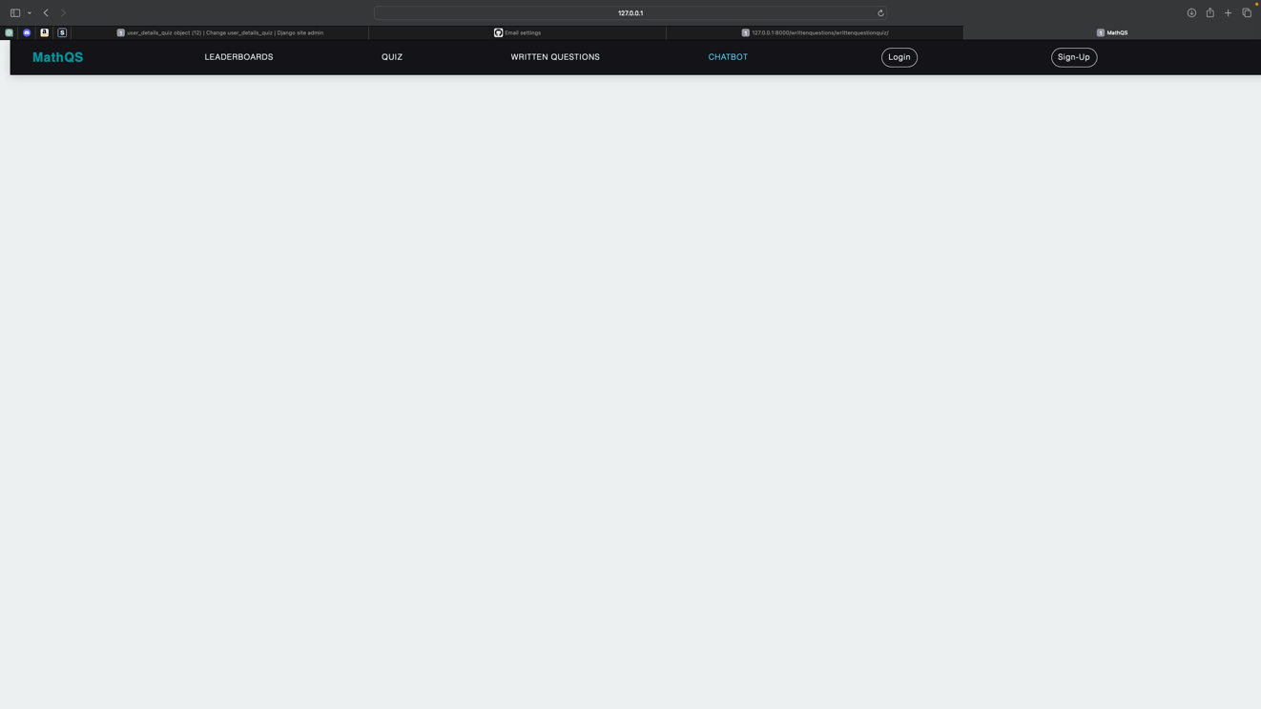

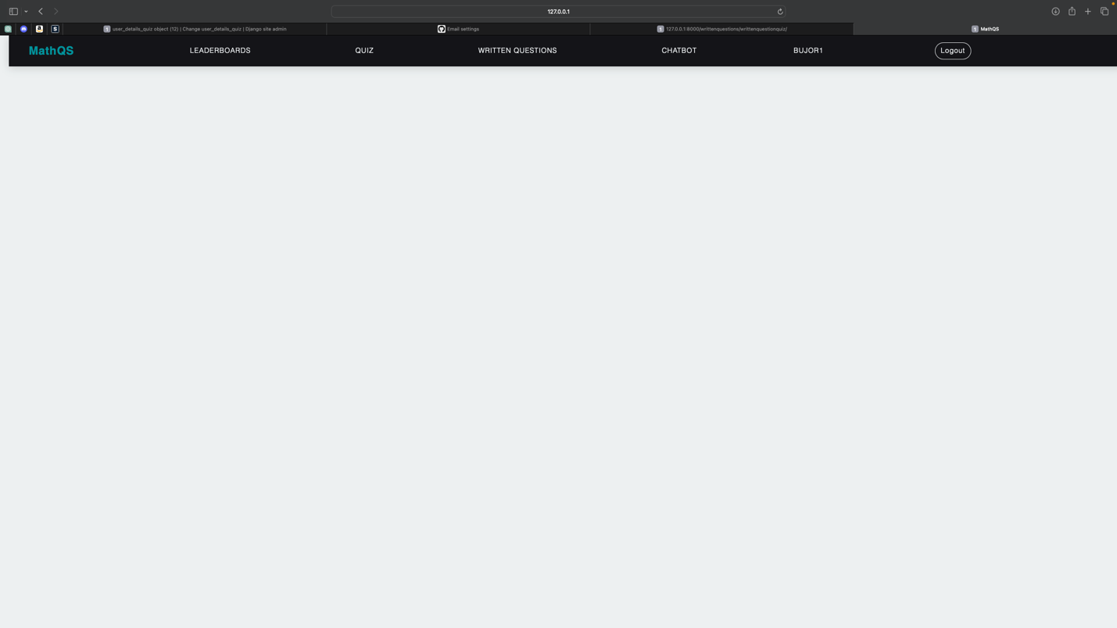

Me: I believe the main menu could have some more features in terms of the styling of the footer or the body of the page however I also do believe a user will find this main menu easy to navigate through due to the nav-bar. This nav bar contains all the features of the website and it has certain dynamic features such as when a certain feature is hovered over, this is shown that it has been selected. I also think user will like the idea of their username being shown at the top.

Daniel Malekinia (Stakeholder) : The user interface displayed by " MathQS" allows for quick, easily accessible knowledge that new users like myself can obtain. Plain and simple, is the way I like to describe it.

CHABOT UI

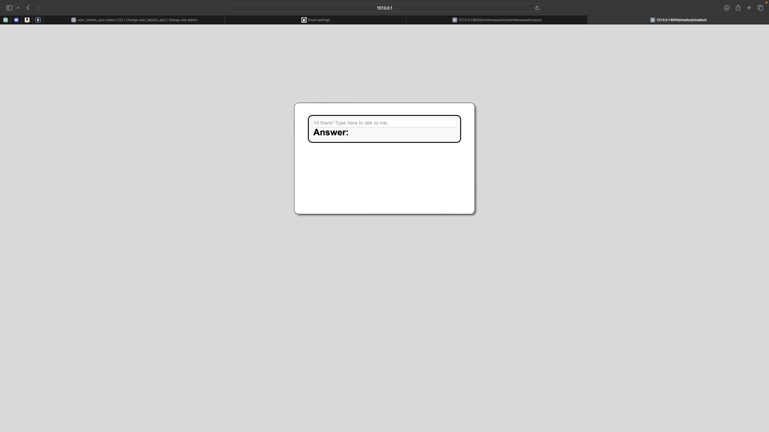

Me: I personally believe that this chatbot user interface is simple to navigate. The placeholder inside of the input box makes it easy for a user to know where to input their enquiries. The answer box also contains a simple font that is in large font size to make it easy to read. However, I do also believe I should include more colour and icons.

Daniel Malekinia(stakeholder): Once again I love the simplicity, as a person that suffers with adhd, it allows me to concentrate and get my work done.

LEADERBOARD UI

LEADERBOARD UI

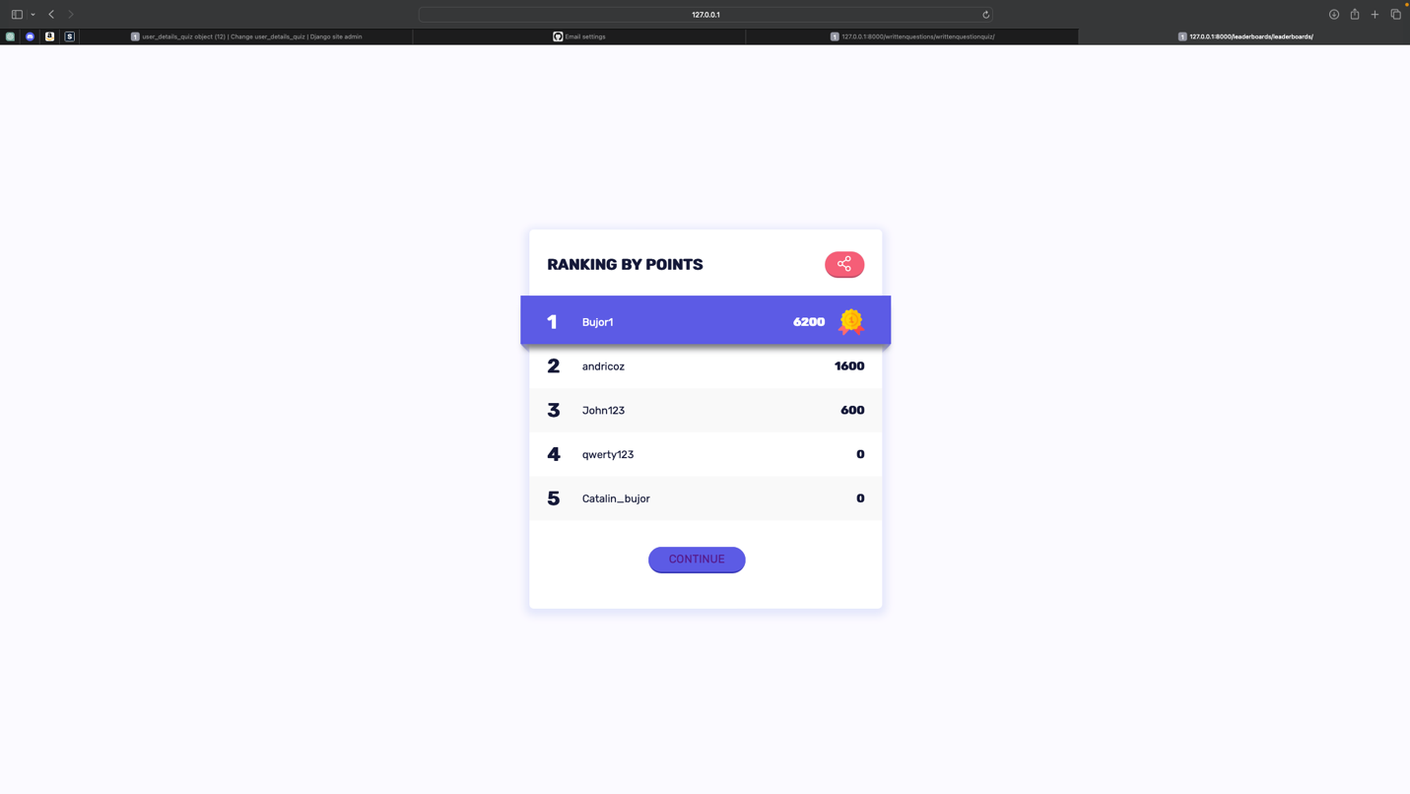

Me – The user-interface provides a nice visual representation of the leader board. The icons allow for a more colourful visual as well as the blue highlighting the name of the rank 1 user making it even more special to hold that rank.

Daniel Malekinia(stakeholder): The choice of colour representing the different ranks allows for a nice visual aesthetic.

QUESTION UI

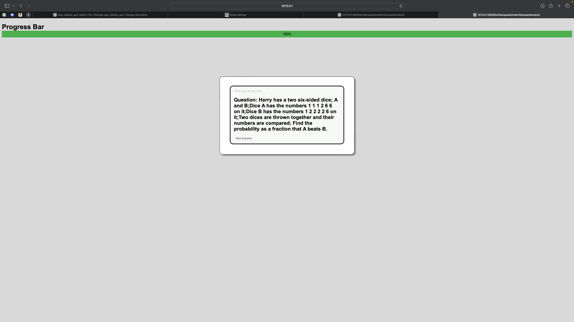

Me: I think that the website has a consistent template, (as this was previously used in the chatbot section) which is essential as it maps everything together. The question is clearly labelled as the question as well as the bold writing in a big font making it easy to see.

The textbox contains another placeholder which lets the user know where to input the answer, as well as a button that is labelled correctly as next question. I personally think I should’ve made this bigger for the user as its quite small.

I think the progress bar almost gives life to the page with its bright green colour and it creates a satisfying aesthetic feeling which I hope makes the user want to answer questions correctly.

Daniel Malekinia(Stakeholder): the user-interface provides a nice representation of the progress bar. The gradual increase in colour displayed on the progress bar motivates students to push until they finish.

ACCOUNT SYSTEM UI

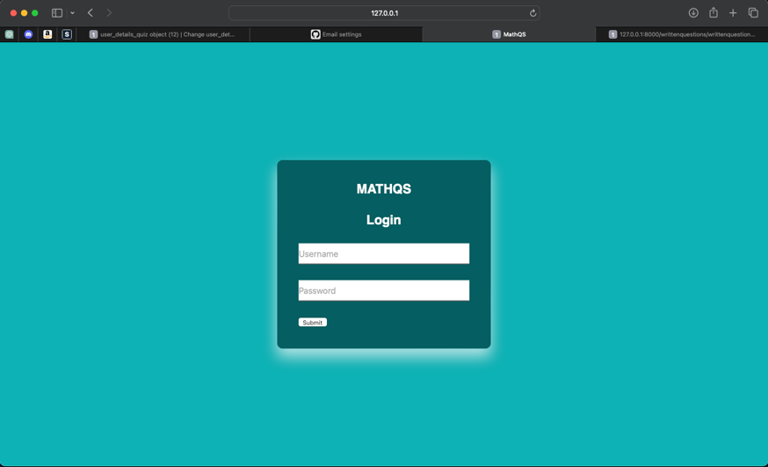

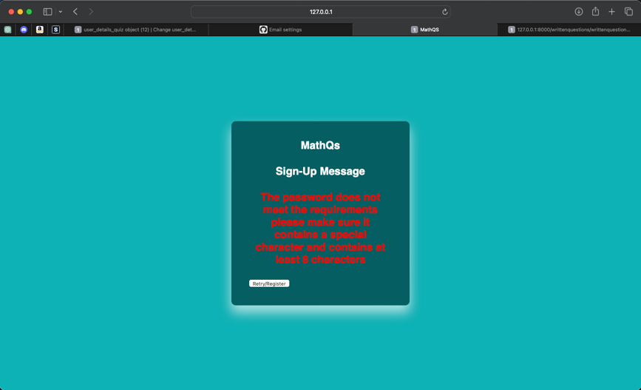

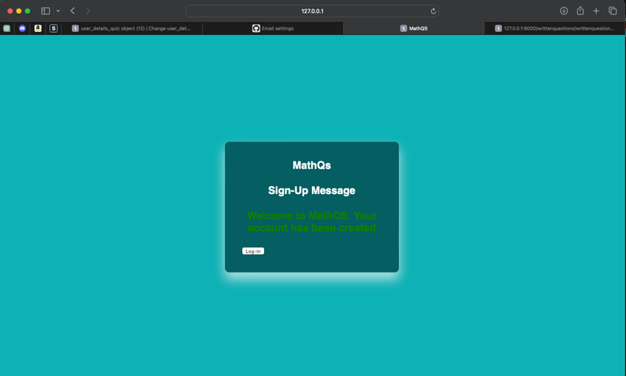

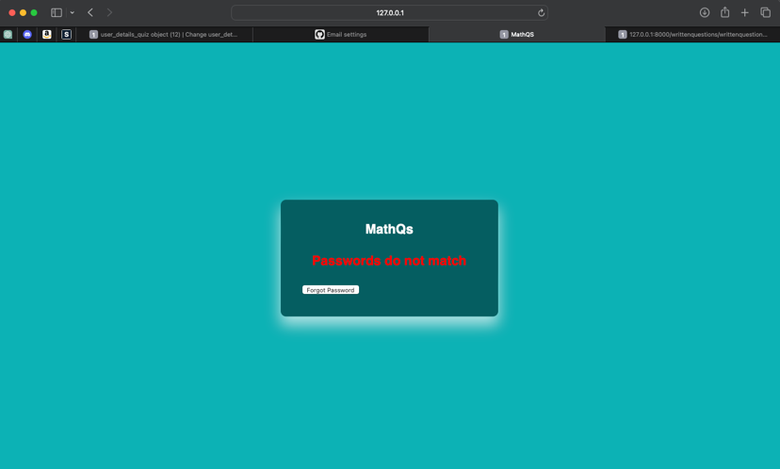

Me: The simplicity of these login screens is what I personally love as it almost creates a trust that the sensitive data is being handled as securely as possible. I also believe a user will like the colour of the text which indicates that the login or sign up was either as success or a fail as well as the buttons which direct the user to the action that should be taken.

Daniel Malekinia(stakeholder): I like how when something goes wrong a red message is displayed and when something goes right a green message is displayed. The colours used are consistent throughout the website.

Success criteria checklist.

|  |  |  |
| --- | --- | --- |
| Requirements | Justification | Reference |
| Start button – this will be activated via a left click on the mouse. | This is to make sure that the time used in order to answer the question is accurate, this is to ensure for an accurate adaptive learning algorithm | Proposed solution |

This requirement was half met.

The start button can be interpreted as the button the main menu. When a user clicks on the text written questions which has an URL path to the quiz, the quiz is started as soon as the user sees the question.

|  |  |  |
| --- | --- | --- |
| Timer – this activates once the start button is clicked | Timer is necessary for students to see if they are completing the question within the time given during a real exam. | Proposed Solution / Mangahigh |

This criteria has been successfully met. Once a user starts a quiz a timer is started to record the amount of time taken to answer the question

|  |  |  |
| --- | --- | --- |
| Written questions are sent back to the user at random times based on the adaptive learning. | Written questions will be necessary for students to attempt more challenging questions which are assessed on the working out as well as the answer. | Proposed Solution / Mathswatch |

This success criteria was also met. The adaptive learning algorithm is able to generate questions which are customised to the user.

|  |  |  |
| --- | --- | --- |
| Algorithm to check if written answers are correct. | This will be based around an array of possible answers and key elements needed in order to gain marks. | Proposed Solution / Mathswatch |

This criteria was met. Once a user inputs an answer this is validated to check that the answer is either correct or incorrect and based on this various data changes.

|  |  |  |
| --- | --- | --- |
| Counter – data type – dictionary  This will hold the number of correct questions. Increments when question is correct | This will be needed to hold the number of questions correct (value) along with the difficulty of the question (key) | Proposed Solution |

Successfully has been met. This counter is stored in the database and is incremented when a user answers a question correctly.

|  |  |  |
| --- | --- | --- |
| AI Chatbot needs to be able to activate once the student is detected to be struggling on a question. ( more than one minute elapsed time) | AI will need to be able to be automatically activated once a certain time is elapsed.  Able to take user’s inputs and process the input for an appropriate answer.  Detect when it isn’t able to help the user and report back as to what question it doesn’t understand (however this could be tackled using a google search library where it will be able to give back URL links to the user). | Proposed Solution |

This has not been implemented at all. This is since I stated earlier in the code which made me realise that the user doesn’t gain much benefit from the ai as it doesn’t directly tell you an answer or hint towards it. However,AI can still be accessed manually.

|  |  |  |
| --- | --- | --- |
| Pop up notifications appear when a student gets the answer correct or incorrect. | This is part of the user interface –  Makes it more user friendly as the user is able receive a quick compliment if they completed the question or a motivational message in order to push the students to do more revision. | Mathswatch |

This success criteria hasn’t been met. I thought that potentially the progress bar could be a good enough indication that the answer is correct or incorrect however, I would love to implement this in the future.

|  |  |  |
| --- | --- | --- |
| Text Box – this is part of the user interface as well as a requirement for the users to submit their answers. This appears at the start of every written question. | This is needed for the user to input their answers to written questions and be retrieved for marking and validation. | Proposed Solution |

This success criteria has been fully met, a text box appears on top of the question that the user is attempting to answer. The input inside this textbox is sent for marking and validation.

|  |  |  |
| --- | --- | --- |
| Users can attempt a question more than once. | This is backed up by the stakeholder interview. This is due to students being able to try questions multiple times as practice. | Stakeholder interview |

I think this criteria can be debated between partially and successfully met. In the context that the question can be answered again despite of the user getting it wrong, this isn’t directly true. However, a user can attempt the same question again at a different stage of their learning if the adaptive system is appropriate.

|  |  |  |
| --- | --- | --- |
| Diagnostics Exam – this will be introductory for every user once they log in.  Sets up the minimum level of the student in the adaptive learning. | This is going to be used as an initial rank (starting point for every topic) for the student. | Stakeholder Interview |

This success criteria has not been met. I believe this was a necessary thing that I should have implemented however, I believe that the adaptive learning system is able to take over despite of the initial rank of the user. This is due to the fast progression and I also believe that every user should start on 0 points as otherwise they would likely not attempt the easier questions which tend to have the most impact on an exam as they are brushed off. Howev

|  |  |  |
| --- | --- | --- |
| Submit Button used to send user input back to the database. | This is going to be used for the user to send the results back to the server once they are pleased with the answers. | Mathswatch / Mangahigh / Proposed Solution. |

Submit button has been successfully implemented. The user can click on this button when they are pleased to submit their answer.

|  |  |  |
| --- | --- | --- |
| Second Counter – Used to count points gained by the user over a certain period.  Counter increases if question is correct. | This is needed in order to determine the rank of the user for the leader boards. | Mathswatch/ Mangahigh/Proposed solution. |

This has been successfully met, user’s total points are stored in the databse users_details_quiz

|  |  |  |
| --- | --- | --- |
| Leaderboard System used in order to sort the best performing users.  Top 3 will be in a bold font as well as coloured in Gold, Silver, Bronze according to rank. | This is going to be a feature where users will be ranked based on their performance in questions, this will be stored in an array / dictionary / linked list. | Mathswatch / Proposed solutions |

This has been completed successfully. An app was created to handle this leader board to show 5 of the top users with the highest points. However, I can see this being further improved by adding leader boards that rank users based on their accuracy on questions.

|  |  |  |
| --- | --- | --- |
| Graph system – separate functionality which is accessed via a menu.  Shows students progress. | This will be used to display progress to the user over time and compare their progress over time. | Mathswatch |

This criteria was not met. I think this could be achieved by pulling all of the data from the database and using a graphing library that is already inbuilt within python such as numpy or others etc.

|  |  |  |
| --- | --- | --- |
| Progress bar -> part of the user interface, will fill up based on the progress of the user. | This is part of the user interface and allows the user to see how well they are doing on a question. | Mathswatch |

This criteria has been successfully met. When a user answers a question correct the progress bar fills up green, if the user answers a question wrong the progress bar remains the colour grey and shows a percentage of 0%

|  |  |  |
| --- | --- | --- |
| User interface for questions ->   * Shows difficulty of the questions * Progress Bar which is filled up when question is answered correctly | This allows the user to see the difficulty of the question and allocate themselves to the conditions needed to answer the questions (time needed, amount of working out) | Proposed solutions / Mathswatch |

This has been partially met. When the user attempts a question the progress bar is shown, however the difficulty isn’t however this could be implemented by passing the parameter of the difficulty to the front end to be added to the template.

|  |  |  |
| --- | --- | --- |
| AI can take in inputs and calculate certainties on which answer to output. | Not enough time to create a neural network where the ai is able to have unsupervised and supervised learning. | Proposed Solution |

This has been successfully met. The chatbot is able to process the user’s inputs and accurately determine if a response is suitable based on the input of the answer using certainties.

|  |  |  |
| --- | --- | --- |
| Algorithm which is able to create different level of questions:  Easy  Medium  Hard | This will be an algorithm used to make questions ranging in difficulty from easy to harder, based on a certain template. | Proposed solution. |

This has not been met. The questions that I used in the website are questions which I took from a credited source provided by my stakeholder Ms Pitsidilles. I think this can be achieved by following a certain template for each type of difficulty of questions by changing the values in further development.

|  |  |  |
| --- | --- | --- |
| Separate app for the monthly prizes tab which will be accessed via left click on the right heading. | This will be accessed via a left mouse click. Users should be able to only choose prizes based on the number of points they have. | Proposed solution. |

This has not been met.

I think however in further development this can be improved by creating an app which is able to pull the user’s points from the user’s details quiz database and through some validation checks based on the prizes points.

|  |  |  |
| --- | --- | --- |
| Streak system – Question is chosen daily and is worth extra points if the users are able to complete it.  Double the points of the question on a normal day. | This will motivate students to log in to their accounts and do maths in order to not miss out on any points as these can be used to claim prizes. | Proposed Solution – Idea taken from LeetCode. |

This has not been met.

I believe this could be achieved by creating an app and using django’s built in feature which is able to calculate the time. The same template from written questions can be used and the same algorithm to generate a question when the time of day is correct.

|  |  |  |
| --- | --- | --- |
| Users should be able to:  Access the community chat forum.  Send messages.  Retrieve messages. | This allows for students to communicate with each other in order to open new ways of thinking. | Stakeholder interview  Proposed solution. |

This has not been met.

I believed this was quite an ambitious ask. The task at hand requires a lot of steps to ensure the security of the messages including encryption and expert session handling which I could master with a longer time of development. However, I would love this feature to be implemented as I believe students and users would love to talk to each other.

|  |  |  |
| --- | --- | --- |
| Plays a sound when the user got a question correct. | Adds to the usability features of the website making it more user friendly. | Mathswatch |

This was not met.

This feature can be implemented within the check answer function. This can be done by adding an audio file and it is played when the user gets the question correct.

|  |  |  |
| --- | --- | --- |
| Play a sound when the timer is about to run out ( 30 seconds before). | This will alert the user when they’ve exceeded their time limit. | Proposed solution |

This was not met.

This was another feature I wish I could’ve implemented as auditory features can make the website more intriguing .

|  |  |  |
| --- | --- | --- |
| Questions are released at the times with the highest user traffic. | This allows for users to be more engaged. | Proposed solution |

This has not been met.

One way I can see this being developed is being creating a database that stores the amount of users logged in every hour and use a sorting algorithm in order to retrieve the times with the highest user traffic.

|  |  |  |
| --- | --- | --- |
| Run the server as a local host.  Website communicates with server. | This is due to scalability not being an issue due to low traffic. | Proposed solution |

This has been successfully met.

The website is run on a local address as a local host. In the released version this can be moved to a public host to host a higher number of users.

|  |  |  |
| --- | --- | --- |
| Data is sent to the database. | This is needed once users need to log in. | Proposed Solution |

This has been successfully met.

Data is sent to the database whenever this is needed to be saved, not only during the log-in section.

|  |  |  |
| --- | --- | --- |
| Multiple input validation algorithms to make sure password and email are in correct format | To make sure that the password is strong enough and that email is valid. | Proposed solution  Mathswatch |

This has been successfully met.

When users create an account, there is certain requirements that need to be met otherwise the password is rejected until the user inputs a password with correct requirements.

Emails were not used in the creation of accounts, so this does not apply.

|  |  |  |
| --- | --- | --- |
| Data is retrieved from the database | This is needed when questions need to be sent back to the website. | Proposed solution |

This has been successfully met.

Data is retrieved from the database whenever is needed for validation or when the questions are sent back to the user.

## Evaluation of solution

Maintenance issues.

I believe that maintenance can be easily managed through further development. This is due to the code being somewhat robust so that they are able to manage through inputs or scenarios that would otherwise cause errors. However, I still think that further robust techniques can be added to make the program even more optimal at handling errors.

Another benefit of the program is that everything can be visually accessed and seen via the admin panel that I have created. This means that in the further development of the website, the developer will be able to have a visual representation of the data which can make it easier to debug as well as to create models for further features that can be implemented.

I believe that another issue that can be addressed at the later stages/post development is user traffic. As user traffic increases a better server needs to be used that is able to handle a higher amount of user requests.

I believe that the program in the future can be changed by creating templates for every app in order to reduce the amount of time taken to create the front end of the website. I also believe that a lot of the code can be used in further implementations of the features I was not able to create therefore creating a library can be very efficient to stop the use of repeated code

### Considered maintenance issues and limitations of the solution

### Described how the program could be developed to deal with limitations of potential improvements/ changes

# Project Appendixes

## Complete Code Listing

Insert as many project appendixes as you need for your project.

These might include, but are not limited to:

* **Complete Code Listing (ESSENTIAL**)
* Interview Transcripts
* Meeting notes
* Observation notes or questionnaires

Chatbot inspiration (https://www.youtube.com/watch?v=Ea9jgBjQxEs)